New Turnitin LTI process and features
From the 18th of July 2022; the process for creating TurnItIn assignment submission links will look and feel different. The majority of the old functionality will remain and there will be some new features as explained in this guide.

Creating a paper submission link
1. From the Blackboard shell, click on the TurnItIn Content Area and move the mouse over Build Content.

2. Select TurnItIn Assignment.
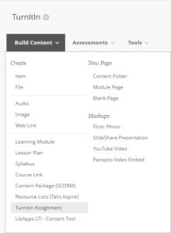

3. Populate the screen with the relevant detail from the module or block’s assessment schedule.

Note: The example below relates to a theoretical piece of coursework related to a block. It conforms with DMU assessment policy in that it is marked out of 100 points and there is 15 days to grade and provide feedback on the submissions.
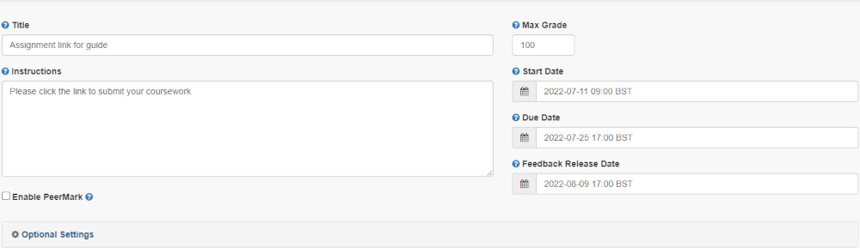

4. Click on Optional Settings.
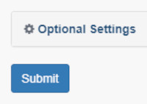

5. Complete the next section of the screen.

Note: The example below relates to a theoretical piece of coursework related to a block. It conforms with DMU assessment policy in that it is marked anonymously and for completeness it shows that a Rubric is in use.
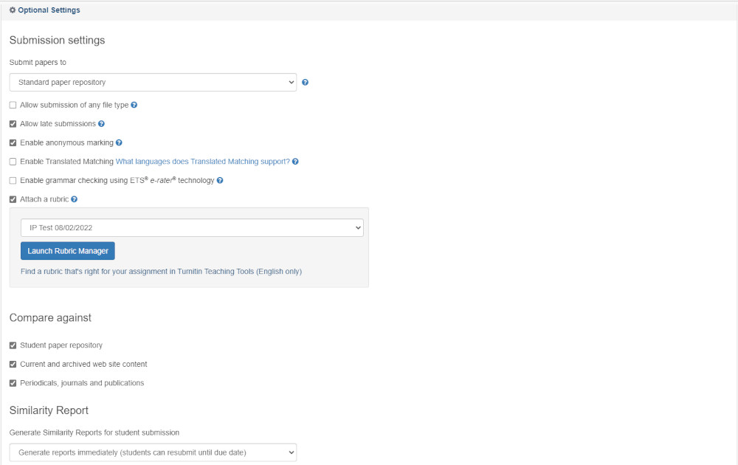
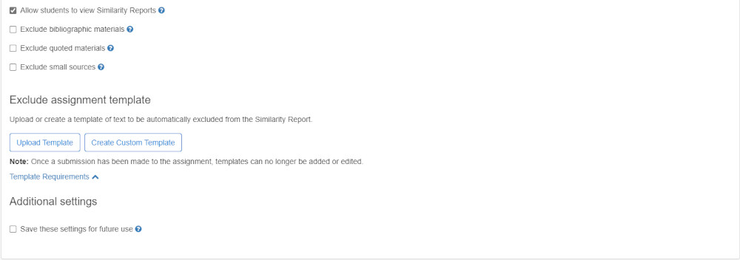
Note: The ‘Allow students to view Similarity Reports’ setting may be enabled at your discretion – for further support with this please contact your local Digital Learning and Teaching Consultant.
6. Click Submit.
7. The new TurnItIn link will now be displayed within the Content Area.
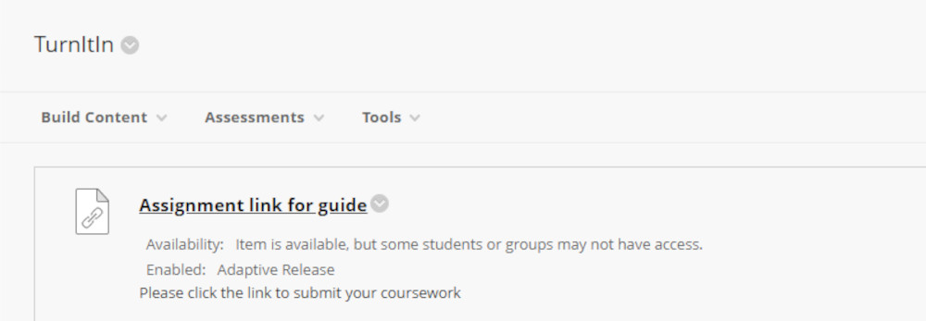

Note: To access the submission for grading, colleagues must re-visit this link which will navigate direct to the Assignment Inbox.

Grading and providing feedback
1. Click the submission link.
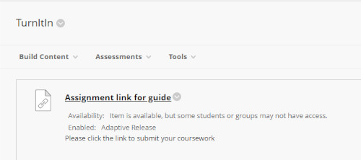

2. The next screen will display the Assignment Inbox.

3. In the Grade column, click the icon for the attempt to be graded.
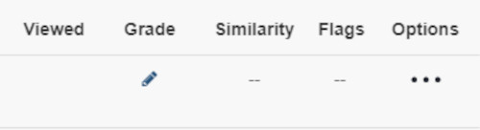

4. The Feedback Studio will launch as normal.

Analytics
The new TurnItIn integration enables easier engagement with analytics regarding the submission link and student interaction.

1. Click the submission link.

2. Toward the top of the screen, click on Analytics.

3. The Analytics Dashboard will be displayed. In here, colleagues can see and download data regarding grades, the Rubric (if in use) and similarity.
