Force Completion and Set Timer – July 2022 onwards

When creating a Test in Blackboard, the ‘Force Completion’ and ‘Auto-Submit’ options on the ‘Modify Options’ screen are now linked. The implication is that once Force Completion is selected; Auto-Submit is turned on by default and cannot be turned off.

This will affect scenarios in which colleagues require students to sit a Test in one sitting but want to allow an amount of leeway after the prescribed time for students to finish the question they are on and Submit their answer(s).

It is recommended, in this scenario, that colleagues add a few minutes to the Test time to enable students to complete the Test – otherwise, Blackboard will Auto-Submit on the students’ behalf as the allocated time elapses.

1. During the Test deployment, navigate to the Test Availability section.
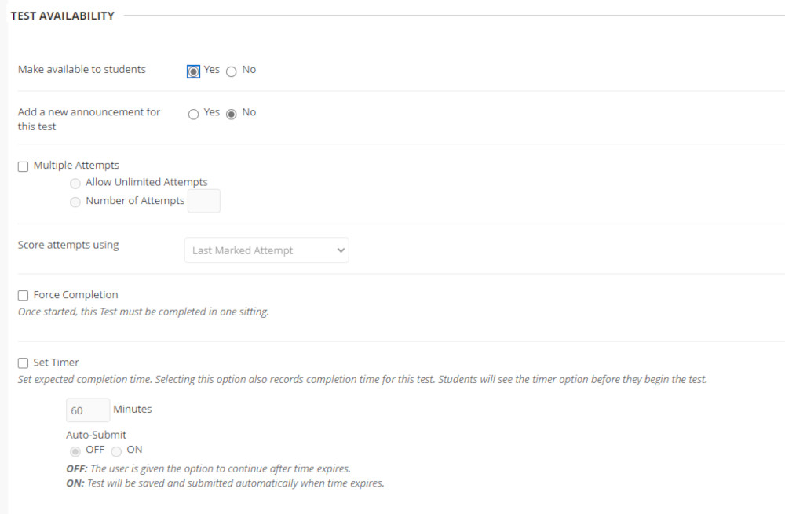

2. If students are required to sit the Test on one sitting, select Force Completion.
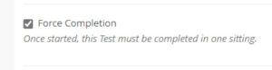
Note: Selecting Force Completion will automatically enable the Set Timer option and Auto-Submit will be turned on.

3. Type the desired time (minutes) into the Minutes field – adding the extra minutes to enable students to Save and Submit should, this be desired
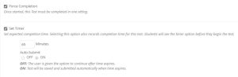

4. Continue with the remaining settings and click Submit.

