Creating a hidden Content Area in Blackboard
In the scenario where colleagues need to share documents or prepare an area in Blackboard for External Examiner access; the following steps should be followed to ensure such an area remains hidden from students.

1. Move the mouse over the Add Menu Item icon and select Content Area.
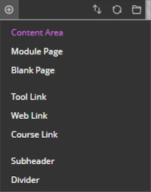

2. In the Name field, type the desired name as it will appear in the navigation and click Submit.
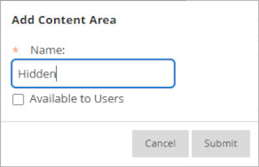

Please do not select Available to Users.

3. The new Content Area will now appear toward the bottom of the navigation.

The ‘This link is hidden from students’ icon is displayed next to the new Content Area.
4. Click into the new Content Area and move the mouse over Build Content.
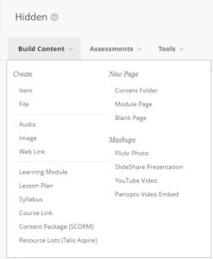

5. Below New Page, select Content Folder.
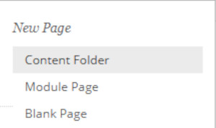

6. Provide an appropriate name for the folder and ensure that Permit Users to View this Content is set to No. Click Submit.
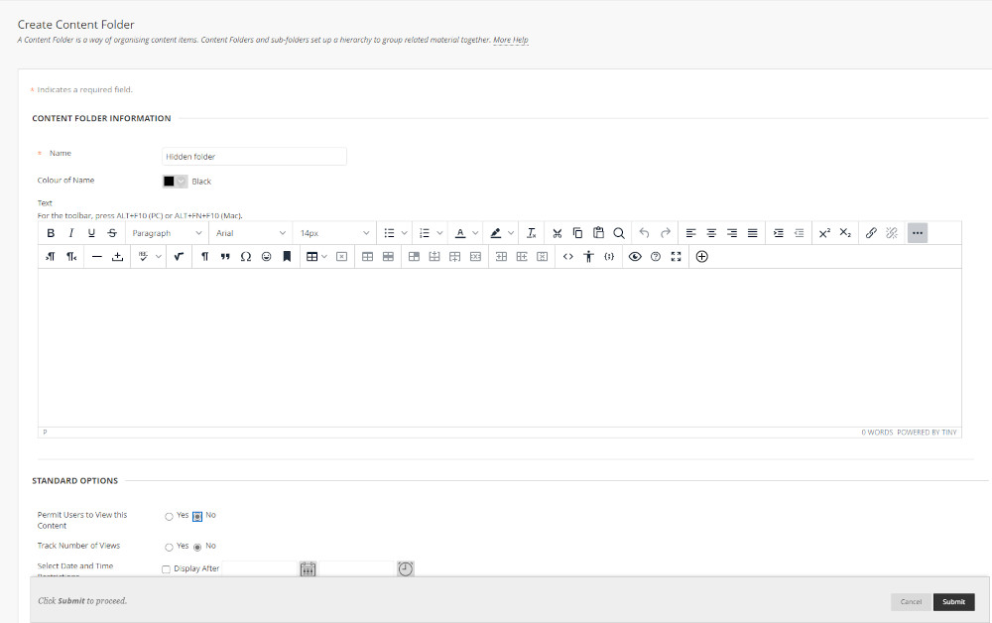

7. The hidden folder now exists within the hidden Content Area.
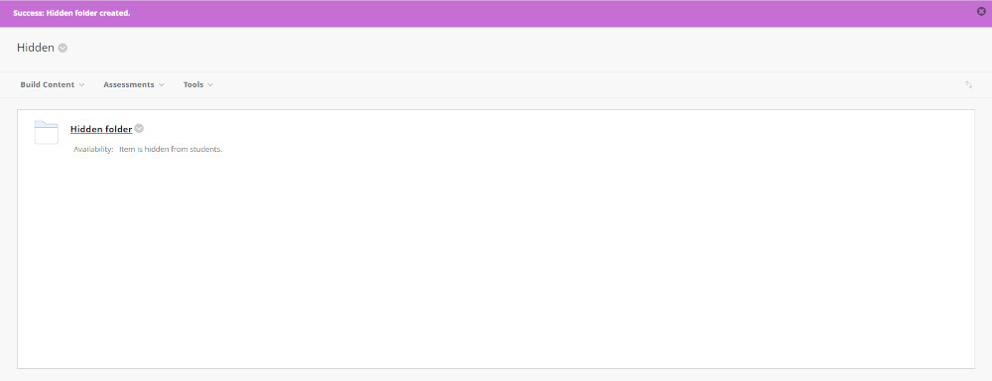

Any documents that are uploaded to this folder should be saved with password protection enabled and passwords shared under separate cover.

