Converting an 0365 Word document to a Webpage, using Sway

- If your Word document is not already in 1Drive: login to your 0365 account and upload your document into your 1Drive
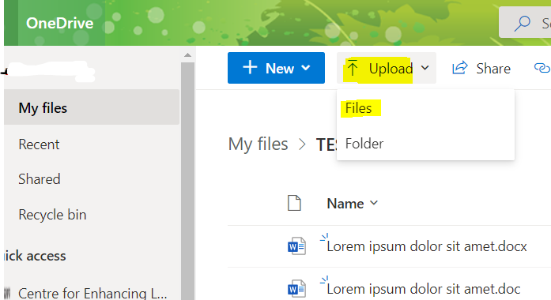

- In 1Drive, open your handbook
To save your handbook as a Sway page: click File>Export>Transform to Webpage
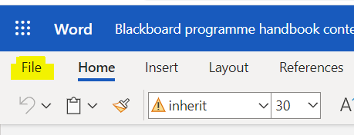
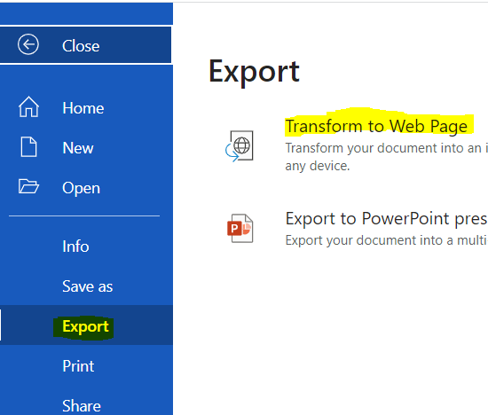

On the next screen you just need to follow through by clicking the Transform button.
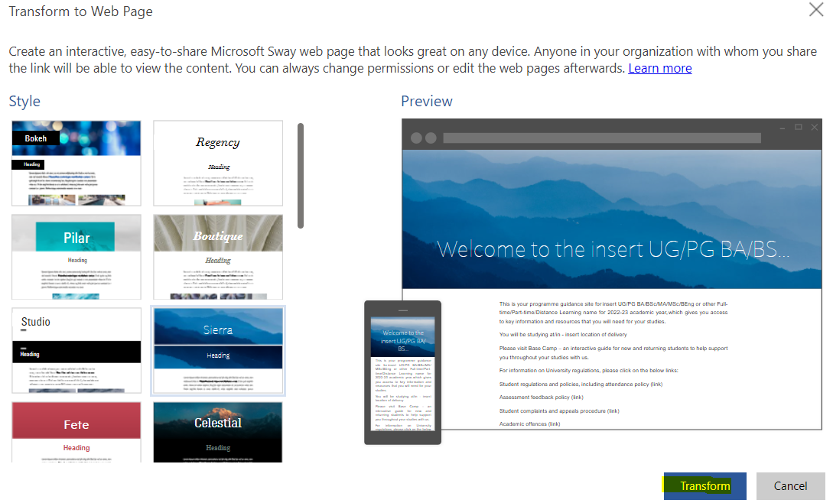
The Sway will now be generated. It may take a minute, then offer the option to Edit.
Note if you are in My Sways you can get the link from there also: click on the 3 dots at the top-right of the Sway. You can either click to copy the link or to play the Sway.
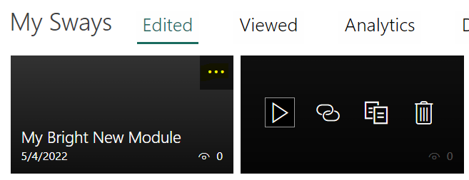
- Sway has accessibility checks built in and available in the settings.
- Ensure you have set the permissions first, to specify who is able to view the Sway before you circulating the link

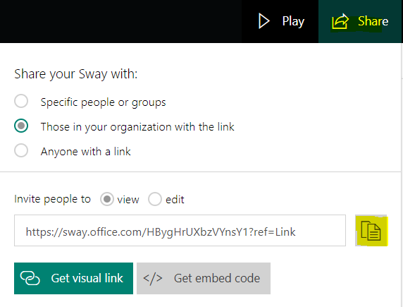

Checking and Editing your Sway
Note: Although Sway will automatically try to convert your document, it may not necessarily create it exactly how you want it. Ensure to have a look through to check and edit the Sway if needed.
If you are unfamiliar with SWAY, a great place to learn is through this SWAY tutorial and example

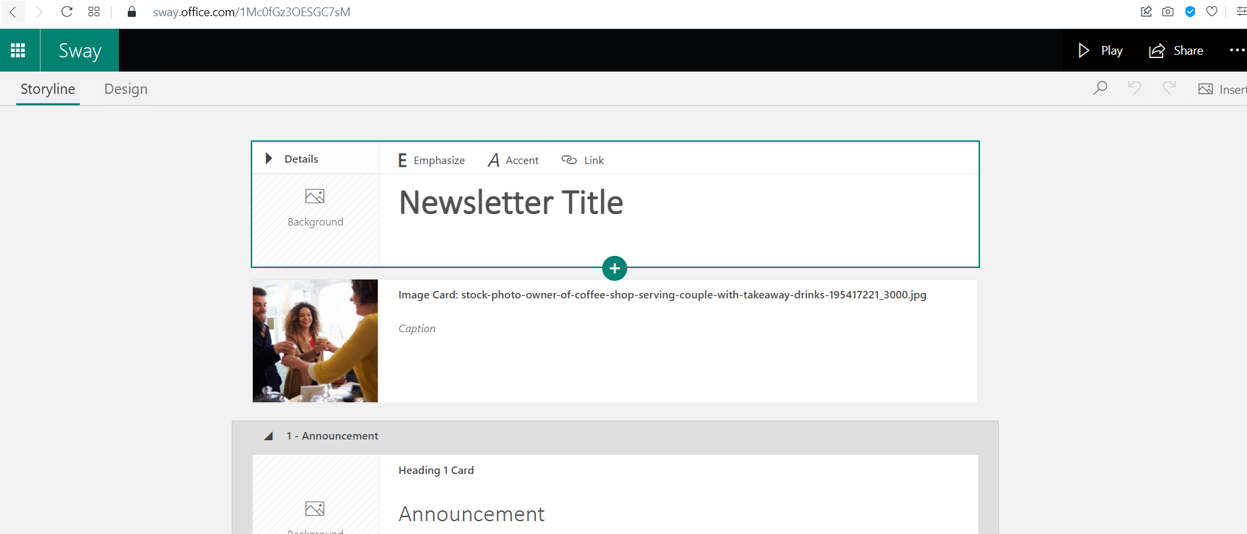

Embedding the Sway

Embedding a Sway
If you decide to use the Embed code to embed the Sway into the content item in Blackboard, pay particular attention that the Sway is displayed as you intended. The process is similar to the above, but this time you select the Embed code in Sway. You then need to ensure you copy the embed code into the source code editor in the Blackboard item text box. The process is described below.

- Access the embed code for your Sway.
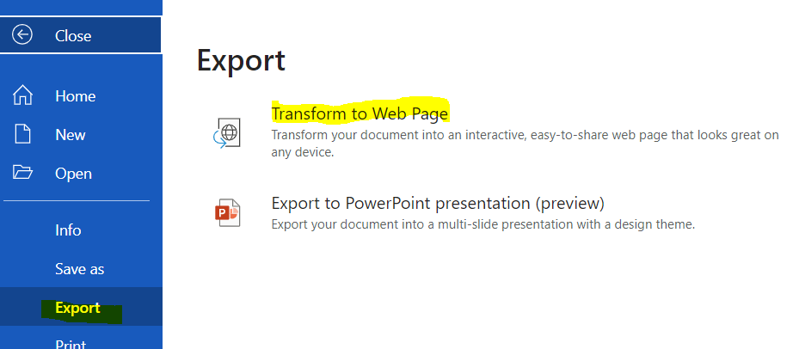
In 1 Drive, click File>Export>Transform to Web Page>Transform. .

This time select Embed code
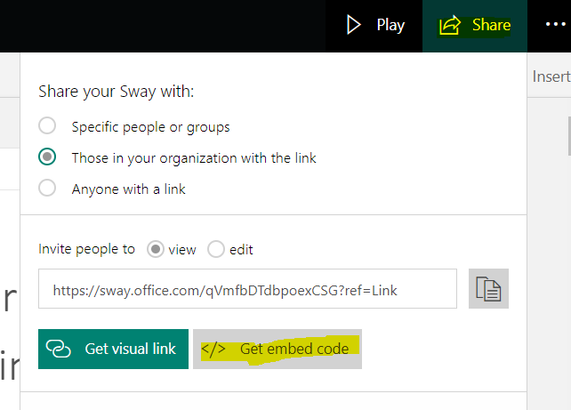
.

Click to copy the Sway embed code. (Note if you do not see the embed code option, click on Edit (top-right of your Sway in 1Drive) then, then Share).

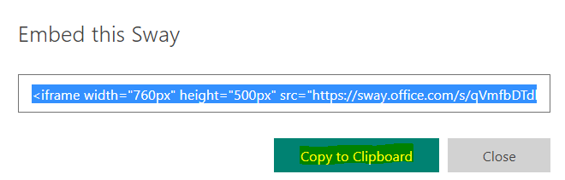

Embedding the Sway
Now, go to the content area where you want to display the Sway.
- Click Build Content>create Item
- Type in a name for the content Item, and then in the text editor switch to the Source code view (you'll find the <> icon on the bottom row in the formatting textbox ).
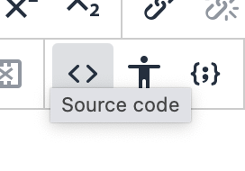
Paste the embed code you previously copied into here and then Save, then Submit.
To improve the appearance of your Sway, you may need to amend the dimensions of the Sway. You can do this by going back to edit the item. Select the Source code icon in the formatting tool bar: check the height and width in particular.
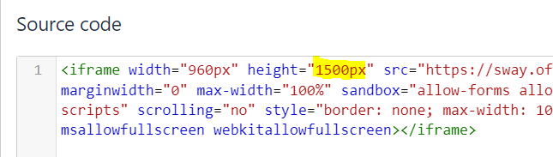
(you may need to edit and save a couple of times to get it to display as you want)

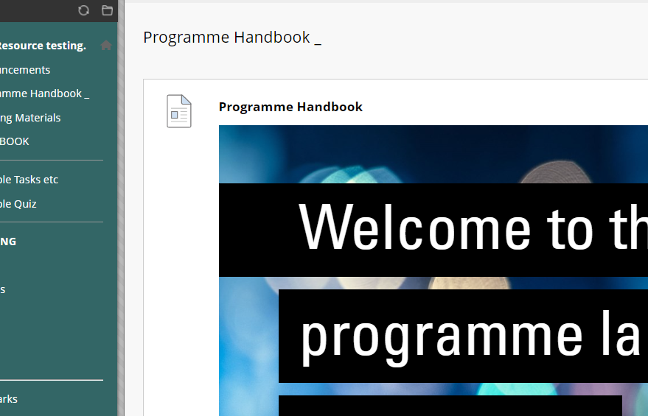
Depending on your settings, note that users may have to login to their Office 365 account, if not already, to view the Sway. Students will be able to download the file if needed.

