Adding your handbook to Blackboard

The example below focuses on the Programme Handbook. The “Programme Handbook Guidance and Template” for 2022-2023 is currently located on the DAQ Website at this link

Once you have adapted and developed the handbook for your own contexts, you should upload the handbook to the Programme Shell on Blackboard.

Create a menu item for the handbook

In Blackboard, navigate to the Programme or Module shell and ensure Edit Mode is ‘On’

The first thing you need to do is to create a menu item called Programme Handbook To do so, Click on the little ‘+’ sign at the top-left of the left-hand menu, and select ‘Content Area’

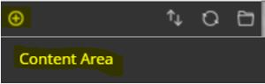

Type in Programme Handbook and submit.

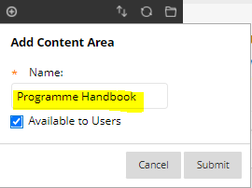
Programme Handbook should now appear on the left-hand menu.

Copy and paste your handbook into Blackboard

The following steps are the best way to copy and paste the content, while ensuring that the links work well in Blackboard.

- Go to the Programme Handbook content area you’ve just created.

- In Edit mode, Select Build Content>Blank page

- Change the title to Programme Handbook. Then Copy all of the text from your handbook and paste this into the text box. Click Submit.
- Note as you copy and paste in, select the option to ‘Keep Formatting’

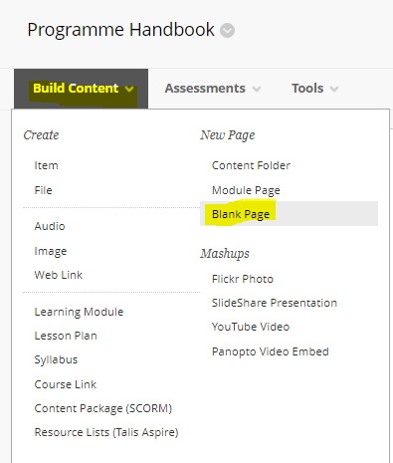

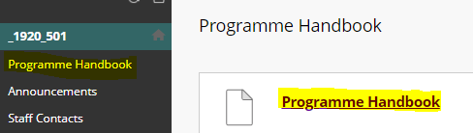
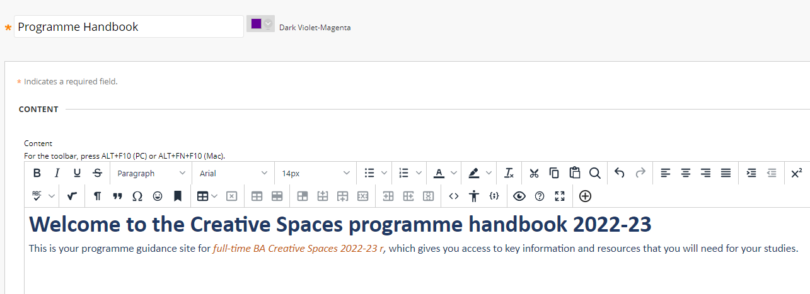
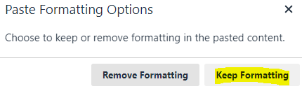
Paste into the Text box (keep Formatting)

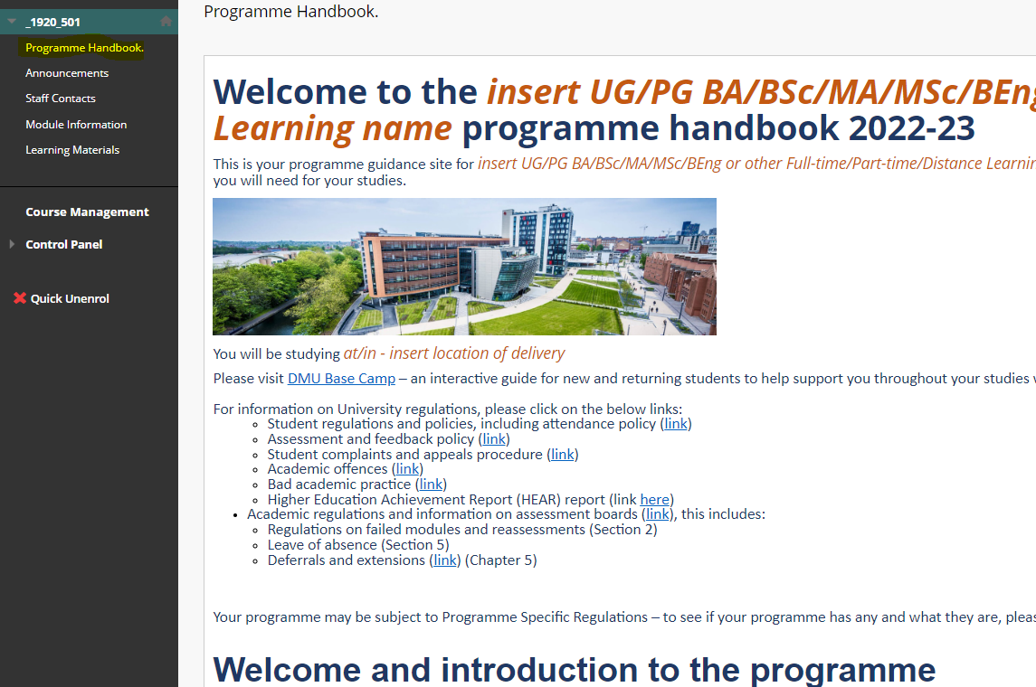
Note - There is some flexibility as you may want to display your handbook
*Please ensure that any alternative formats are accessible.
*To display your handbook with Sway, [see how-to save as Sway]
Please ensure that you have removed all annotation and guidance notes from the handbook. You can remove the pink boxes easily, by selecting the box and click X to delete.

