Managing Class Teams synchronous sessions
Note: This approach is to be employed for synchronous sessions that are to be delivered via a Microsoft Teams meeting. The creation of a Group in Blackboard will create a Microsoft Class Team via which synchronous sessions can be created and delivered.

Note: Once the Blackboard Group and subsequent MS Class Team have been set up, the information source for the synchronous sessions is the academic register.

1. From the Blackboard shell click on Users and Groups>Groups.
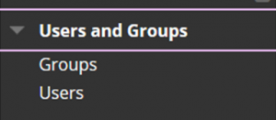

2. Move the mouse over the Create button.
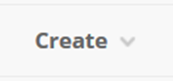

3. If a single Group with all module students is required, click on Manual Enrol under Single Group.
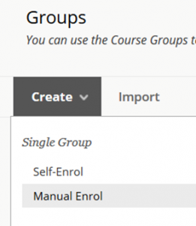

4. In the Name field include the module code and title and _msteams.
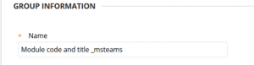

5. Ensure Group is Visible to Students is set to No.
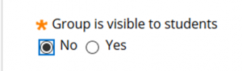

6. Under TOOL AVAILABILITY ensure that all tools are turned off.
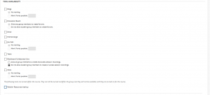

7. Click the Add Users button.
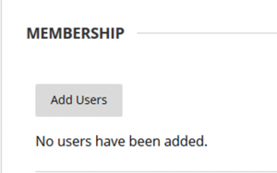

8. Ensure that the ‘The Show all users regardless of role check box’ is selected to ensure that staff members (Instructors) are included.
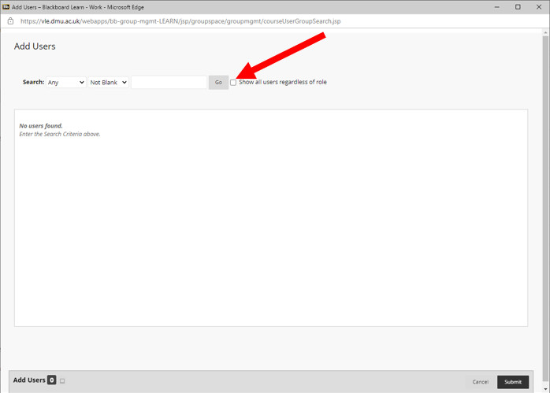

9. To ensure all people on the module are included click the Show All button toward the bottom of the screen.
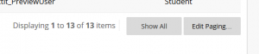

10. Click the Select All box to select all students and staff members in the list.
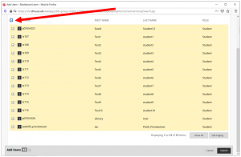

11. Ensure that any staff members (Instructors) who do not require access to the Team are removed by deselecting them.

12. Click Submit to finish creating the Group.
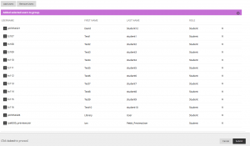

13. The Group is now created. In approximately 24hours a corresponding Microsoft Class Team will have been created and can be used for synchronous, live sessions.
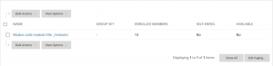

Note: It is possible to create more than one Group in Blackboard with the _msteams suffix where there is a requirement to group students into different MS Class Teams. However, virtual groupings may also be achieved in MS Teams by creating Channels that only specific students can see.

Microsoft Class Teams
With the Microsoft Class Team in place:
- Identify the date and time for your synchronous sessions from your academic register.
- Visit the Team and schedule the session(s).
- Include the name of the tutor associated with each group in the session name.

Note: If students leave or join the module mid-semester, you must ensure that the Blackboard Group membership is updated to include any students added to your cohort as late enrolments etc. The Microsoft Class Team will be updated overnight to include any new students.

Note: MS Class Teams links should be made available in a specified Blackboard Content Area. Guidance for setting up a Blackboard content area is available at this link. If multiple Blackboard groups (and hence, Teams) have been created then the meeting links can be added with adaptive release. Guidance for setting the adaptive release of content folders is available at this link.

Note: If you have set up a single MS Class Team for a large cohort and are intending to run multiple sessions (repeated) for sub groups. These sub groups should be set up as Groups in Blackboard first, which will enable the formation of separate Teams.

