How to create a Class Team for your Module
If you would like to use the features within a Class Team such as channel discussions, file sharing and Class Notebook, with your students, you can create a Class Team based on a Blackboard group.
By creating a group in Blackboard following the steps in this guide you will create a corresponding Microsoft Class Team.

Creating a Blackboard Group with all enrolled students included
- From the Blackboard shell click on Users and Groups>Groups.
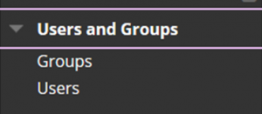

- Move the mouse over the Create button and click on 'Manual Enrol' under Single Group.
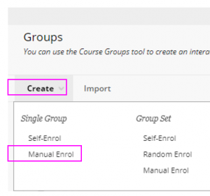

3. In the Name field include the module code and title followed by _msteams.
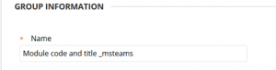

4. Ensure Group is Visible to Students is set to No.
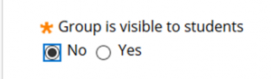

5. Under TOOL AVAILABILITY ensure that all tools are unticked.

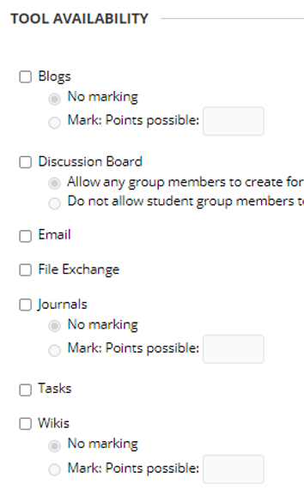

6. Click the Add Users button.
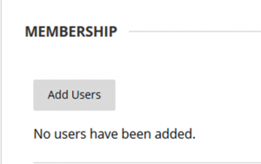

7. To ensure all students on the module are included click the Show All button toward the bottom of the screen.

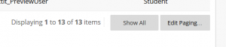

8. Click the Select All box to select all students in the list and click Submit to finish creating the group.
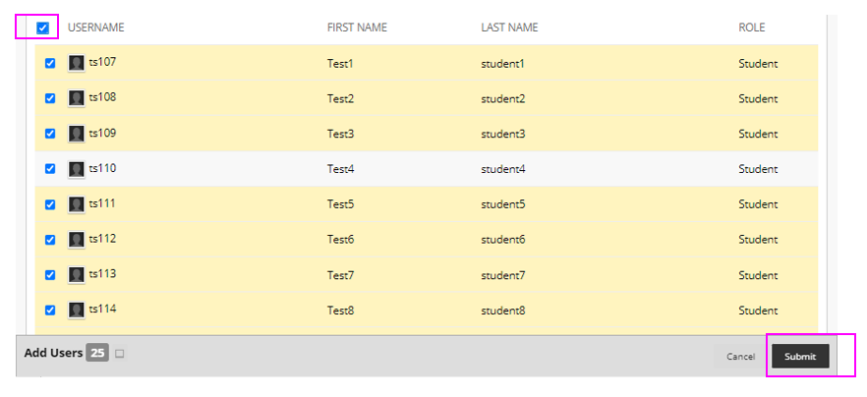

09. The Group is now created. In approximately 24 hours a corresponding Microsoft Class Team will have been created.
Links to the Class Team can be made available in a Blackboard content area.

Updating the Class team membership
If students leave or join the module mid-semester, you must ensure that the Blackboard Group membership is updated. The Microsoft Class Team will be updated overnight to reflect the updated group membership in Blackboard.

