Blackboard Module shell preparation 2021-22
1. Open Blackboard and with Edit Mode turned on navigate to the Module shell.
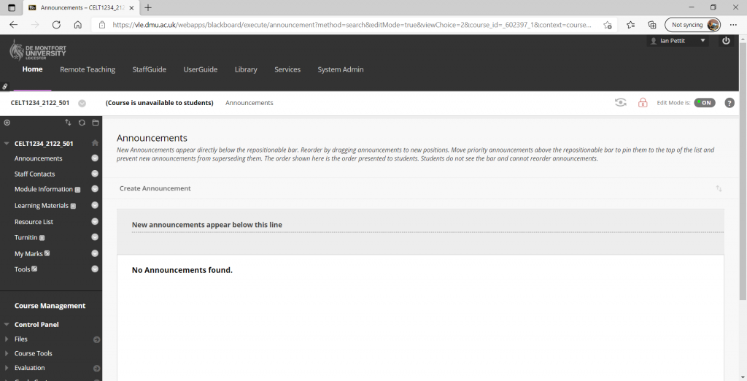

2. Click on Add Content and select Blank Page.
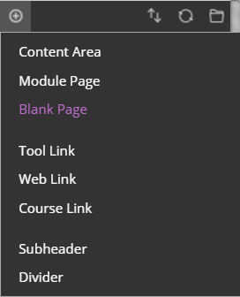

3. Type the word ‘Welcome’ into the Name field and select ‘Available to Users’.
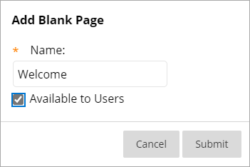

4. Click Submit.

5. A link to the new Blank Page, now titled ‘Welcome’, will appear toward the bottom of the shell. Use the double-arrow icon to drag this new link to the top of the list.
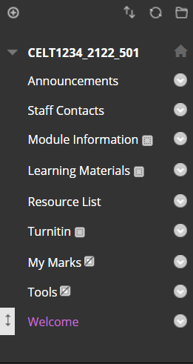

6. Open the Module shell template Word document.
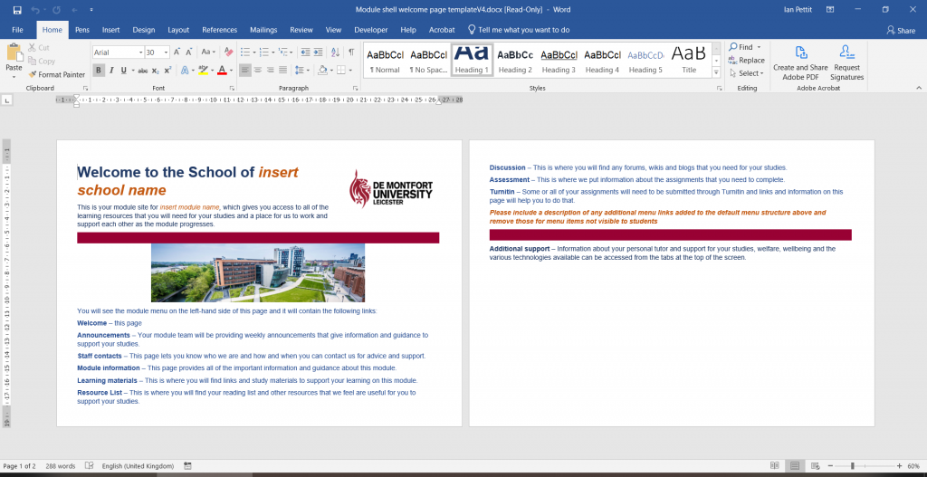

7. Using the mouse or the ‘Ctrl+A’ keyboard shortcut select the entire contents of the document and copy to the computer’s clipboard.

8. Paste the copied content into the Content field in Blackboard.
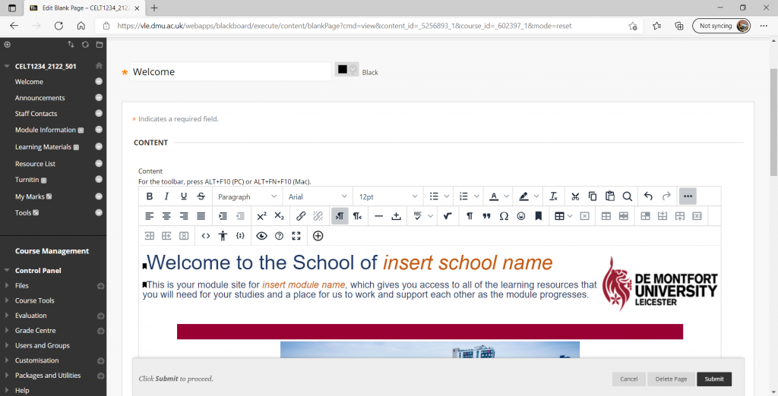
Note: If prompted, select to keep or preserve formatting during the paste process.

9. Using the mouse, select the ‘Welcome to the School of insert school name’ text and set this to Heading.
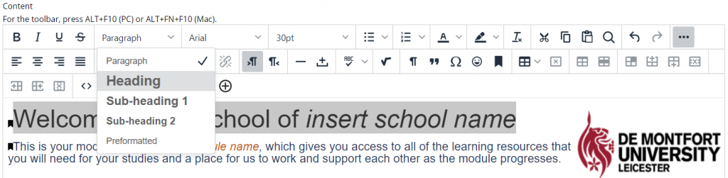

10. Overtype any orange text with the specifics relating to the school and Module that the shell is being prepared for.
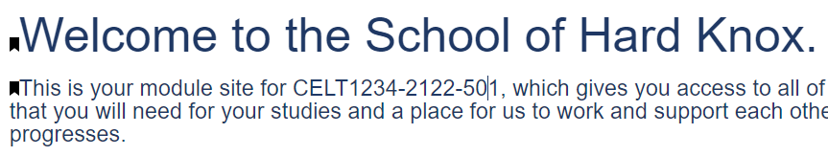

Note: As instructed, ensure that the list of menu items is described and that the list is adjusted to accommodate any additional or hidden menu items. Please remove the remaining orange text.
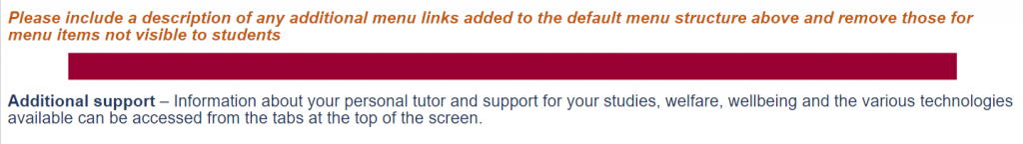

11. Click Submit.

12. Under Course Management click on Customisation>Teaching Style.
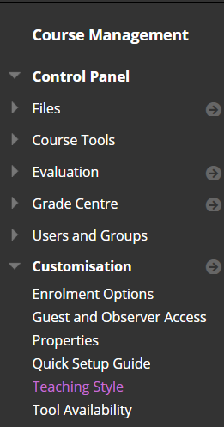

13. Change the Course Entry Point to the new Welcome page.
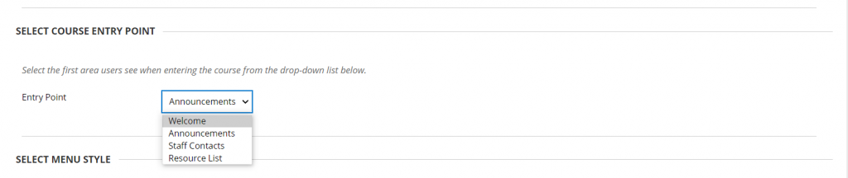

14. Click Submit.

15. Click on Add Content and select Content Area.
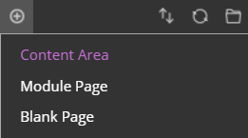

16. Type the word ‘Assessment’ in the Name field and select Available to Users.
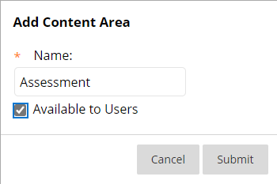

17. Click Submit.

18. Repeat steps 15 to 17 to create another new Content Area named Discussion.

19. Using the double-arrow icons, order the links to match the order of the descriptions on the welcome page.
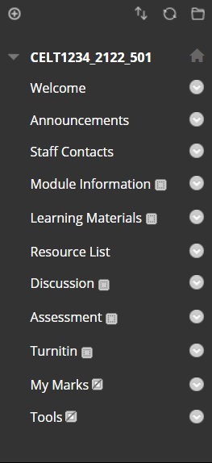

Note: To hide any of the links from the student view, select the link’s Edit Icon and click on Hide Link.
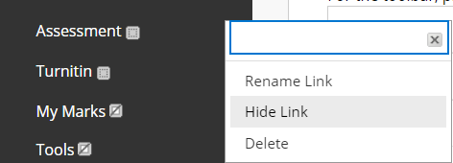

20. To see the student view, turn the Edit Mode off.
