Setting up and managing an online exam using a Blackboard Test
Note: This guide describes the process required when providing a blank exam paper for students to download, complete and submit in lieu of attending a face to face exam using the File Response question type.

Learning outcomes
By the end of this guide you should know;
- How to create a Test in Blackboard as an exam,
- How to use the ‘double-timed’ technique to ensure students are timed, and
- How to access and provide grades and feedback for submitted exams.

1. From the Content Area move over Assessments and click on Test.
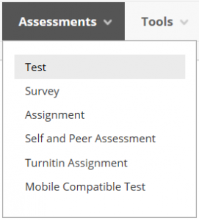

2. Click the Create button.
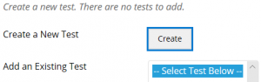

3. Provide a name and instructions, click Submit.
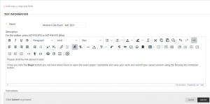

4. Move over Create Question and select File Response.
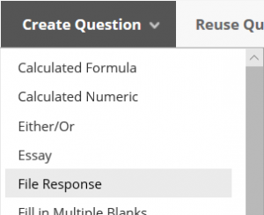

Note: The Essay question type could be used as an alternative but it is recommended that the File Response is favoured.

5. Complete the Question Title and Question Text fields, click Submit.
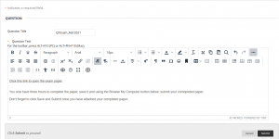

Note: The Question Title is not visible to students – this is for staff reference only.

Note: Ensure that the blank exam paper is included in the Question Text only, alongside the further instructions.

Note: The students will only be able to upload and submit one file per question. Please ensure that they are made aware of this and if necessary, add multiple File Response questions where multiple answer sheets are required.

6. Ensure the Points field is set to 100 and click Submit and Ok.
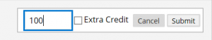

7. Select the new Test and click Submit.
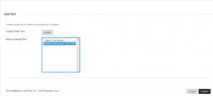

8. On the following screen set these options:
- Show test description to students before they begin the test. NO
- Open test in new window. NO
- Make Available to students. YES
- Add a new announcement for this test. NO
- Multiple Attempts. NO
- Force Completion. NO
- Set Timer. YES
- Minutes. THE AMOUMT OF TIME THE EXAM REQUIRES (e.g. 180 minutes for a 3 hour exam)
- Please do not include any extra time for students who require adjustments or stop the clock breaks at this point, please see step 9. below regarding adding extra time.
- Auto-Submit. ON
- Display After. 8AM ON THE DAY OF THE TEST
- Display Until. 6PM ON THE DAY OF THE TEST
- Password. LEAVE BLANK.

Note: Students must be advised that they should start their attempt in time to complete it by 6pm to ensure support is available if required during their exam time.

9. Allocate any extra time requirements (for IEA and/or stop the clock breaks) using the Add User or Group button. Click Submit.
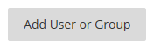

Note: Click here to see how to create Blackboard Groups and manage students who require extra time and stop the clock breaks when taking online exams.

Note: When allocating extra time requirements please be aware that time should be allocated to those students who qualify for extra time and those who qualify for a stop the clock break, or both. Students for whom extra time has been added will not be aware of this – the timer will show their amended timer throughout the attempt.

Note: Extra time should be added to the initial exam time and the total typed in. For example; if the exam is 180 minutes and the student requires 25% extra, the figure ‘225’ should be typed.

Note: If an individual student does not see the correct exam time, advise them to click ‘Save and Submit’ and clear their Attempt in the Grade Centre. You should then edit the Test Options and add the student’s extra time and/or stop the clock allocation using the Add User or Group button; please do not make any other changes. Advise the student to Begin the Test again.

10. The Test is now deployed and will be available to students at 08:00hrs on the day of the exam. When students click the Begin button to start the Test, the timer will begin.
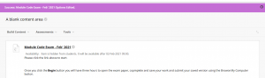

11. If a student experiences a technical failure during their attempt and after the Display Until time has elapsed; you will need to Modify the Test Options in order to manipulate the Display Until date. This will make the Test link available to them once more in order for them to be able to continue their attempt. However, the timer will not pause and any time spent restarting/logging back in will be lost.
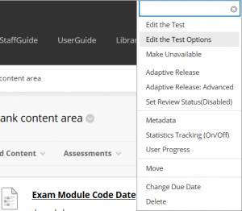

Note: If a student experiences a technical failure, provided the Display Until time has not elapsed they will be able to return and continue their attempt. However, the timer will not pause and any time spent restarting/logging back in will be lost.

11. To mark the completed exam papers click on Grade Centre>Full Grade Centre.
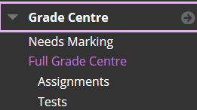

12. Students who have attempted the exam will show with the Needs Marking icon in the exam column.
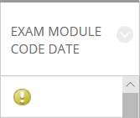

Note: Where the submissions are to be marked anonymously, click the Edit Icon toward the top of the column and select Mark with Usernames Hidden.
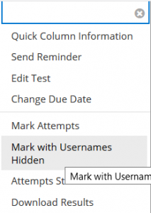

Note: Click the Needs Marking icon and select ‘Attempt xx/xx/xx‘.
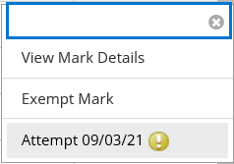

14. Next to ‘Given answer’ click the link to open the students’ completed exam paper.
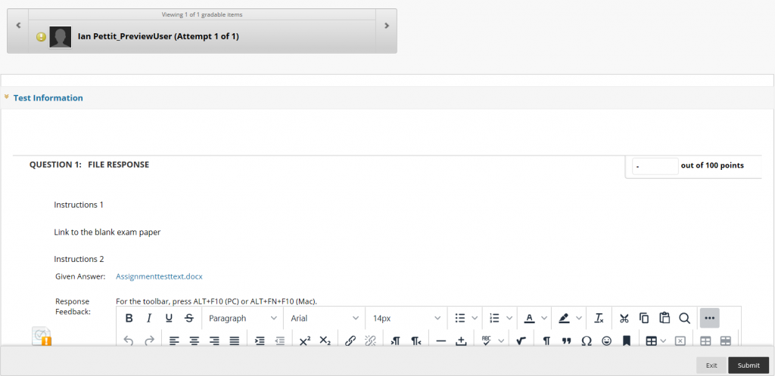

Note: The submitted exam paper will open in the appropriate software dependent on your local computer settings. Do not close Blackboard or move away from the Attempt in the background.

15. Read/review the submitted exam paper. If an electronic marking grid is in use, complete this as usual.

16. Once a grade has been arrived at, click on Blackboard in the background to return to the student’s Attempt and type the grade into the Points box.
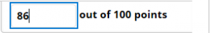

17. Using the ‘Feedback and notes for attempt’ section, type the feedback into the ‘Feedback to Learner’ section. If an electronic marking grid has been used, attach this using the Add Content button.

Note: By default, students will be able to see their exam mark in the Blackboard My Marks section, if this is not desired please hide the Grade Centre column from students.

Note: Do not use the Response Feedback section for administering feedback.

Note: Please do not write comments on the student’s submission, all feedback should be added to the Feedback to Learner section only.
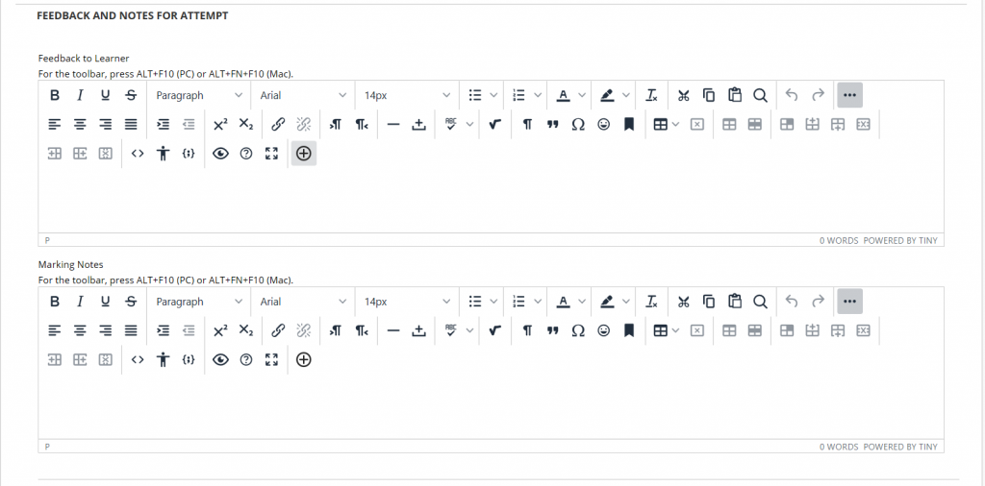

18. Click the Submit button.
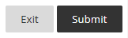

19. You will be returned to the Grade Centre and should repeat from step 12 until all Attempts are marked with feedback.

Note: It is not possible to batch download Attempts when using Blackboard’s File Response question type in this way. Therefore colleagues must be online to mark exams that have been conducted using this technique.

Note: At the end of each marking session, please remove the downloaded student submissions from the Downloads (or equivalent) folder on your computer.

