Setting up and managing Blackboard Groups relating to extra time and/or stop the clock breaks for online exams
Note: This guide describes the process required when providing extra time and/or stop the clock breaks for students when setting up an online exam.

Learning outcomes
By the end of this guide you should know;
- How to create and add students to Groups in Blackboard, and
- How to pull the Group(s) through to the Test Availability and Exceptions section of the Test Options screen.

1. From the Blackboard shell click on Users and Groups>Groups.
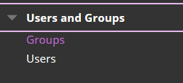

Note: You may be required to create up to three groups as follows;
- A group for students who qualify for extra time,
- A group for students who qualify for a stop the clock break, and
- A group for students who require both extra time and a stop the clock break.

2. Hover over Create and under Single Group click Manual Enrol.
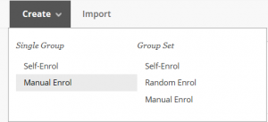

3. Provide a Name and ensure that Group is Visible to Students is set to ‘No’.
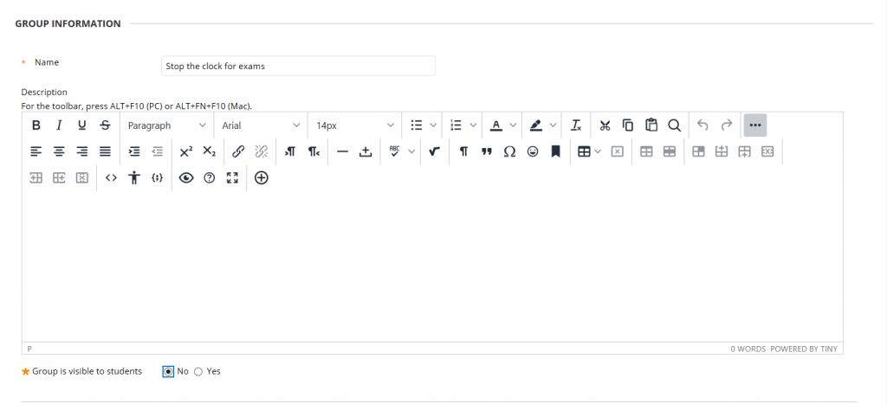

4. Remove all Tools in the Tool Availability section.

5. Click Add Users.
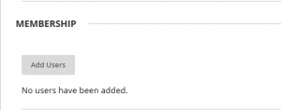

6. Select the students to be added to the Group and click Submit.
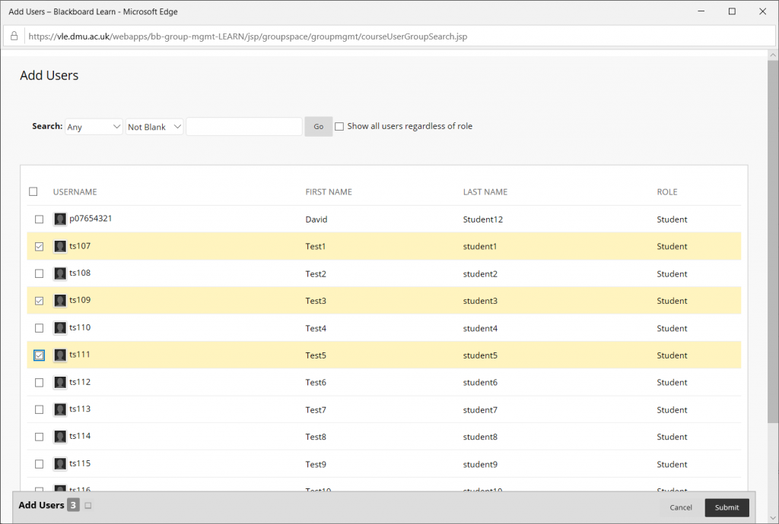

7. The selected students will be displayed, click Submit.
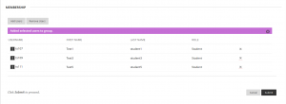

8. The Group will be shown, repeat from step 2 until all required Groups are created.
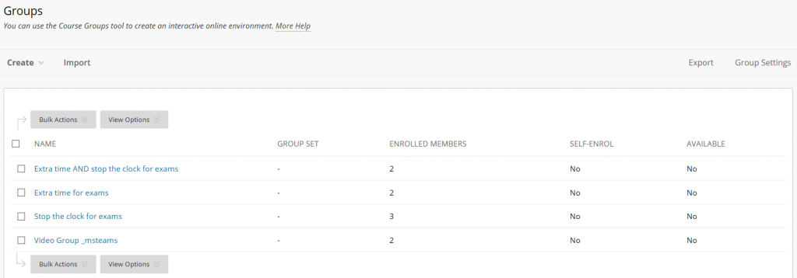
Note: The Group(s) are now created and ready to be pulled through to a Test.

9. When creating the Test click the Add User or Group button.
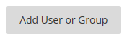

10. The Groups will appear toward the end of the student list. Select the required Group and click Submit.
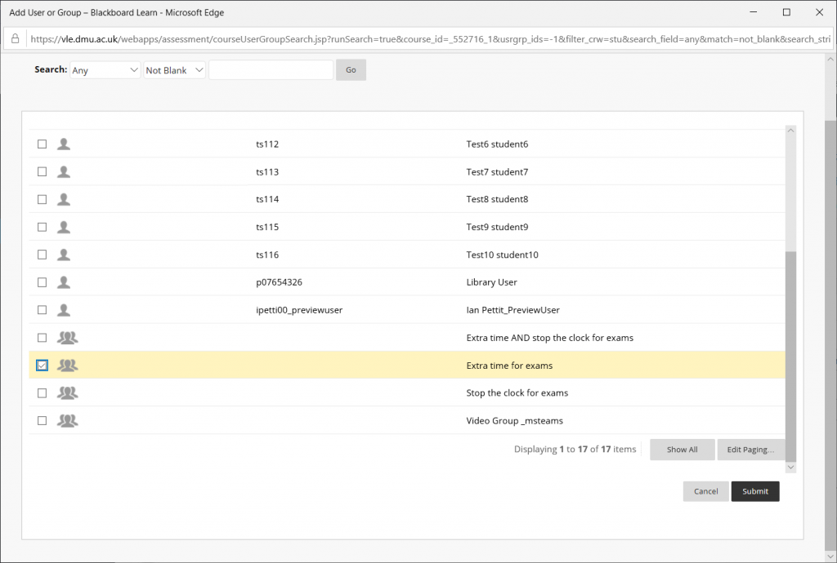

11. Repeat from step 9. until all three Groups (if required) are added.
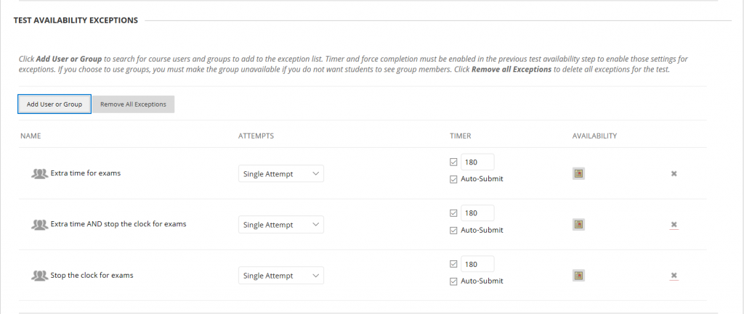

12. In the Timer column, adjust the amount of time accordingly:
- All stop the clock breaks are 30 minutes regardless of the length of the exam.

- Extra time is calculated as 25 per-cent of the total exam time – for example;
  - A one hour exam requires 15 minutes extra time,
  - A one and a half hour exam requires 25 minutes extra time,
  - A two hour exam requires 30 minutes extra time,
  - A three hour exam requires 45 minutes extra time, and
  - A four hour exam requires 1 hour extra time.

For the Group that contains students who require extra time and a stop the clock break, the additional time must be calculated. For example; for a three hour exam, this cohort of students will qualify for the initial 180 minutes (three hours) plus 25 per-cent (45 minutes) plus a further 30 minutes for their stop the clock break. The total time a student may qualify for in this example is 255 minutes.

Note: When allocating extra time requirements please ensure you type the total time in the Timer column, including the initial exam time and the relevant, calculated, additional time as described above. The example below shows how the three Groups would be set up for a three hour online exam.
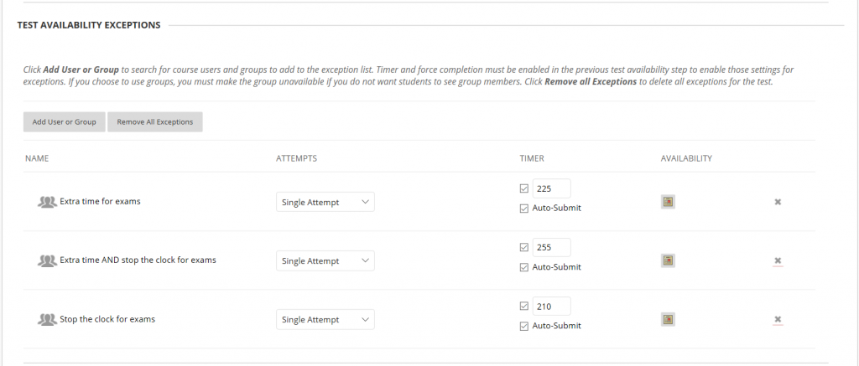
Note: Please do not change any other settings within Test Availability and Exceptions – you should only need to amend the Timer column.

13. Click Submit.

Note: If, during the exam, an individual student does not see the correct exam time, advise them to click ‘Save and Submit’ and clear their Attempt in the Grade Centre. You should then edit the Test Options and add the student’s extra time and/or stop the clock allocation using the Add User or Group button; please do not make any other changes. Advise the student to Begin the Test again.

