Setting up a practice exam using a Blackboard Test
Note: This process employs different settings to those recommended for the formal examination. This is to ensure that your students are able to access this practice examination over an extended period and with multiple accesses.

Learning outcomes
By the end of this guide you should know;
- How to create a Test in Blackboard as a practice exam, and
- How to use the settings to ensure students can practice effectively.

1. From the Content Area move over Assessments and click on Test.
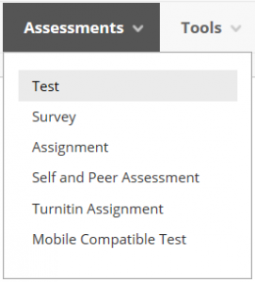

2. Click the Create button.
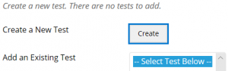

3. Provide a name and instructions, click Submit.
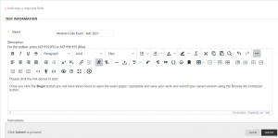

4. Move over Create Question and select File Response.
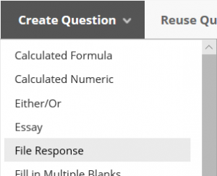

5. Complete the Question Title and Question Text fields, click Submit.
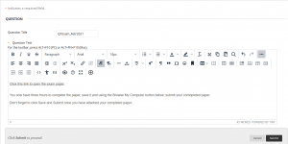

Note: The Question Title is not visible to students – this is for staff reference only.

Note: Ensure that the blank exam paper is included in the Question Text only, alongside the further instructions.

6. Ensure the Points field is set to 100 and click Submit and Ok.
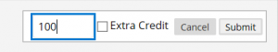
7. Select the new Test and click Submit.
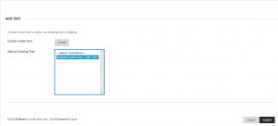

8. On the following screen set these options for a practice test:
- Show test description to students before they begin the test. NO
- Open test in new window. NO
- Make Available to students. YES
- Add a new announcement for this test. NO
- Multiple Attempts. YES (Allow Unlimited Attempts)
- Force Completion. NO
- Set Timer. YES
- Minutes. THE AMOUMT OF TIME THE PRACTICE EXAM REQUIRES (e.g. 180 minutes for a 3 hour exam)
- Auto-Submit. ON
- Display After. SELECT DATE/TIME WINDOW FOR PRACTICE TEST
- Display Until. SELECT DATE/TIME WINDOW FOR PRACTICE TEST
- Password. LEAVE BLANK.

Note: For a standard exam, a window for access of 8am to 6pm may be recommended, students will then have a fixed time to complete, say 120 minutes, with additional minutes being added for those with additional requirements and stop the clock breaks. This will ensure that they are able to complete their exam within an ITMS/academic support window. However, for a practice test you may wish to allow students to access the test over a longer period (e.g. one week) with unlimited attempts for practicing and familiarisation of the Blackboard Test process/interface.

9. Allocate any extra time requirements using the Add user or Group button. Click Submit.
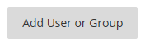

Note: You may not wish to apply extra time requirements for a practice exam.

Note: When allocating extra time requirements please be aware that time should be allocated to those students who qualify for extra time and those who qualify for a stop the clock break.

10. The Test is now deployed and will be available to students at the defined date/time of the practice exam. When students click the Begin button to start the Test, the timer will begin.
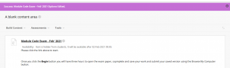

11. To ensure the practice exam is not included in any Grade Centre calculations (i.e. the grade should not be added to a student’s ‘Total’ score in the Grade Centre), go to Control Panel>Full Grade Centre>Tests.
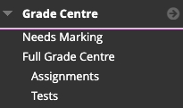
12. Locate the column for the practice exam, hover over and click the downward arrow and then ‘Edit column information’.
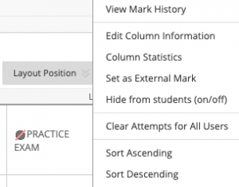

13. On the column settings, ensure ‘Include this column in Grade Centre calculations’ is set to ‘No’.
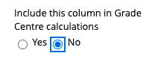

14. click the Submit button.

