Moving Teams recordings into your Blackboard module or programme
This guide shows how to move a Teams recording to Blackboard
When you record in MS Teams your video will become available in MS Stream
After recording in Teams, you will also receive an email to confirm that your recording is ready in Stream. If you are already logged into O365 you can click to go directly to the video.
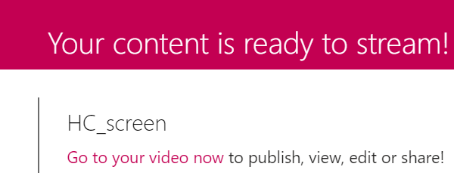

Download Video from Stream
Below the recording you will see some options for sharing, editing details.
Click on the three dots, then Download Video

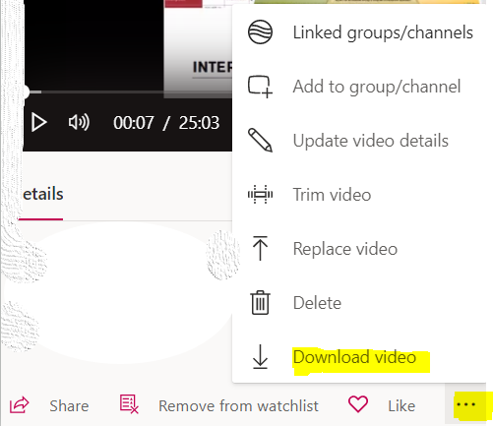

Upload to Panopto
You can upload to the panopto folder for your module in a number of ways
You can locate the appropriate folder at http://panopto.dmu.ac.uk
Or
Within your Blackboard site, locate Panopto Content, as below
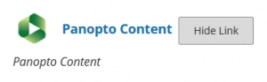
8. Click the Create button and select Upload media.
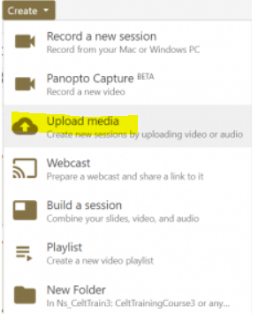
Either drag the downloaded video file into the grey box or click the box and browse for the downloaded .mp4* file.
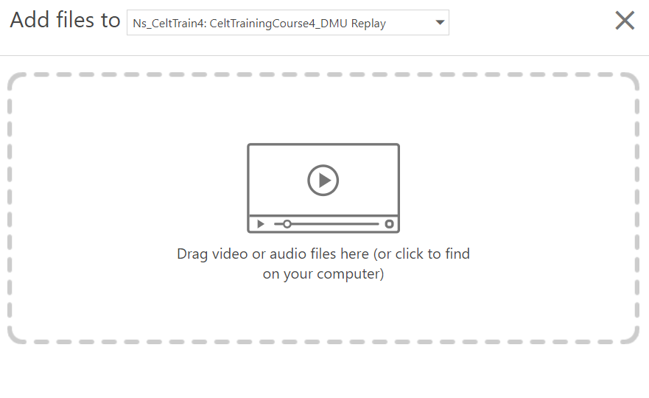
NB: When uploading downloaded .mp4 files, please note you can drag and drop or browse for multiple files, allowing them to be uploaded in a batch

3) Add your recording in Blackboard
You can now post your recording in the usual way into the appropriate Content Area of your Module
See Quick Guide for adding your recording to Blackboard

