Downloading and deleting recordings and transferring to DMU Replay
Note: Recordings made outside of DMU Replay need to be added to the module folder in DMU Replay to ensure:

- Captioning for students with specific requirements as a component of UDL are fulfilled.
- Students are able to interact with and search recordings.

Note: Recordings are started by clicking by the Start Recording link.
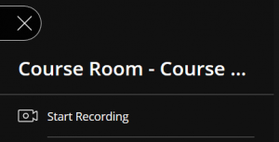

Please click this link for more information about GDPR and completing a Data Protection Impact Assessment prior to recording using Blackboard Collaborate Ultra.

Learning outcomes
By the end of this guide you should know;
- How to download a Blackboard Collaborate Ultra recording and upload it into DMU Replay, and
- How to delete the recording from Blackboard Collaborate Ultra.

1. Click the burger bar menu and select Recordings.
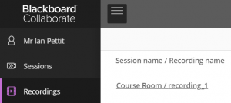

2. Select Recording options and click Download.
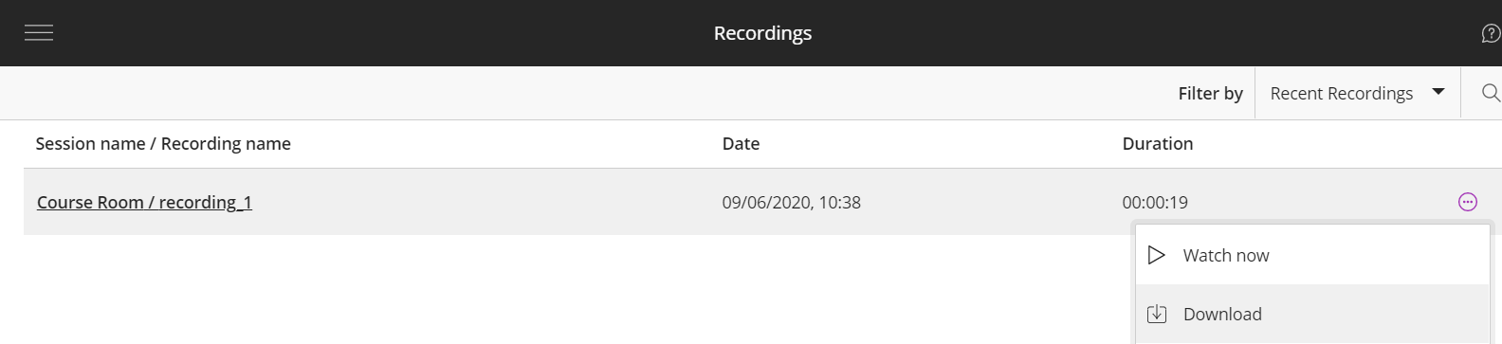
3. The recording will be downloaded.
Note: For Windows users, this will likely be downloaded to the computer’s Downloads folder. At this point you should check that the downloaded video plays.

4. Click on Recording options and Delete.
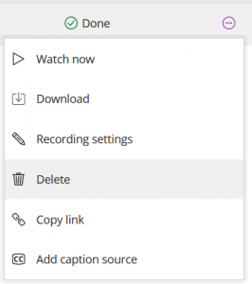

Note: Deleting the recording is crucial to ensure any potential GDPR breaches are avoided.
5. Click on Tools followed by Panopto Content.
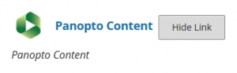

6. Click the Create button and select Upload media.
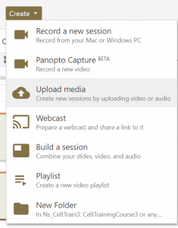

7. Either drag the downloaded video file into the grey box or click the box and browse for the downloaded .mp4 file.
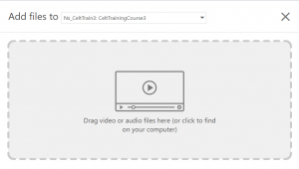

8. Delete the downloaded video file (.mp4) from your computer.

Note: Deleting the recording from your computer is crucial to ensure any potential GDPR breaches are avoided.

