A model of support provided by CELT
The CELT support @ DMU model shown below provides a graphical representation of the technologies and services for which CELT provides pedagogical and practical support.
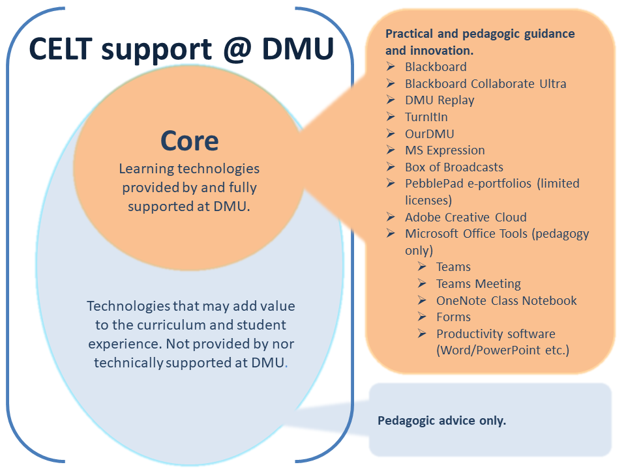

Contact the ITMS Business Partner (and copy your local ELT Project Officer) to request new technologies (and hardware) to support teaching, learning and assessment that are non-Core.

Note: ITMS and CELT will explore the use of an existing Core technology to fulfil the required need before any additional technologies can be procured.

Funding considerations.
Neither ITMS nor CELT have a budget to procure learning and teaching technologies that may be requested on an ad hoc basis. Funding will need to be provided from faculty budgets, IPE or other internal bid outcomes or external grant income.

