Downloading an attendance list in Teams
This can only be completed during the MS Teams session, and only takes attendance up to the point that the attendance list is taken.

Note: Attendance cannot be taken after you leave the MS Teams meeting.

There are 4 steps:
1. Within the Teams session, bring up the participants list by pressing the participants button

2. Select the More Actions, next to the Participants

3. Select the Download attendance list
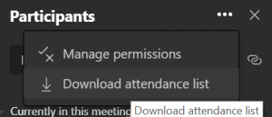

4. A file called “meetingAttendanceList (x).csv” is saved in your “Downloads” folder on your PC. This can be found by opening File Explorer (Windows key and E pressed together will launch File Explorer)
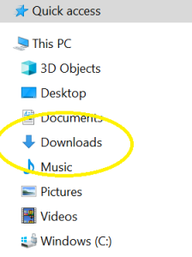

The attendance list contains the full name, and the joined and left dates and times at the point the attendance list was taken. An example extract is below, the real names have been redacted.

Full Name | User Action | Timestamp
Jon Hill – ITMS | Joined | 9/9/2020, 2:58:42 PM
Person 1 | Joined before | 9/9/2020, 2:58:42 PM
Person 1 | Left | 9/9/2020, 3:19:49 PM
Person 2 | Joined | 9/9/2020, 2:58:43 PM
Person 2 | Left | 9/9/2020, 3:19:55 PM
Person 3 | Joined | 9/9/2020, 2:58:53 PM
Person 3 | Left | 9/9/2020, 3:19:56 PM
Person 4 | Joined | 9/9/2020, 2:58:58 PM
Person 4 | Left | 9/9/2020, 3:20:00 PM

5. Rename the file to include the timetabled teaching session

For timetabled events, please send this file to your faculty office for inclusion in the attendance data, as you would with a manual attendance list.

