Setting up tutorial groups in Blackboard Collaborate Ultra
Note: This process should be used for setting up timetabled tutorial group sessions to be delivered in Blackboard Collaborate Ultra.

Learning outcomes
By the end of this guide you should know;
- How to create a Content Area and a Folder in Blackboard.
- How to set up a recurring Blackboard Collaborate Ultra session for each tutorial group.

1. Move the mouse over the Add Menu Item icon and click Content Area.
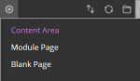
2. In the Name field type ‘Live online sessions’, tick to ‘Make available to students’ and click Submit.
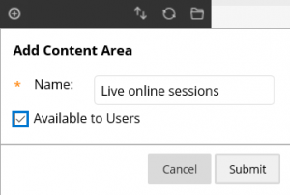

3. The new Content Area will be displayed in the main navigation – use the drag function to position this as desired.

4. Click on the new Content Area and select Build Content>Content Folder.
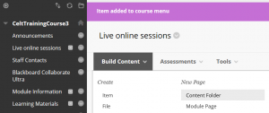

5. Complete the Name and Description field before clicking Submit, an example is given below.
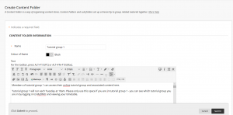

Note: The Name field should include the staff member’s name who is leading the tutorial group as it appears on the Timetable. This is to ensure that students enter the correct session when tutorial groups are run concurrently.

6. The new Content Folder will be created – repeat for each tutorial group.
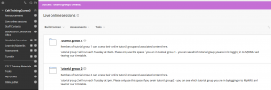

7. Click on Tools>Blackboard Collaborate Ultra.
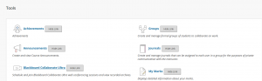

8. Click on the Create Session button.
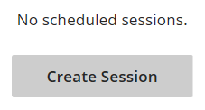

9. Complete the name and the start and end dates/times for the first occurence of the virtual tutorial group session. Click Repeat session and set the options as desired.
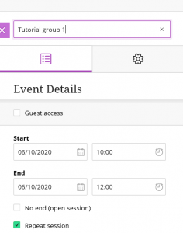

Note: The Name field should include the staff member’s name who is leading the tutorial group as it appears on the Timetable. This is to ensure that students enter the correct session when tutorial groups are run concurrently.

Note: In the example below, a new Blackboard Collaborate Ultra session will be created called ‘Tutorial group 1′. It will first be available on Tuesday 6th October from 10am ’til 12 noon at which point it will close. The session will become available between those times every Tuesday for an eleven week duration.
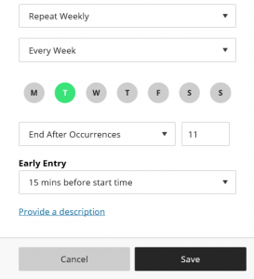

10. Change the session settings as desired and click Create.

11. Return to the new Content Folder and click Tools>More Tools>Blackboard Collaborate Ultra.
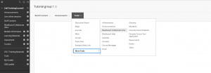

12. Provide a description for the students and click Submit.
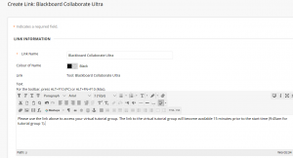

13. The link will be displayed within the relevant tutorial group’s Content Folder.
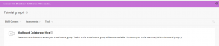

Note: In this example, tutorial group 1 students should be instructed to click the same link each week and no earlier than 15 minutes prior to the tutorial group start time. They will then automatically be presented with the relevant tutorial group 1 session link depending on the date.

