Semi-automated Tutorial Group creation in Blackboard

Stage 1 – creating the Groups

From Users and Groups>Groups, click the Import button.

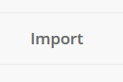

A .csv file should then be created ready for Import, an example file can be downloaded for editing by clicking on More Help.

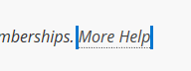

When opened, the following headings will appear at the top of the example .csv file (columns A to L inc’ in MS Excel). These fields define how the Group(s) are set up upon Import. Definitions and examples for each field are included in the table below.

Note: there is no option to ‘Create a Smart View’ when creating Groups using the Import method. Therefore, this method is not appropriate if Groups are being created in order to easily filter the Grade Centre view.

Heading [sic] | What this does | Acceptable values
Group Code | This is the name of the group as it appears in Blackboard’s database. Words must be separated by underscores. For example; ModuleCode_TutorialGroup_1. | Text and numeric strings separated with underscores.
Title | This is the friendly name that staff and students will see. For example; IMAT3430 Tutorial Group 1. | Text and numeric strings – no special separators required.
Description | This is the Description text that describes the purpose of the Group – staff and students will see this. | Text and numeric strings that start and end with the HTML paragraph tag (<p> and </p>). For example; <p> this Group is for tutorial group one on IMAT3430, please use the Group to produce your group coursework</p>).
Group Set | This tells Blackboard whether the Group is part of a parent Group Set. When creating tutorial groups it would be sensible to create a ‘Tutorial Groups’ Group Set and have all of the Groups created within the Set. | Text and numeric strings separated with underscores. This field can be used to create new Group Sets too – there is no need to create the Group Sets manually.
Available | Tells Blackboard whether the Group should eb available for students as soon as it is created. | Only ‘Y’ (yes) or ‘N’ (no) is accepted in this field.
Personalization | Tells Blackboard whether we want students to be able to personalise the Group. | Only ‘Y’ (yes) or ‘N’ (no) is accepted in this field. Yes should be the preferred option for accessibility reasons.
Self Enroll | Sets whether students can ‘see’ the Group when browsing DMU’s Blackboard Course Catalogue and enrol themselves | Only ‘Y’ (yes) or ‘N’ (no) is accepted in this field. This should be set to No.
Max Enrollment | Sets the maximum number of students that can bee added (self or manulally) to the Group. | This can be left blank (unlimited) or a numeric value can be added to cap the number of students that can be added to the Group.
Show Members | This mandates whether students in the Group will be able to see which other students have also been added to the Group. | This can be left blank (No) or a ‘Y’ can be added to enable this setting.
Sign Up From Group List | If enabled, this will create a Sign Up sheet based on the Group enrolments. For example, if you want to take a Tutorial Group on a field trip, having a Sign Up sheet is useful for students in the Group to sign up to partaking in the trip. | This can be left blank (No) or a ‘Y’ can be added to enable this setting.
Sign Up Name | This is the name of the Sign Up sheet, if ‘Sign Up From Group List’ is set to Yes. Staff and students will see this when using the Sign Up sheet. | Text and numeric strings – no special separators required.
Sign Up Instructions | This is the Description that accompanies the Sign Up sheet, if ‘Sign Up From Group List’ is set to Yes. Staff and students will see this when using the Sign Up sheet. | Text and numeric strings – no special separators required.

The example below should create a Group Set called Tutorial_Groups_2020/21 containing two Groups that are available to students, can be personalised, are not available for Self-Enrol, that have no maximum number of members and that will show each student who is in their Group with them.

Note: all columns must be present in row 1 in the saved file. Below, columns J to L are not in use but the headings must remain for the import to be successful. Please do not apply any formatting to any of the data.

The dataset above is saved as a .csv file, this format should be the default as it was created using the example Blackboard file. I have named the file ‘Tutorial group creation testing’. The .csv file is now closed.

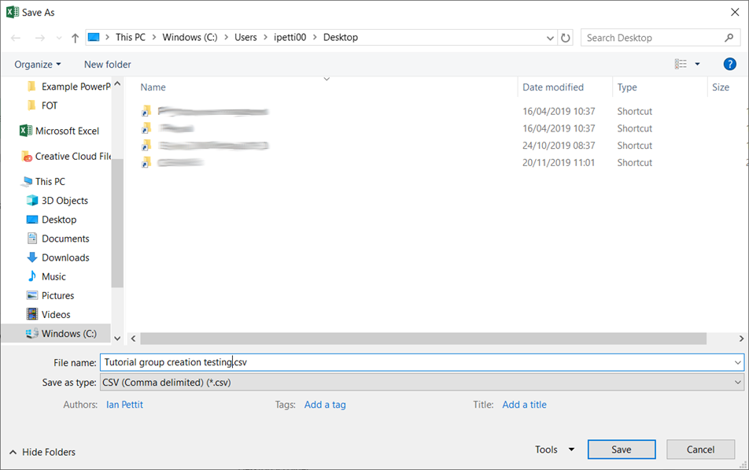

Back in Blackboard, under Tool Availability, select the Tools to be added to the Group(s) being created. In this example the Group Discussion Board and Blackboard Collaborate Ultra room have been selected.

Note: the Bb Collab’ room(s) will not appear in the usual list of scheduled sessions with the Course Room. They will be accessible to students and staff only via the Group links that will be created automatically upon the Group(s) being Imported. Without the ‘Available’ column being set to ‘Y’, students will not see a link to their allocated Group and therefore will not be enabled to access the Group Bb Collab’ room.

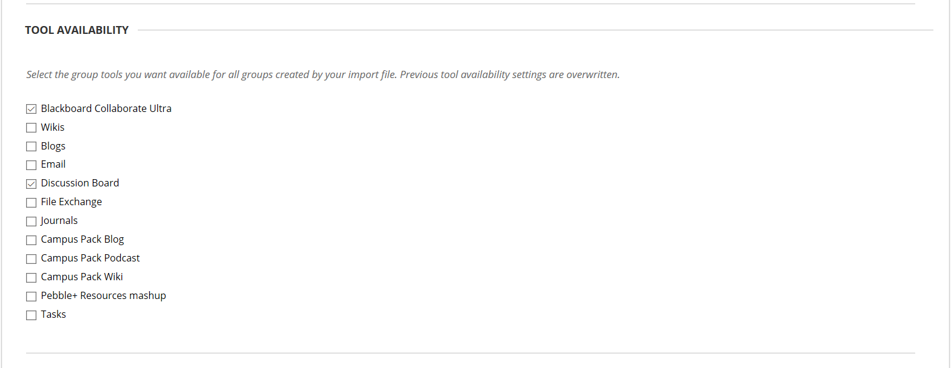

Click Browse My Computer under IMPORT GROUPS.

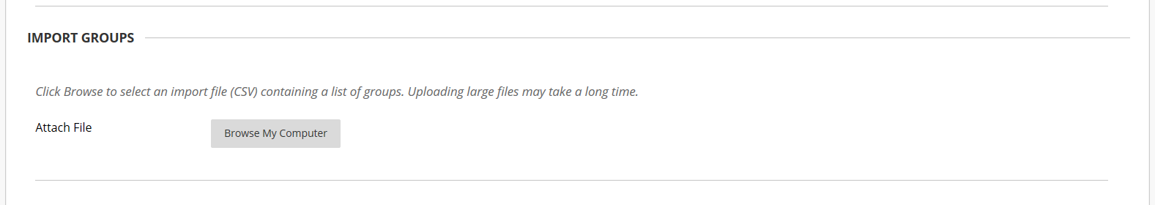

Select the saved .csv file and click Submit.

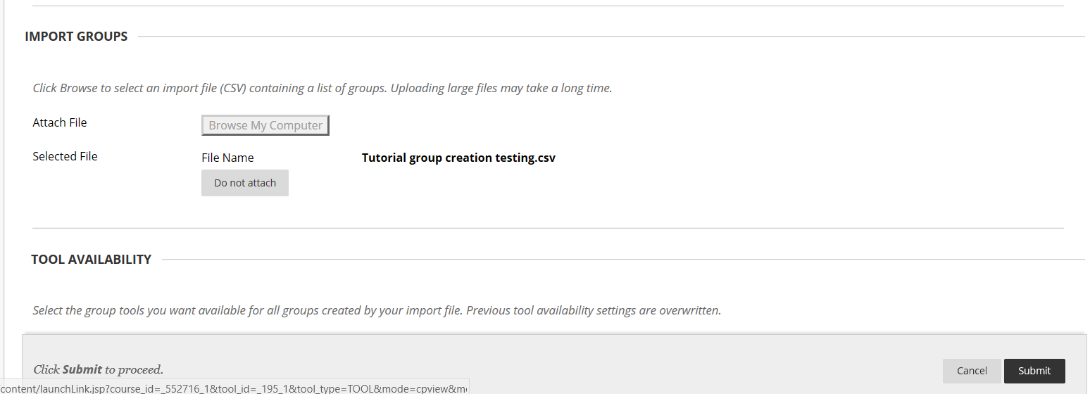

The following message will be displayed, await the email from bbtutor-enrol@dmu.ac.uk.

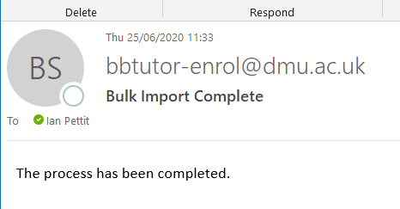

Refresh the Groups page in Blackboard and the Groups will appear.

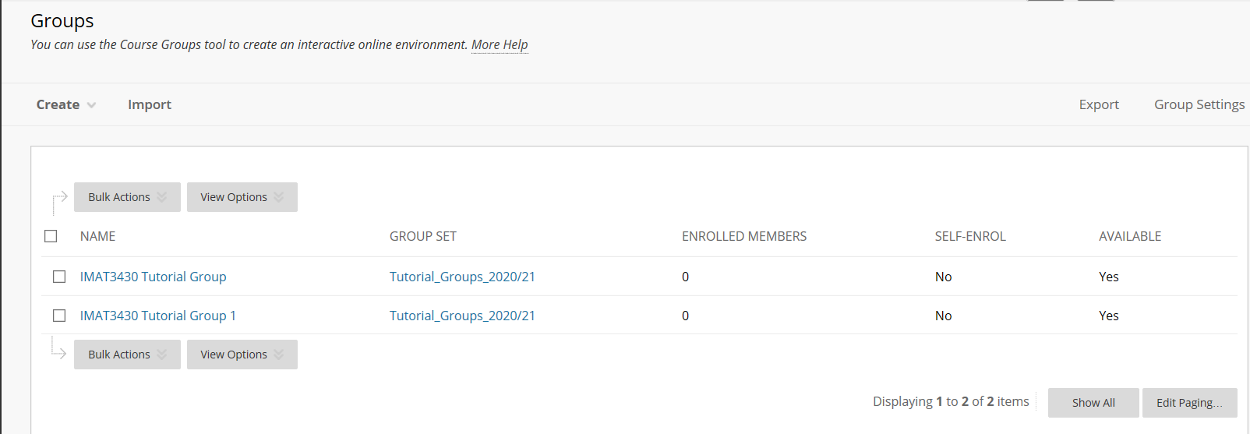

Click through to a Group to check the correct Tools are enabled.

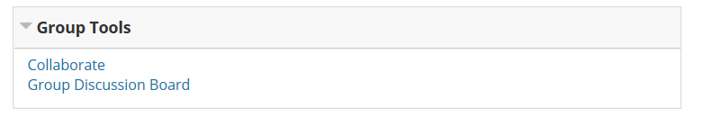
To check the Group Set, click on Group Sets.

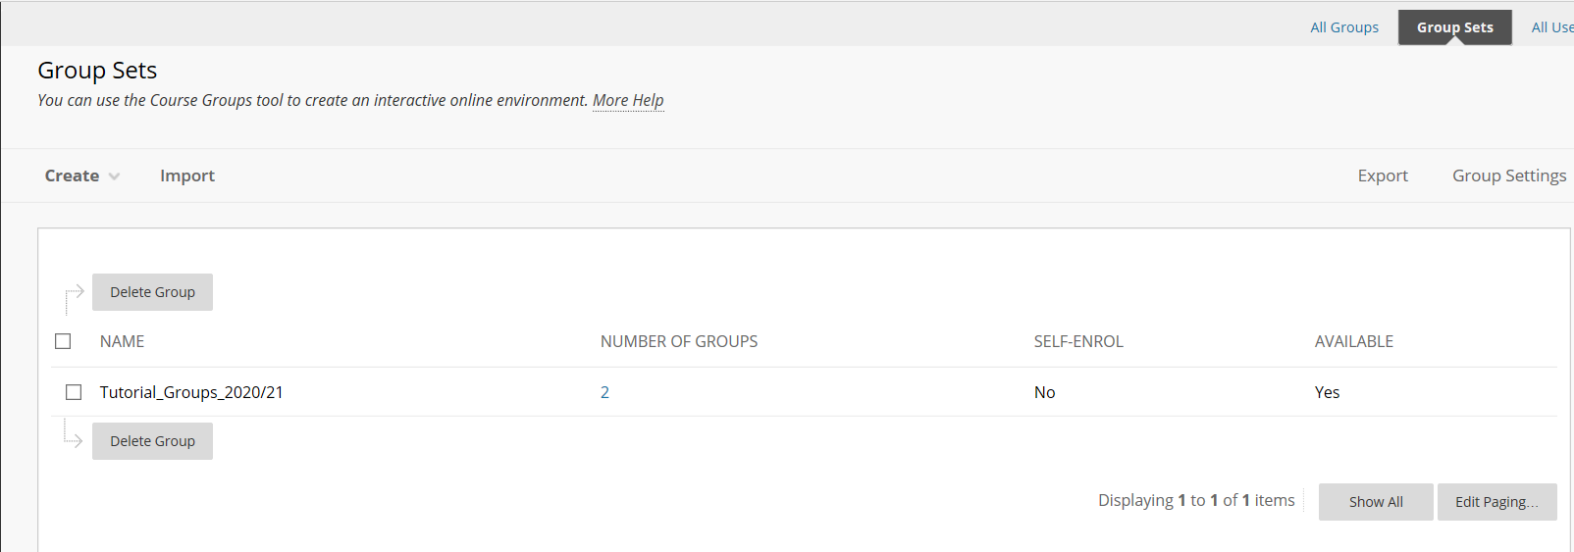

Stage 2 – enrolling students

As before, from Users and Groups>Groups, click the Import button.

A .csv file should then be created ready for Import, an example file can be downloaded for editing by clicking on More Help.

The .csv file will include two headings; Group Code and User Name.

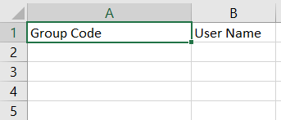

In this test I will use the Group Codes from my two newly created Groups and I will include a third Group Code to see if Blackboard can create a Group using this method too.

I will also see if usernames (pnumbers) can be added using a comma separated string in column B rather than having to include a row per student.

Firstly, here’s my completed .csv file with usernames appearing singularly in column B. I have included a third Group in column A with two usernames, this Group does not exist on the shell as yet.

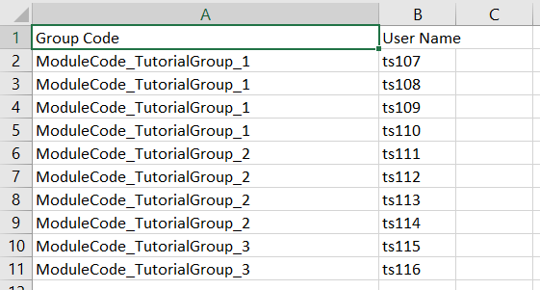

Having saved the .csv file, click on Browse My Computer under Import Group members.

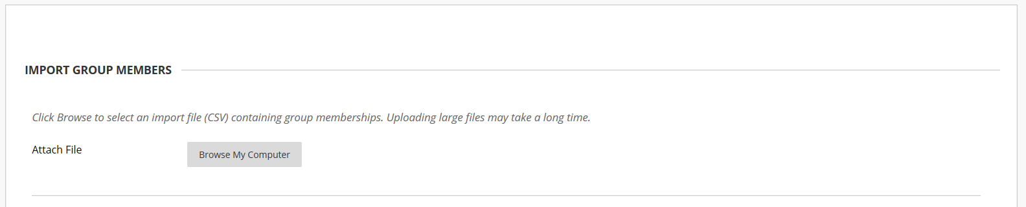

Locate the .csv file and click Submit.

As before, the action will be queued and an email received when finished.

Having refreshed the page, it appears as though the Import failed to create the third Group but has enrolled the other eight students into the two pre-existing Groups.

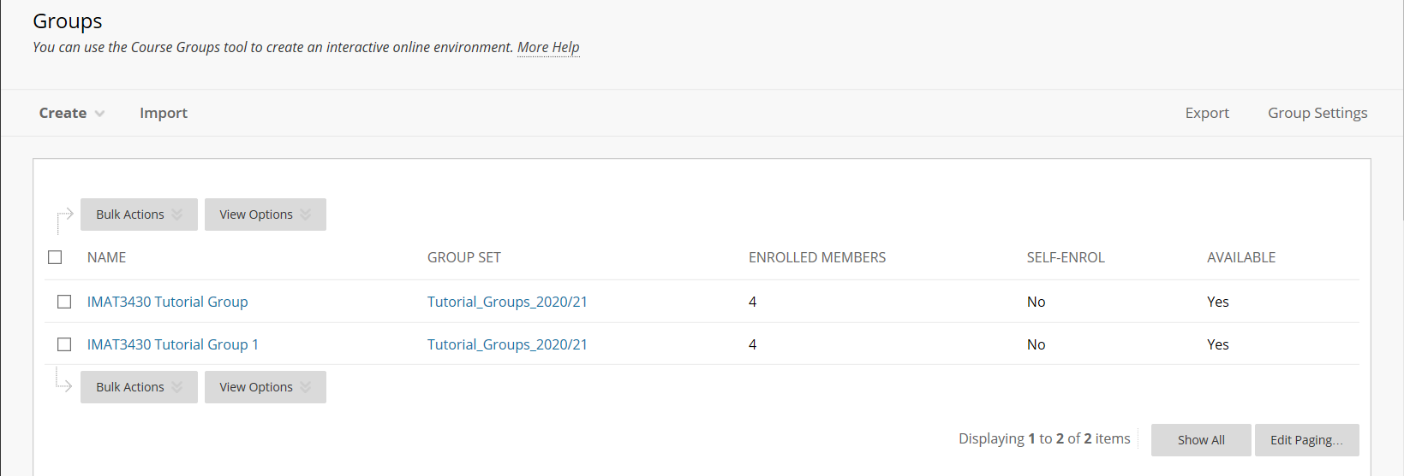

I will now re-run the entire Import both with the remaining two students having been allocated an existing Group in the .csv file.
The re-run has successfully allocated the two previously unallocated students and has not affected the other eight students. Note: this is an important test as these Groups will need to be re-run/updated as students leave/interrupt/defer etc.
Finally, I have removed the student enrolments and re-run the Import but with usernames being comma separated in the .csv file. This is a technique often used when enrolling colleagues onto shells as the UserName field behind ‘Find Users to Enrol’ can accept a continuous, comma separated, string.
Unfortunately, this final test was unsuccessful. This is important when considering the data format that TT will need to produce as they will need to produce a .csv file with one row for every student.
