Using the whiteboard – sharing from breakout to main room
Note: When using breakout rooms, it may be relevant to share and feedback to the main room.
Students could provide an audio report of any changes and additions to the whiteboard.
Staff could share a visual (screen grab) of the breakout room whiteboards.
This is particularly important where a whiteboard or breakout group discussion is being shared with the whole group.

Learning outcomes
By the end of this guide you should know;
how to take a screen grab of a breakout room whiteboard, and
how to share the screen grab with the Main Room.

How to
Windows users
1. With the Blackboard Collaborate Ultra breakout room open, ensure that the students are finished updating the breakout room whiteboard.

2. With the breakout room whiteboard on screen, press Ctrl+Alt+Print Screen on the keyboard.
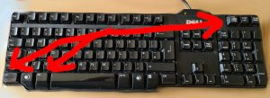

Note: For Windows users, the Ctrl+Alt+Print Screen combination will copy a picture of the active window onto the clipboard.

3. Move participants back to the Main Room.

4. Click on the Share Content button.
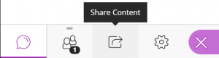

5. Click on the Share Files link.
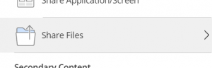

6. On the computer keyboard press the Ctrl+V (paste) combination.

7. The image of the breakout room whiteboard will upload and be available for sharing.
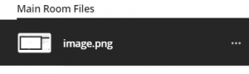

How to
Mac users
1. With the Blackboard Collaborate Ultra breakout room open, ensure that the students are finished updating the breakout room whiteboard.

2. With the breakout room whiteboard on screen, press Shift + cmd + 4 and draw a box around the area you wish to share.

3. Move participants back to the Main Room.

4. Click on the Share Content button.

5. Click on the Share Files link.

6. Click Add Files and locate the screenshot on your Mac (this will generally be on the Desktop).
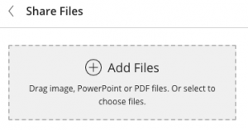

7. The image of the breakout room whiteboard will upload and be available for sharing.

