Using the Groups function in Blackboard to organise marking in Turnitin

Learning outcomes
By the end of this guide you should know;
- How to use the Groups function in Blackboard to assign specific groups of students to specific instructors for marking in Turnitin
- How to access a marking group in Turnitin

The groups function in Blackboard can be used to assign specific groups of students to specific instructors for marking in Turnitin.
This can be particularly useful in modules with a large cohort where there are several instructors who are sharing the marking, the groups function can be used to present each instructor with a specific list of student work to mark in Turnitin avoiding the instructor having to identify their students from a list of all students in the module.
As follows:
Step 1: Create groups
Setup Groups in the module as normal using the method described in this guide
Inform each instructor which group they have been assigned for marking. E.g.
Tutor: Joe Doe – Group 1
Tutor: Jane Bloggs – Group 2
Etc.
Step 2: Marking work via the Group setting in Turnitin
When ready to mark students work in Turnitin:
1. In the Control Panel > Course Tools area select Turnitin Assignment by Groups
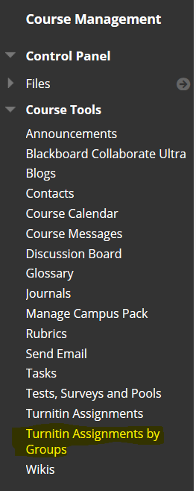
2. From the Turnitin Assignments by Groups list, select the assignment that you want to mark
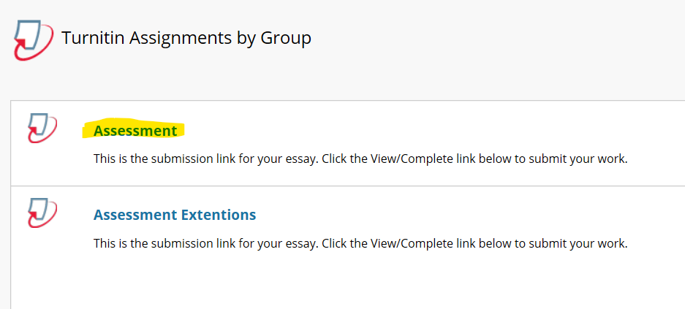
3. Choose your allocated group from the drop down menu and click Go
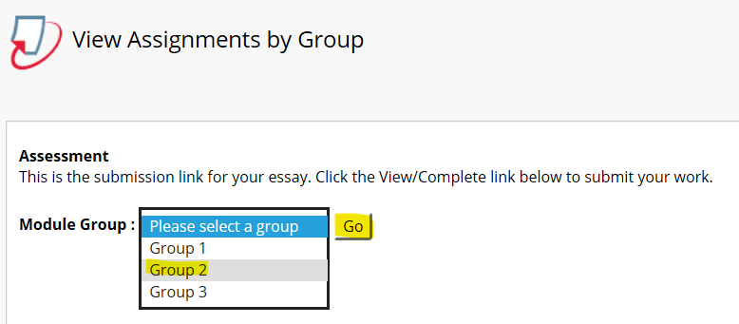
4. You will then be presented with a list of submissions only from those students that have been assigned to you via the Group function.
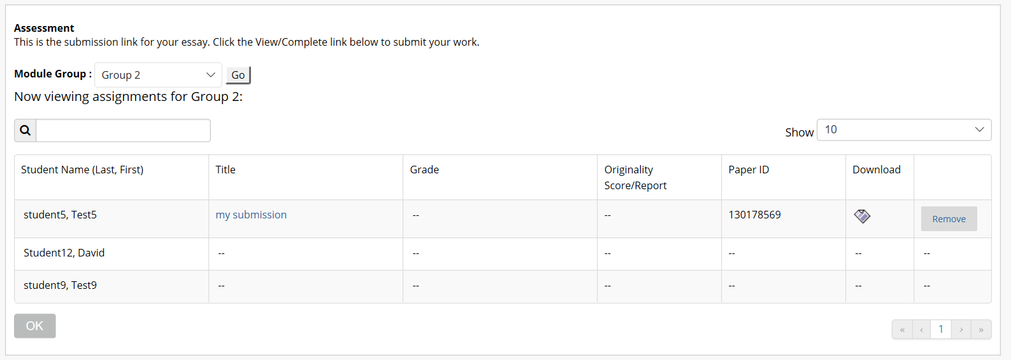
You can access the submissions for marking directly from this list.

