Using and managing the raise hand tool
Note: Considerations when using the Raise Hand tool:
- It is a useful knowledge checking device – remember to ask students to put their hands down after use or control this yourself.
- If there is a large group; asking students to raise their hands with questions can be problematic.
  - Do you have time to address them all?
  - It may prove to be more beneficial to say that you can deal with questions after the event.
  - For instance, you may be available in the Collaborate space for an additional 20 mins, or
  - set up a forum for further asynchronous discussion.

Learning outcomes
By the end of this guide you should know:
- How to use the ‘Raise hand’ tool.
- How to manage the ‘Raise hand’ tool.

How to
In Collaborate Ultra:
1. Locate the ‘Raise hand’ option, which usually appears towards the bottom centre of the screen.

2. Left-click the ‘Raise hand’ option. When you do so, a hand will appear next to your name in the Attendees panel at the right-hand side.
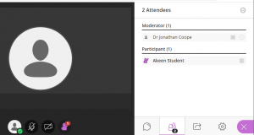

3. If somebody else has already raised their hand before you raise your hand, the number next to your own raised hand indicates where you are in the queue order. The ‘2’ next to the ‘Raise hand’ option below indicates that this attendee’s raised hand is second in the queue.
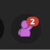

4. You will notice that other attendees who have raised their hand also have a number to indicate where they are in the queue order.
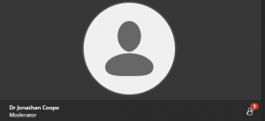

5. To lower your own raised hand, click your ‘Raise hand’ button a second time.

6. If you are a Moderator, to lower the hand of other attendees: from the Attendees panel, select ‘Attendee controls’.
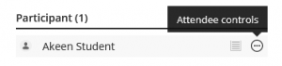
7. From the ‘Attendee controls’ options, select ‘Lower hand’.
