Transferring a video from a video camera, smartphone or tablet into the DMU Replay service
Note: Please be certain that you have permission to make a copy of any video files that you may add to a DMU Replay recording.

Learning outcomes
By the end of this guide you should know;
- How to add an existing .mp4 video (created using a camera, ‘phone, tablet or other device) into a DMU Replay recording.

How to
1. Locate the DMU Replay recording that you wish to work with in the DMU Replay portal and click the Edit button.
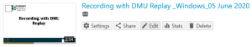
2. Move the Playhead to the desired time at which the .mp4 video is to be inserted.
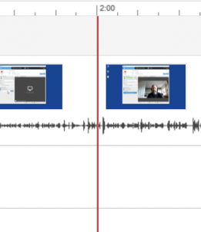
3. Click the Add Content (+) button and select Add a stream.
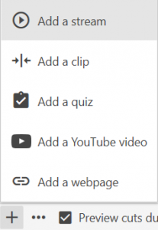
4. Using the mouse, drag the .mp4 file into the Upload primary audio or video section and release the mouse button to drop it.
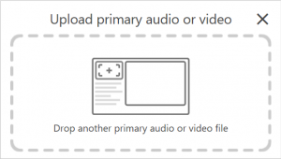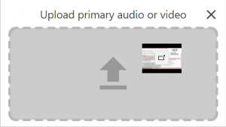
5. The .mp4 video will now appear as a new Primary Stream in the left hand side and will play at the desired time as the students watch your DMU Replay resource.
