Support students using the interactive elements of your DMU Replay recording
Note: It is important for our students to be able to annotate and navigate recordings as a part of UDL practise.

Learning outcomes
By the end of this guide you should know;
- How to search a recording,
- How to add a Bookmark, and
- How to add a Note.

How to
1. With a DMU Replay recording open, students can search the recording using the Search this recording box.
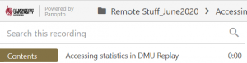

Note: The search function will include results where the search term was included as text on screen or in the spoken audio (voice) of the recording.

2. To add a Bookmark at a specific point in the recording, students can click the Bookmarks link and type their text in the box.
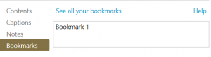

Note: Bookmarks will remain personal to each student. Students can see a collated list of all of their Bookmarks, across all recordings they have access to at replay.dmu.ac.uk.

3. To add a Note, students should click the Notes link and type their Note.
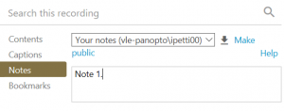
Note: Students can share their Notes with the other students on the module by clicking the Make Public link. This will only share the Notes with the other students who are on the module.

