Setting up discussion forums for specific groups in Blackboard

Learning outcomes
By the end of this guide you should know;
- How to set up discussion forums for specific groups in Blackboard
- How to view a specific group discussion board

Each group within a Blackboard module can be assigned its own Blackboard discussion space. Discussion forums can be an effective asynchronous mechanism for engaging students in collaborative/social/peer learning, particularly when utilised as part of an integrated blended learning approach.
In Blackboard whenever Groups are created a Discussion Board area for each Group is automatically created. These group discussion boards can be accessed by module instructors via the Discussion Board tab in the Course Tools menu.
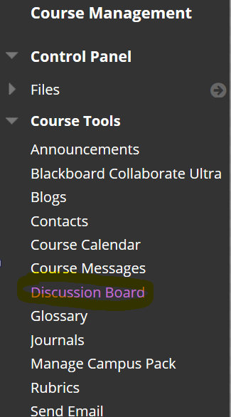
To access a specific group discussion board – click the group name.
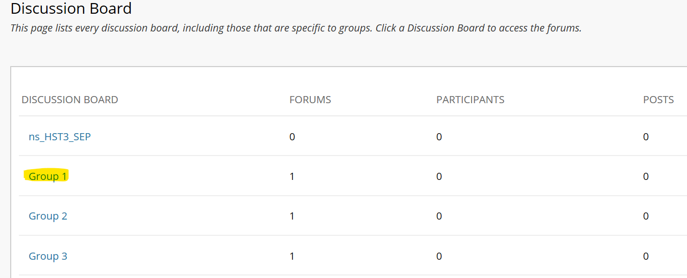
The group forum panel appears. This panel lists all forums (discussion topics) for the group. There will be a default forum which has the group name. You may want to use this default forum for general group discussion (it can be re-purposed/re-named for any other use).
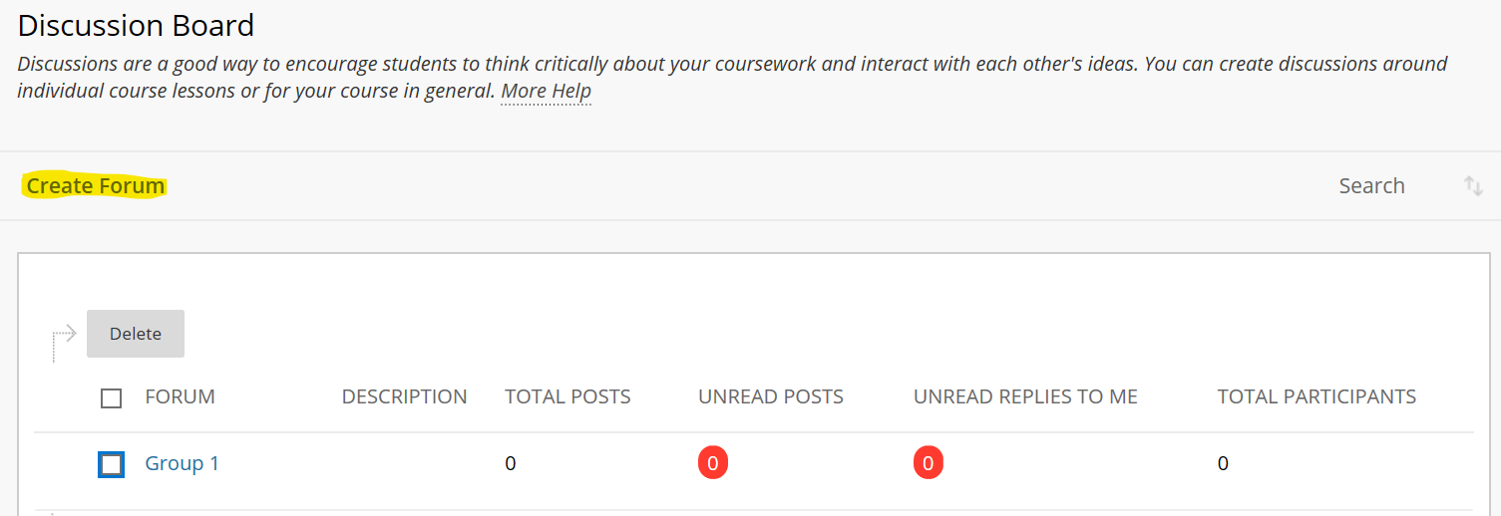
New forums (discussion topics) can be added by the instructor via the Create Forum button.
Click this link for further guidance on how to utilise Blackboard Discussion Forums [opens website]
NOTE: Only instructors have automatic access to a Group discussion forum. For students to be able to access their Group Discussion Forum - follow the guide below.

Student access to their group discussion boards
If you have already setup groups in the module, but did not give the groups access to the Discussion Board tool using the Tool Availability panel –
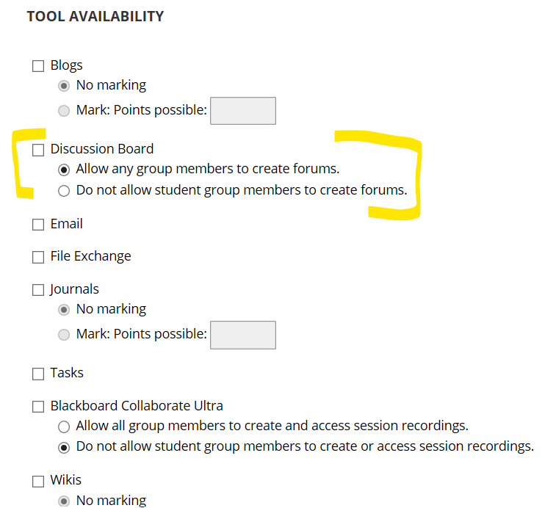
You will need to assign the Discussion Board tool to each group individually

Students access their Group Discussion Board via their Group link located in the Main Menu.
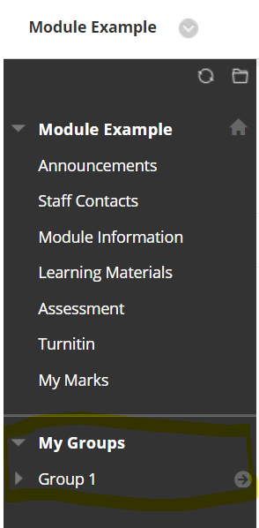
Clicking on their group name reveals the tools which have been assigned to their group.
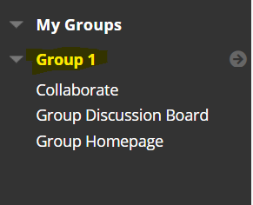
Clicking on the Group Discussion Board link gives them access to their Group discussion area.
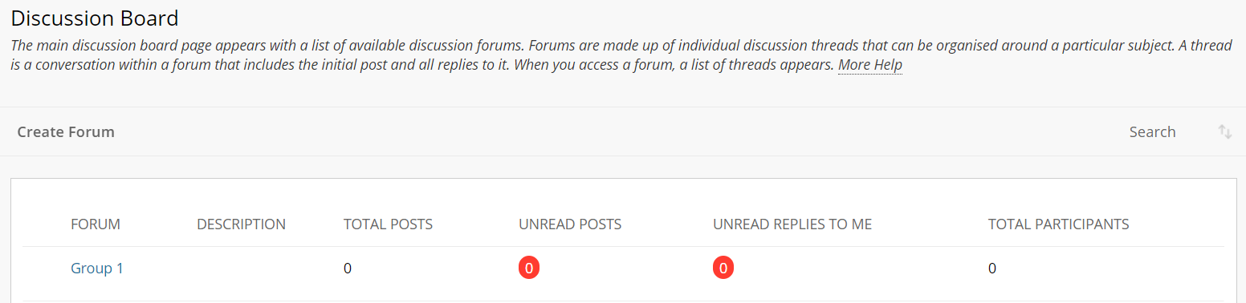

Activating the Discussion Board tool for Groups in Blackboard
[if you had not activated it when you first setup the Groups]
1. Navigate to the Groups list
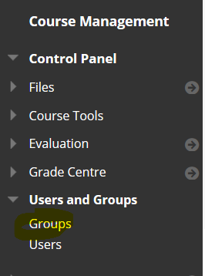
2. Click the Group option button
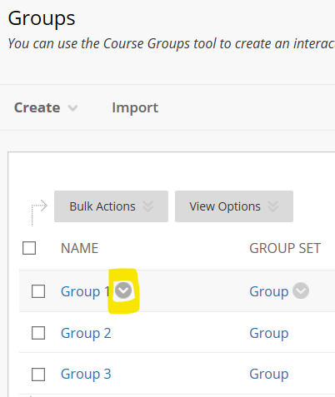
and select Edit Group
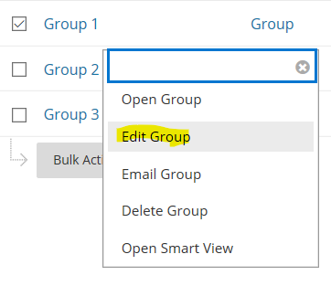
3. Scroll down the page to the Tool Availability panel and check the Discussion Board option – then click submit.
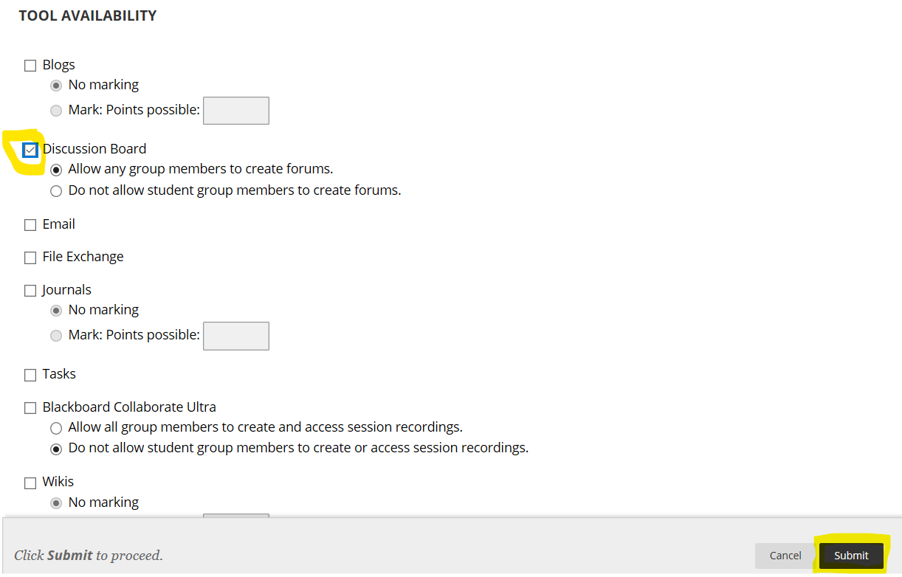
4. Repeat this process for each group.
How do students access their Group Discussion area?

