Setting up a Collaborate Ultra session in Blackboard
Note: Collaborate sessions can be recorded.

Learning outcomes
By the end of this guide you should know;
- How to add Blackboard Collaborate Ultra to your Blackboard module or community shell (Windows and Mac users),
- How to set up the course room session (Windows and Mac users), and
- How to turn off the course room session (Windows and Mac users).

How to
Add Bb Collaborate Ultra to the course menu
1. Click the ‘Add Menu Item (+)’ to open the drop-down list and select ‘Tool Link’.
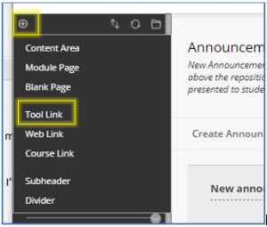

2. Type in a name, for example Collaborate Ultra.

3. For the Type drop down list select Blackboard Collaborate Ultra.
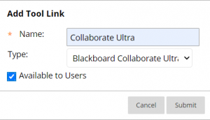
4. Click Submit.

Add Bb Collaborate Ultra to a content area
1. Open the content area where the tool is to be made available.

2. Click on Tools button to open

3. Click on More Tools to open

4. Click on Blackboard Collaborate Ultra to select
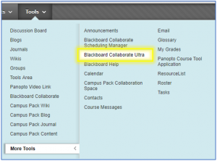

5. Complete the Create Link form.
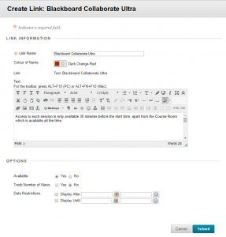

Note:
- Link Name: leave on default Blackboard Collaborate Ultra, unless you have a good reason to change it. However, if you do change it make sure the students, etc, know it is Collaborate Ultra
- Colour of Name: if you change the colour ensure it meets accessibility requirements, i.e. has a ratio to the background of more than 1:4.5.
- Text: add details, i.e. “Access to each session is only available 30 minutes before the start time, apart from the Course Room which is available all the time.”
- Options: Make available if you want the students to see Collaborate Ultra straightway.

6. Click the ‘Submit’ button.

To lock the Course Room

1. Open Blackboard Collaborate Ultra (when you first access Blackboard Collaborate, you will see the Collaborate Scheduler, or sessions list).

2. At the top of the scheduler you will see the Course Room. On the right-hand side you will see the Sessions Option menu.
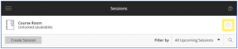
3. Select Lock Course room. The session options menu is also where you can join the session, edit it, view reports or copy the link for guests not on your shell.
