Setting rooms for individual students or groups
Note: Group rooms for individual students or groups can be used for group working, co-creation, and assessment (formative and summative).

Learning outcomes
By the end of this guide you should know;
- How to set up random enrolled rooms for individual students or groups (Windows and Mac users).

How to

With Edit Mode On
1. From the control panel, on the bottom left side of the page, click on Users and Groups and then click on Groups.
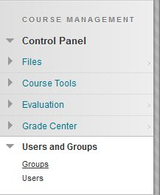
2. Hover over Create Group Set and click on Random Enroll.
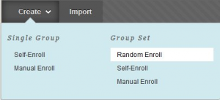

3. Type in a name and description for the group.
4. Choose to make the group unavailable or available. No makes the group unavailable in case the instructor still needs to set some options before the students can see the groups. Yes make the groups available for the students to use.

5. Under Tool Availability, tick Blackboard Collaborate Ultra. Select to either allow group members to access session recordings or not.
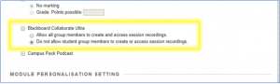
6. Select any other tools that you want the groups to have.
7. Select if you want to grant students control of how the group page looks.
8. Either type in the Number of Students per Group or the Number of Groups that you want Blackboard to create. Make sure you click on the radio button next to whichever you wish to enter. If you want to create a Collaborate session for each individual student then ensure the number of students per group is 1.
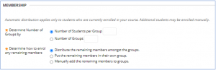
9. The Determine How to Enroll any Remaining Members option is in case the instructor adds an odd number of students to groups. For example, say you have 21 students and you tell Blackboard to create 5 groups. There will be 4 students in each group but there will be 1 student who is left over… That’s what this option is for.
10. Click the Submit button.

Note: Group Rooms can be recorded by moderators, but additional sessions cannot be scheduled.

