Setting planned multiple sessions with different rooms
Note: Scheduling multiple sessions using different rooms is useful for group working, co-creation, and assessment (formative and summative).

Learning outcomes
By the end of this guide you should know;
- How to schedule multiple sessions within Blackboard Collaborate Ultra using different rooms (Windows and Mac users).

How to
1. Open Blackboard Collaborate Ultra.
2. Click either of the Create Session buttons.
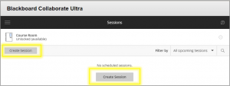
3. When it opens a New session, type a name in the text box.
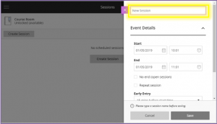
4. Enter the event details, if you need to open them, click the chevron.
5. Under Start set the date and time.
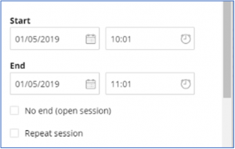
6. Under End set the date and time. After this time you will no longer be able to join the room, but if you are already in the room you will not be forced to leave.
7. Tick No end (open session) if you want the session to remain open.
8. Tick Repeat if you want to repeat this session. You can repeat it daily, weekly or monthly.
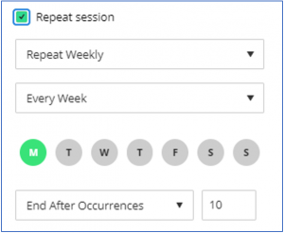
9. Select the time you want available for Early Entry, this allows participants to enter the room before the start time. It is useful for the presenter to enter early to prepare and set up the session to enable a prompt start.
10. Finally, click on Provide a description, to add text that is visible to participants before a session is available. i.e. “This session is repeated on Thursday afternoon. It will be available 30 minutes before the start time.”
11. Click Save. The session is now listed in the Collaborate Scheduler/ Sessions list.
12. Repeat if you want to add another session.

