Set up DMU Replay and access the folder structure
Note: Setting up the DMU Replay recorder to use the correct folder for your module is crucial for students with a specific disability or learning difference.

Learning outcomes
By the end of this guide you should know;
- How to set up the DMU Replay recorder software
- How to select the module folder for the recording.

Windows users

How to
1. Open the DMU Replay recorder and sign in.
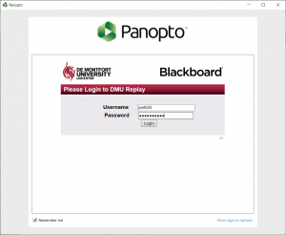

2. The software will open with the default settings.
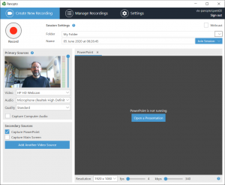

3. Change the following settings to replicate the standard settings as presented when DMU Replay opens in a DMU classroom.
- Video – None
- Audio – The microphone of your choice
- Quality – High
- Capture Computer Audio – Yes
- Captire Main Screen – At your discretion
- Resoultion – 1920 x 1080
- fps – 8
- kbps – 750.

4. Ensure that the module code for the recording is selected in the Folder field. The recorder should now look like this.
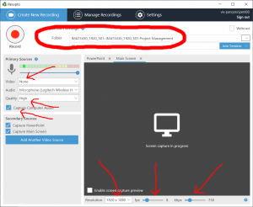

5. To start the recording click Open a Presentation and begin recording in the usual manner.
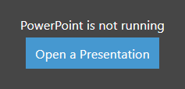

Mac users

How to
1. Open the DMU Replay recorder and sign in.
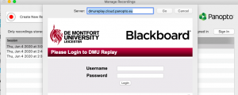

2. Click Create New Recording.
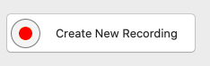

3. The software will open with the default settings.
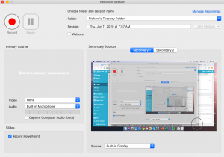

4. Change the following basic settings to replicate the standard settings as presented when DMU Replay opens in a DMU classroom.
- Video – None
- Audio – The microphone of your choice
- Capture Computer Audio – Yes
- Secondary 1 Source – Built-In-Display – At your discretion (this is your whole screen)

5. Go to Panopto > Preferences and change to:
- Primary Video Quality (standard motion)
- Secondary Video Quality (Ultra motion)

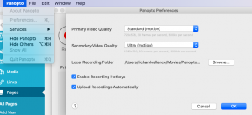

6. Ensure that the module code for the recording is selected in the Folder field. The recorder should now look like this.
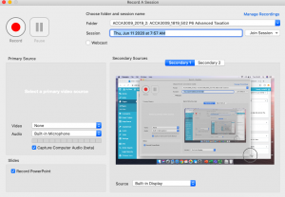

7. Open up your PowerPoint slides (if using). Unlike recording on a Windows PC (e.g. during a lecture at DMU), you do not need to open the PowerPoints via the recorder.

8. Click the Record button.
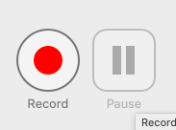

9. Navigate to the PowerPoint slides or your screen and present in the normal way.

