Recording with DMU Replay
Note: For UDL purposes it is important that:
- Recordings with DMU Replay take into account the sound quality and camera use/angle if included, and
- Recordings are of sufficient quality for all users to access and use them.

Learning outcomes
By the end of this guide you should know;
- How to check the sound recording level
- How to set up a camera – if required, and
- How to change the frames per second (fps) when recording detailed videos.

Windows users

How to
1. With the DMU Replay recorder open click on the Audio field and select your preferred microphone.
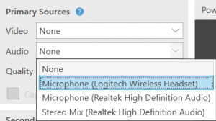

2. With the microphone selected a level meter will appear – ensure that the sliding blue dot is moved toward the right.
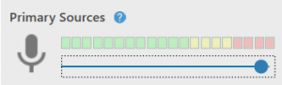

3. If a camera is required, click on Add Another Video Source.
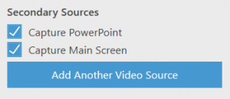

4. Select the camera of your choice. A new tab will appear with a preview of the camera image.
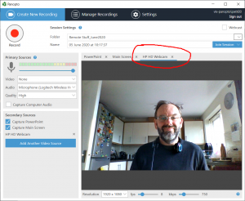

Note: To ensure the best quality of image, please do not sit with the light behind you. In the example above the light is on the left of the subject and this is noticable. Try to ensure that the light source is behind the camera and directed at the subject.

5. For videos that will capture screen detail, (Main Screen) set the fps (frames per second) to 30.

Note: As this action is taken the kbps will change to 2500. This is fine but please do not change the Resolution.

Mac users

How to
1. Open the DMU Replay recorder. Ensure you have signed in and clicked Create New Recording
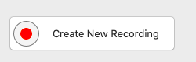

2. With the DMU Replay recorder open click on the Audio field and select your preferred microphone.
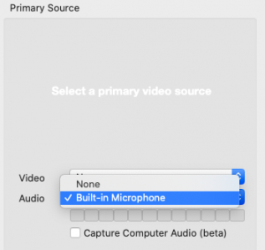

3. With the microphone selected a level meter will appear below – ensure that when you talk these levels are moving.
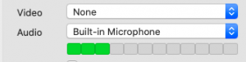

4. If a camera is required, it is recommended you add it as another screen (this can give more options to edit it later if needed). Click on Secondary 2.
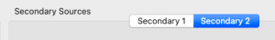

5. Select the camera of your choice using the Source option (FaceTime HD is the in-built Mac camera). A new tab will appear with a preview of the camera image.
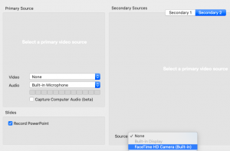

Note: To ensure the best quality of image, please do not sit with the light behind you. Try to ensure that the light source is behind the camera and directed at the subject.

6. For videos that will capture screen detail, (using Secondary video as instructed above) set the fps (frames per second) to 30 for the video. This can be done by going to Panopto > Preferences and changing the Secondary Video Quality to Ultra (motion). You should see this changes to 30 fps.
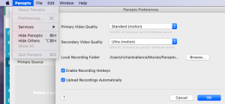

Note: As this action is taken the kbps will change to 1500.

