Open the DMU Replay recorder on a DMU issued computer
Note: This guide is only for when a DMU issued Windows PC is in use.

Learning outcomes
By the end of this guide you should know;
How to open the DMU Replay recorder software.

How to
1. With a web browser open, navigate to software.dmu.ac.uk.

2. Sign in to the website using your usual DMU details.
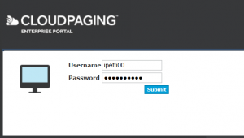

3. Click the Launch icon next to DMU Replay v3 (Portable).

4. Click the Continue button.
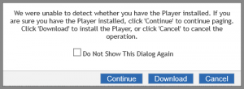

5. With DMU Replay v3 (Portable) selected, click the second Launch icon.
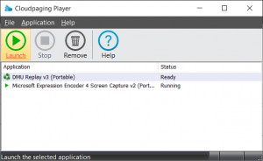

6. The DMU Replay recorder software will open and be ready to sign in.
