Blackboard – Creating Groups using the Group Set Random Enrolment option
If you want to automatically create a specified number of Groups and randomly assign students to each group.
- Click the Create tab and select Random Enrol under the Group set option.

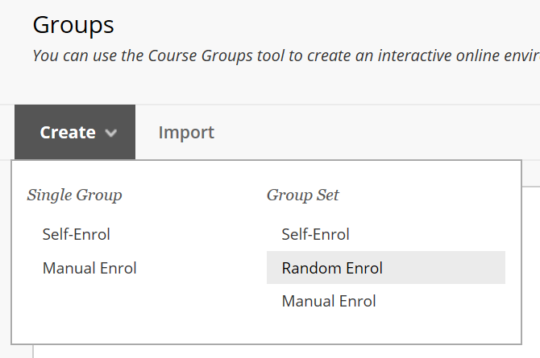
2. Give the group set a name – e.g. Group; and ensure the group is visible to students.
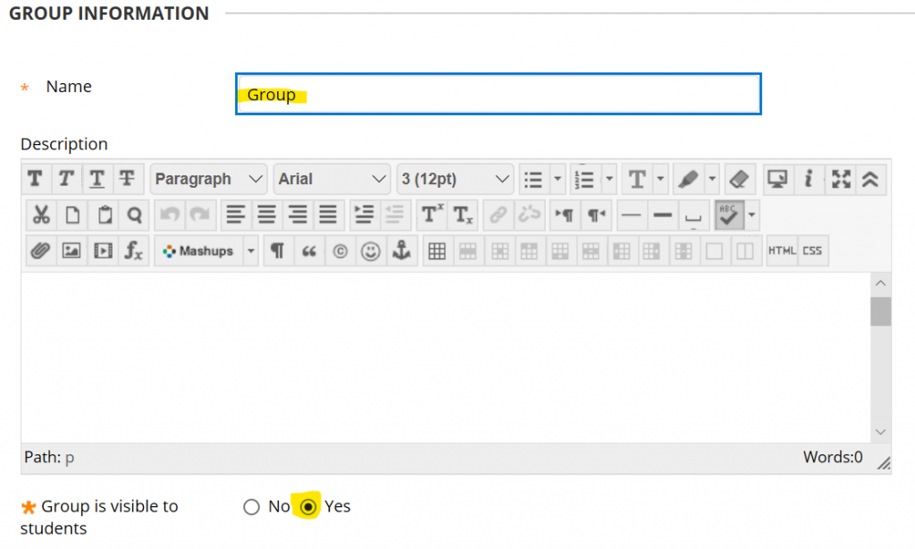
3. Scroll down the page to the Tool Availability panel and indicate the tools that you want each group to have access to. In this example each Group will have access to its own Group Discussion Board and its own Group Collaborate area.
NOTE: if you do not select any tools at this time, but then decide to give groups access to specific tools at a later date having set up the Groups – you will have to activate the tools for EACH INDIVIDUAL GROUP; which could be time consuming.
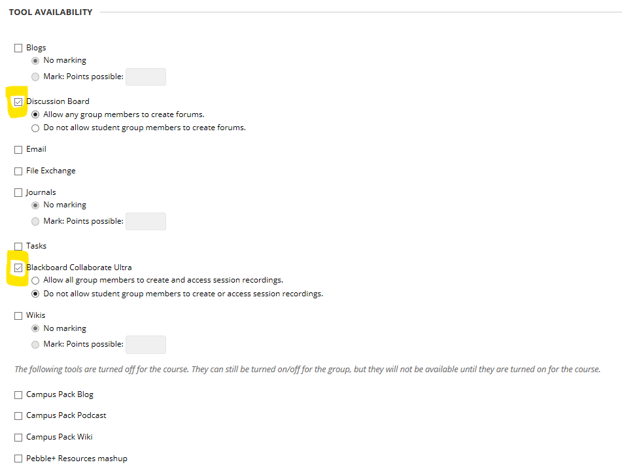
NOTE: these tools only apply to Groups. If you do not check any tools in this list they will still be available across the module for general use.
4. Scroll down the page and un-check the module personalisation setting.
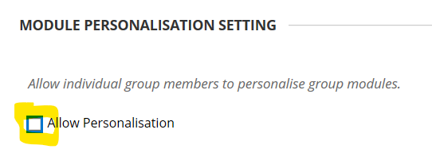

5. In the Group Set Options panel, check the Create Smart View . . . option. This will allow you to filter the Grade Centre to only show results for the students in each Group (should you require this option).
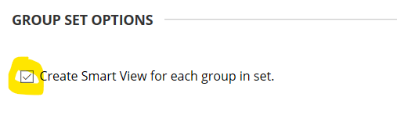
6. Scroll to the bottom of the page and use the membership options to determine how many groups/students per group there will be. Then click Submit.
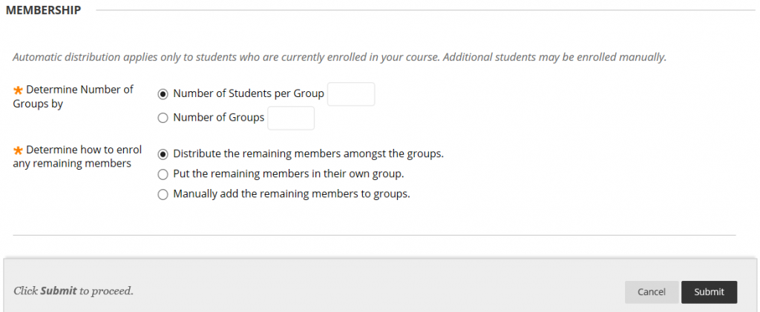
7. The groups panel will appear showing a series of auto-generated groups and how many students have been enrolled in each group. Students will have been randomly assigned to a group.
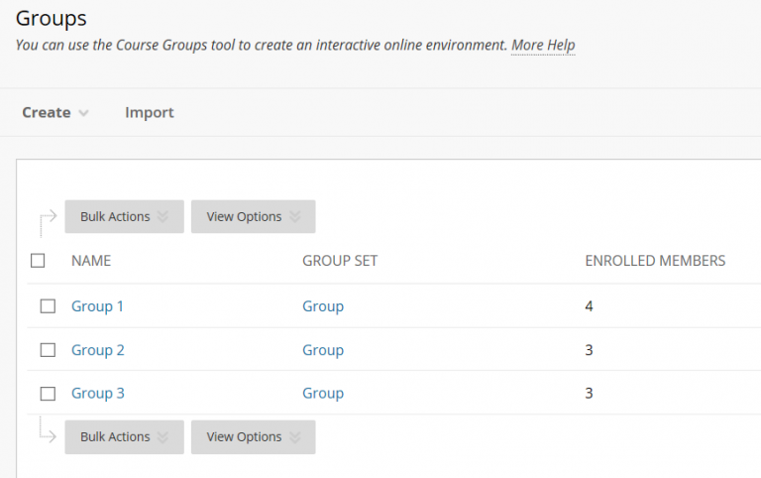
Clicking on a Group name will present a list of the Group members.
