Blackboard – Creating Groups using the Group Set Manual Enrolment option
If you want to automatically create a specified number of Groups and then assign specific students to each Group.
1. Click the Create tab and select Manual Enrol under the Group set option.
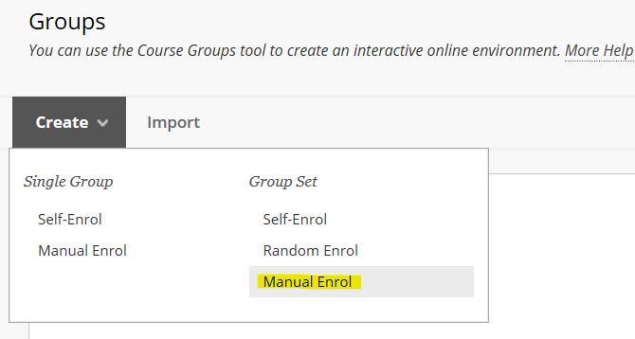
2. Give the group set a name – e.g. Group; and ensure the group is visible to students.
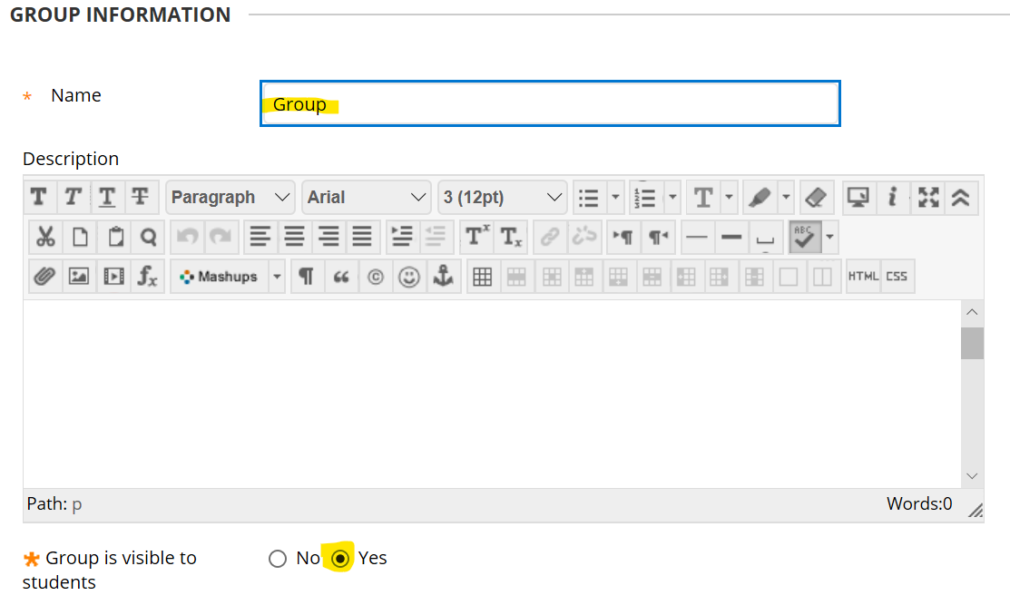
3. Scroll down the page to the Tool Availability panel and indicate the tools that you want each group to have access to. In this example each Group will have access to its own Group Discussion Board and its own Group Collaborate area.
NOTE: if you do not select any tools at this time, but then decide to give groups access to specific tools at a later date having set up the Groups – you will have to activate the tools for EACH INDIVIDUAL GROUP; which could be time consuming.
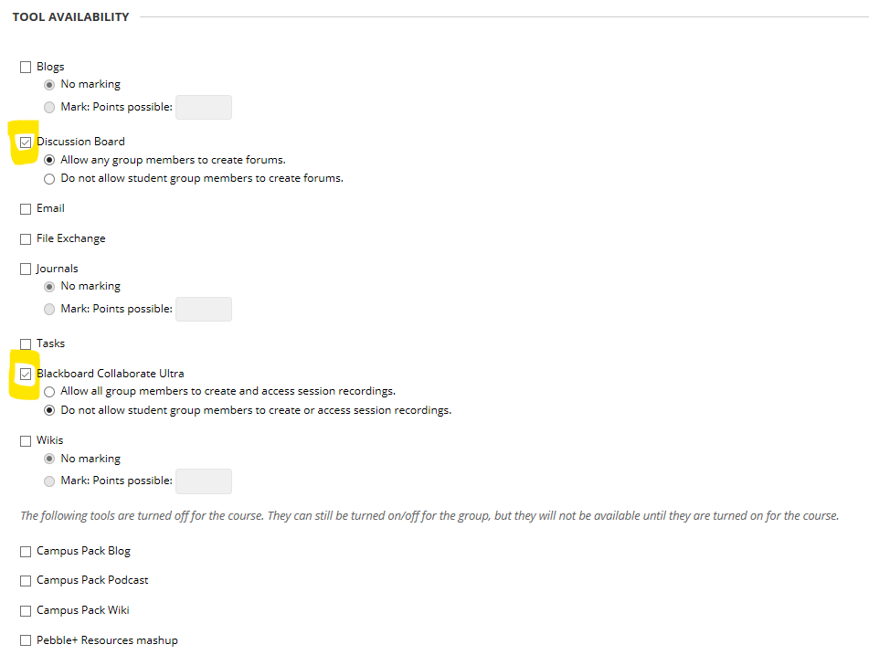
NOTE: these tools only apply to Groups. If you do not check any tools in this list they will still be available across the module for general use.
4. Scroll down the page and un-check the module personalisation setting.
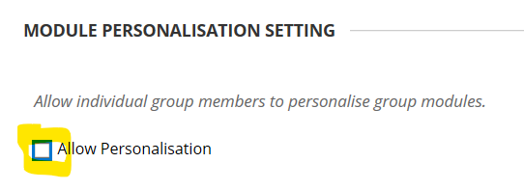
5. In the Group Set Options panel, enter the number of Groups that you want to be created and check the Create Smart View option (this will allow you to filter the Grade Centre to only show results for the students in each Group - should you require this option).
Click the submit button.
6. In the Group Set Enrolments panel – click the Add Users button for a Group
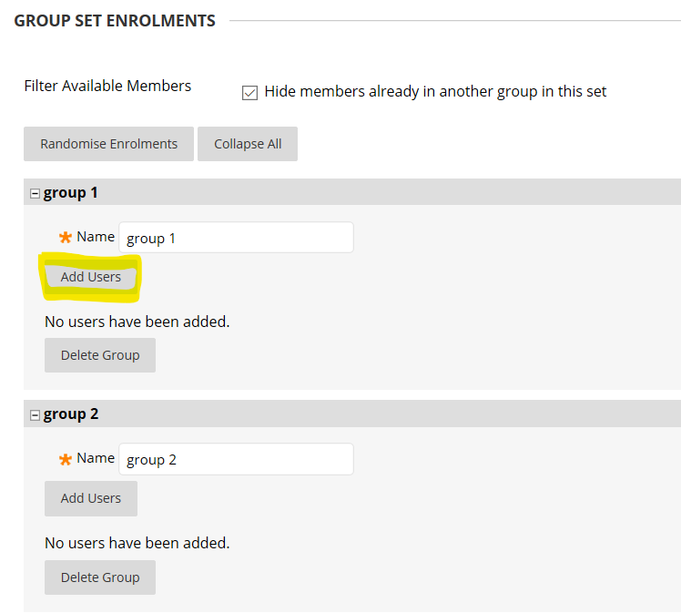
7. From the student list indicate which students you want to add to the Group and click Submit.
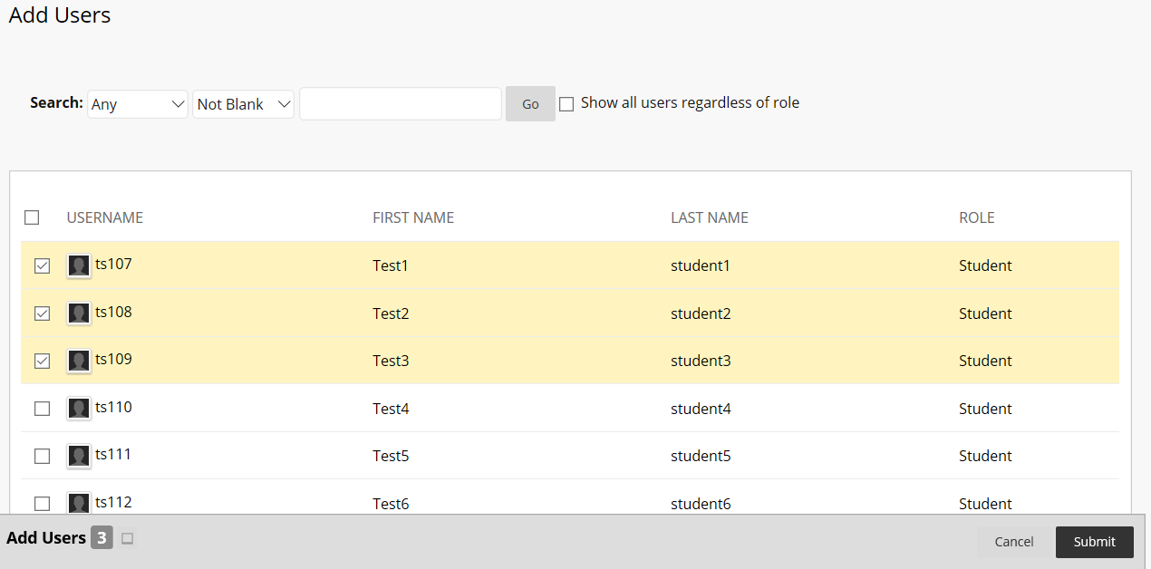
The students will be enrolled on the Group
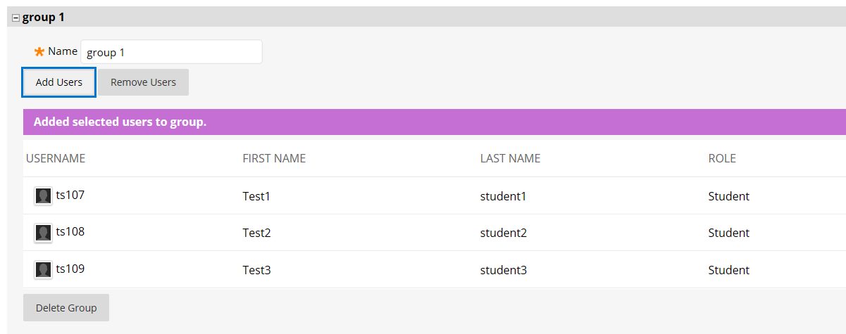
Repeat this process for each Group.
8. When all Groups have been setup, click Submit.
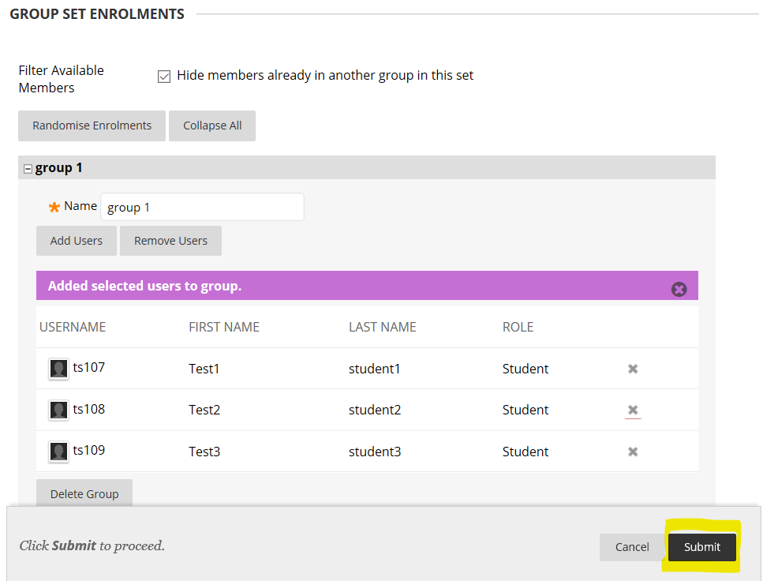
The Groups will be saved.

