Blackboard – Creating Groups using the manual setup and enrolment option
If you want to manually create individual groups and manually assign specific students to each group.
1. Click the Create tab and select Manual Enrol under the Single Group option.
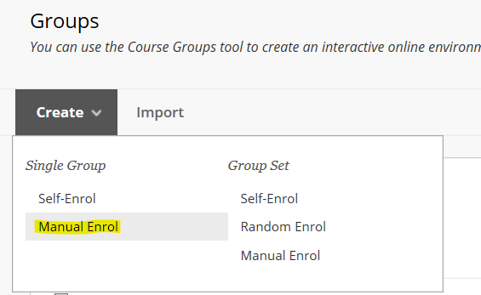
2. Give the group a name; and ensure the group is visible to students.
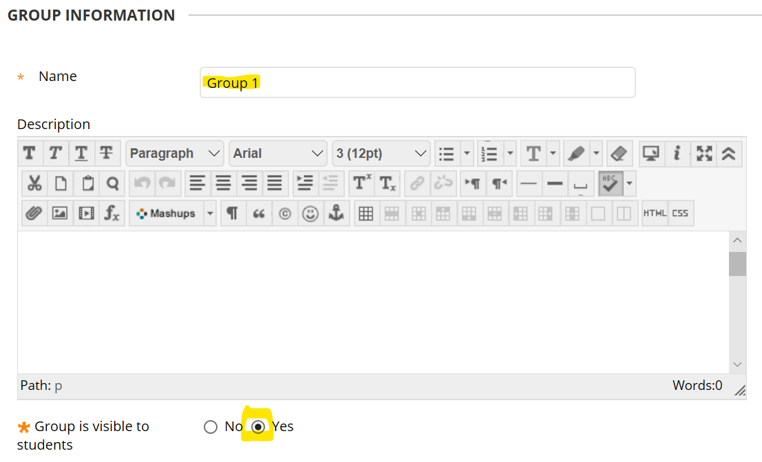
3. Scroll down the page to the Tool Availability panel and check the tools that you want each group to have access to. In this example each Group will have access to its own Group Discussion Board and its own Group Collaborate area.
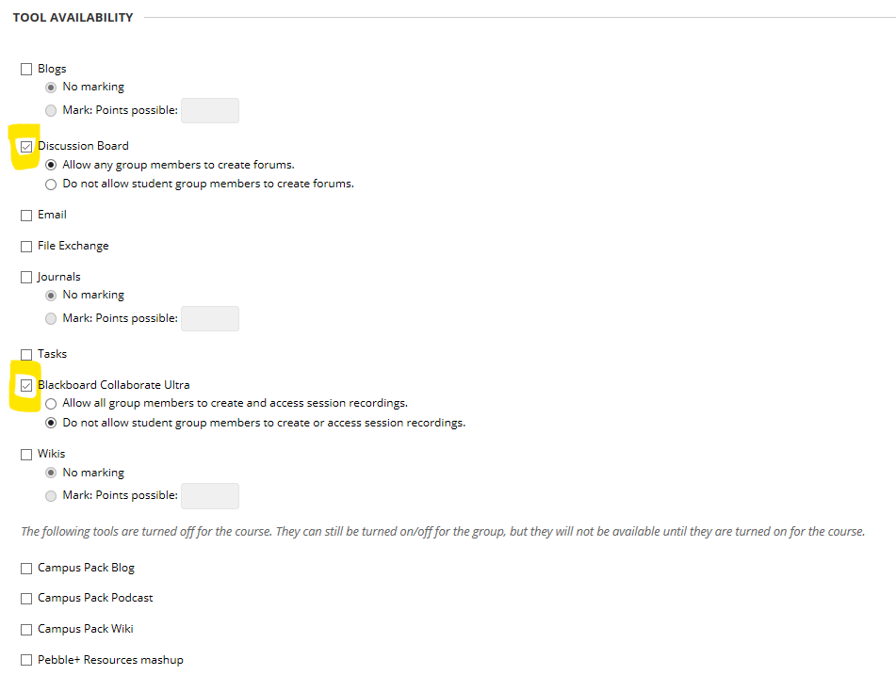
NOTE: these tools only apply to Groups. If you do not check any tools in this list they will still be available across the module for general use.
4. Scroll down the page and un-check the module personalisation setting.
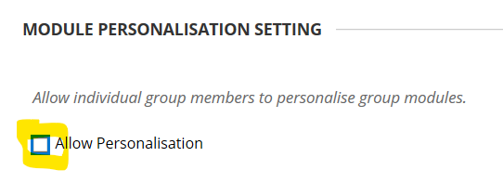
5. In the Group Set Options panel, check the Create Smart View . . . option. This will allow you to filter the Grade Centre to only show results for the students in each Group (should you require this option).
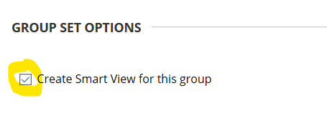
6. In the Membership panel click the Add Users button.
7. From the list of users – select the students who you want to be in this group, and click the Submit button.
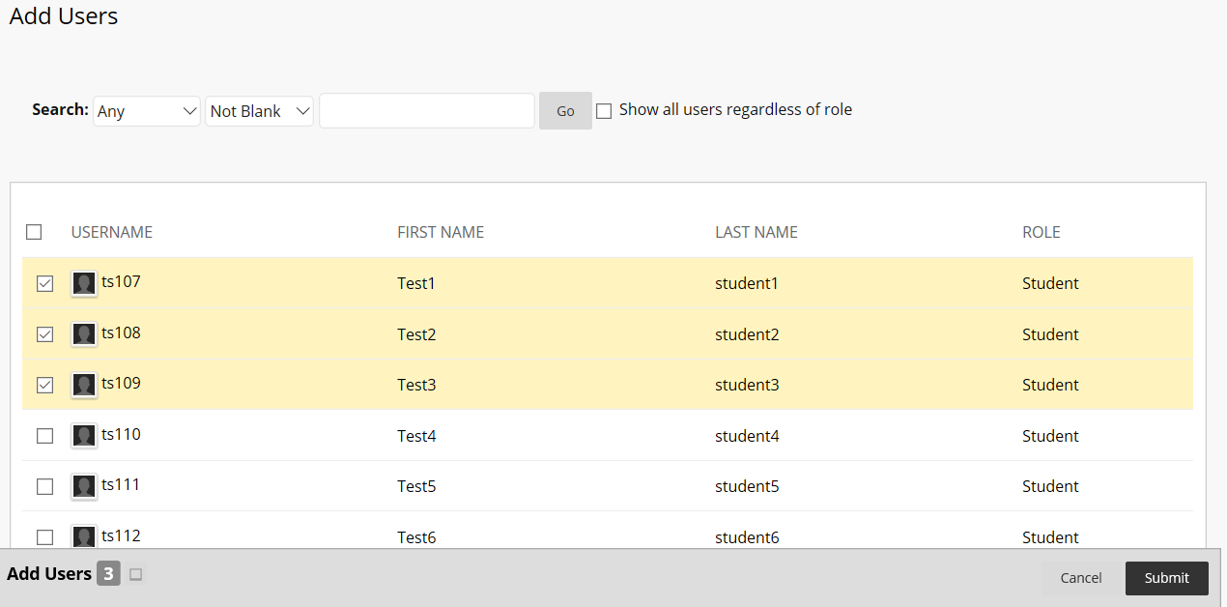
8. Click the submit button to save the group.
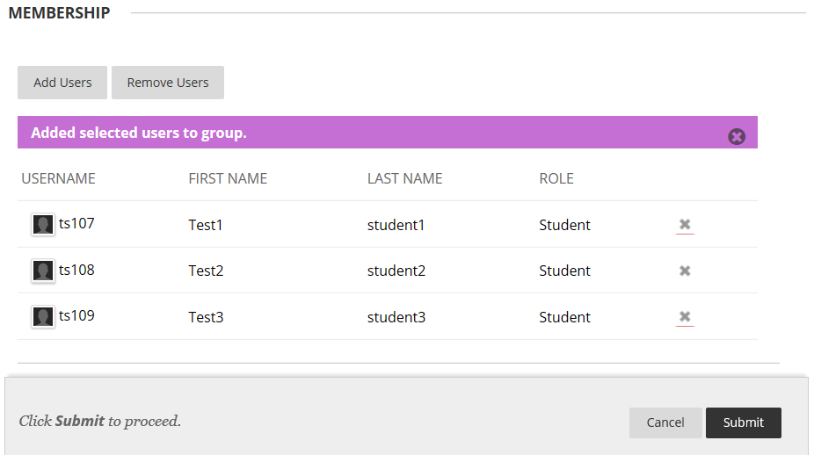
Repeat this process for each group until all students have been assigned a group.

