Embed other media types into a DMU Replay recording
Note: When embedding third party online content we must:
- Ensure that resources follow the principles of UDL and general accessibility legislation, and
- We do not break copyright law.

Learning outcomes
By the end of this guide you should know;
How to embed a YouTube video into your DMU Replay recording, and
How to link from your DMU Replay recording to a webpage.

How to

1. In the DMU Replay portal, click the Edit button for the recording to be augmented.
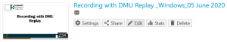

2. Move the playhead to the time at which you want the embedded content to appear.
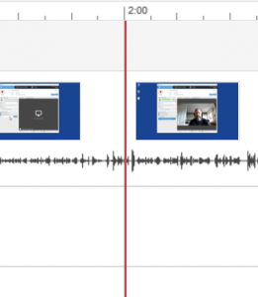

3. Click the Add Content (+) button.
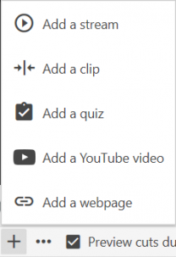

4. To embed a YouTube video, click on Add a YouTube video.

5. Paste the link to the YouTube video into the Link field and click Done.
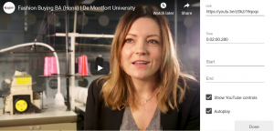

6. To the left, locate the new link in the Contents list and click Add a title.

7. Type a name for the link and press return on the keyboard.
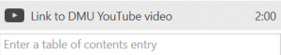

8. To add a link to a website repeat the above process but select Add a webpage.

9. Complete the Title and Link fields and click Save.
