Editing a DMU Replay resource (top and tail)
Note: Whilst not trying to provide professional standard recordings, by editing in DMU Replay we can;
- Develop some consistency in approach and delivery, and
- Ensure that standard recordings do not exceed 20 – 30 minutes.

Learning outcomes
By the end of this guide you should know;
- How to open the DMU Replay Editor,
- Trim the start and end of a recording (top and tail), and
- Remove chunks from the middle of recordings.

How to
1. Open the DMU Replay Editor by clicking the Edit button next to the desired recording.
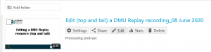
2. To trim the beginning (top), move the mouse to the left of the timeline until the mouse pointer becomes a thick grey vertical line.
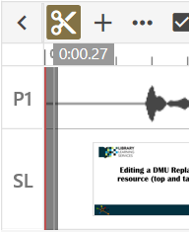

3. Click and hold the left mouse button and drag to the right. Release the mouse button at the new start point.
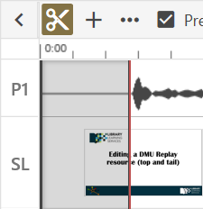
4. To trim the end (tail), repeat the process but this time move the mouse to the right hand end of the timeline and drag to the left.
5. To remove a section from the middle, click the mouse on the timeline roughly where the section to be removed appears.
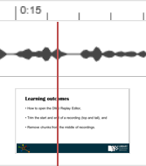

6. Click and hold the left mouse button at the selected point and drag to the right. Release the mouse button.
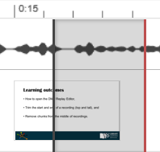
7. Use the black bars that appear either side of the cut to fine tune the selection.
