Downloading DMU Replay on a personal computer
Note: This guide is for those who do not have access to a DMU computer or who are using a Mac. You must have the ability to make changes to the computer you are using (administrator account) to install DMU Replay.

Learning outcomes
- By the end of this guide you should know;
- How to access the DMU Replay portal using a web browser (Windows and Mac users),
- How to download and install the DMU Replay recorder software (Windows and Mac users), and
- How to set the Panopto Web Server (Mac users only).

How to

1. In a web browser, navigate to www.replay.dmu.ac.uk.

2. Click the Sign in button.

3. Leaving ‘DMU Replay’ selected click the second Sign in button.
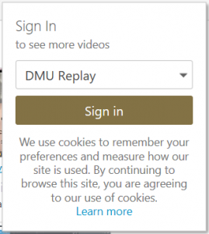

4. Sign in using your usual DMU username and password.
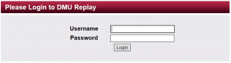

5. Click the Download Panopto link that appears just below your name.

6. The system will detect the correct version of DMU Replay for your computer, click the Download Panopto button.
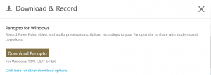

7. Your browser should now offer a number of options. In this example, Microsoft Edge asks if I want to Run, Save or Cancel. For convenience, I will Run the file but you may Save it if you need to install DMU Replay on multiple computers or if you wish to keep a copy to install later. Cancel will stop the operation entirely.

8. Install the software as usual for your computer (Windows or Mac).
Note: For Windows users; the following will appear during installation – please leave all settings as below and click Next.
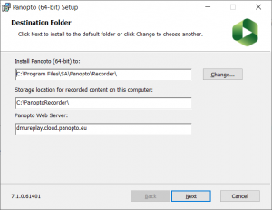

Note: For Mac users; you will need to enter the Panopto Web Server and manually select ‘DMU Replay’ as the provider. The Panopto Web server is dmureplay.cloud.panopto.eu. The steps below show how to enter this detail and get the list of providers.

9. On the Panopto application, click the Sign In button.
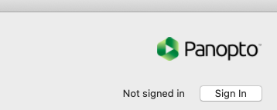

10. Enter dmureplay.cloud.panopto.eu in the Server field and click Go. This will bring up the DMU single sign on. Enter your login details as normal and click Login. You will now be signed in.
