Creating Group Content Folders in Blackboard

Learning outcomes
By the end of this guide you should know;
- How to setup and organise Content Folders in Blackboard that are only accessible to specific student Groups

Groups in Blackboard can be used to disseminate teaching, learning and assessment content to specific groups of students. This can be a particularly useful approach for managing the delivery of blended learning. In Blackboard, a Content Folder (and all the content within it) can be assigned to be visible only to a pre-defined group of students.
NOTE: this approach should only be used if there are a small number of Groups per module instructor, as setting up individual Group Content Folders is time consuming.
1. An example of the use of Group content folders
2. The process for creating Group content folders

In this example the instructor has created a Learning Materials content folder for each Group.
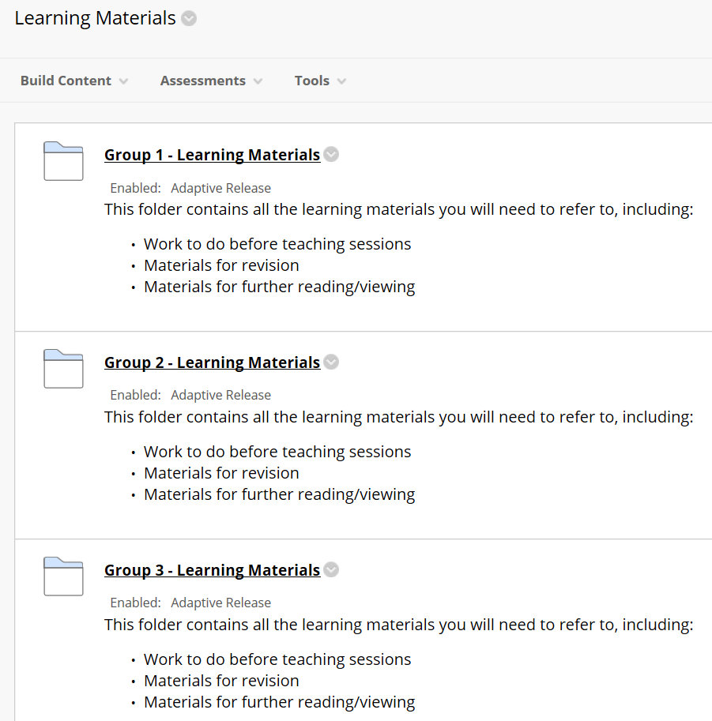
Within each group content folder, the instructor has added the weekly learning materials that are specifically for the group. E.g. when going into the Group 1 – Learning Materials folder we see:
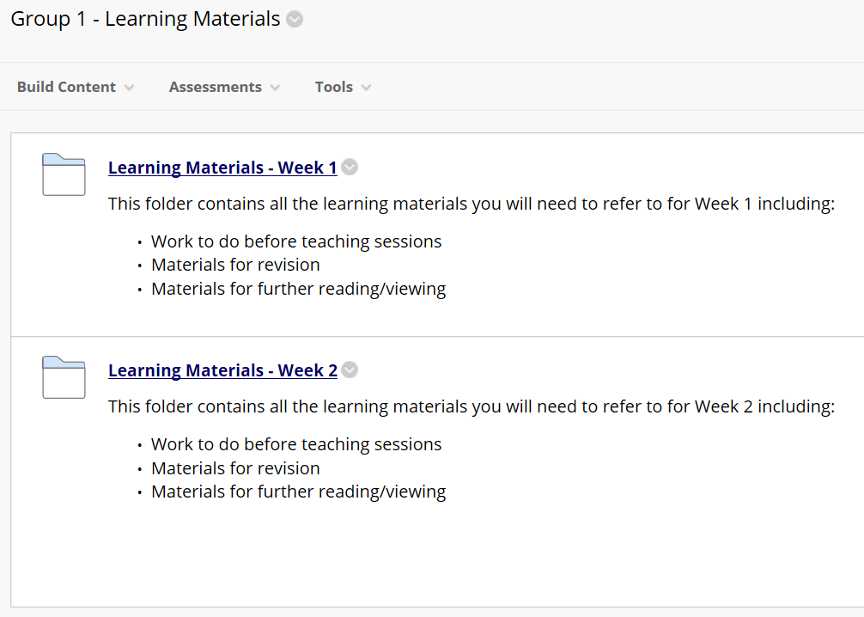
Using this approach means that when a student accesses the Module they will only see content that has been allocated to their group. E.g. when a student from Group 1 logs in to Blackboard and accesses the Learning Materials content area
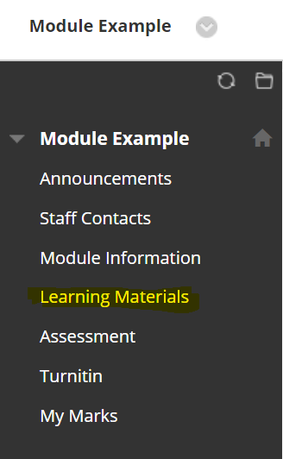
they will be presented with their group Learning Materials content folder.
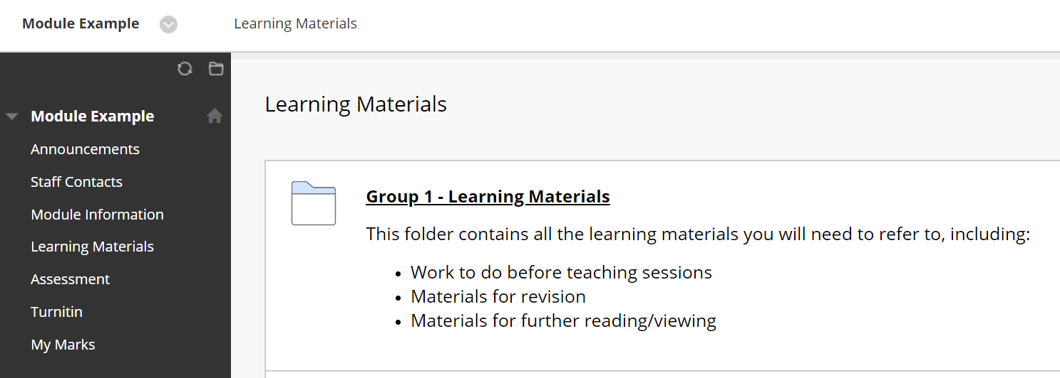
Here is a side by side comparison of what a student in Group 1 and a student in Group 2 sees when they click on the Learning Materials content area in the main menu.
Group 1 student view
Group 2 student view
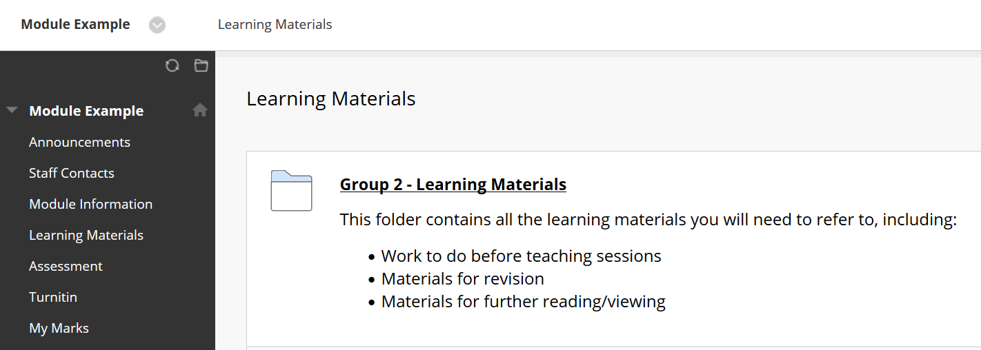
Students will only see content that has been allocated to their Group.
How do instructors access particular Group folders?
All instructors who are enrolled on a module can access all group folders. The group folders only limit access to students, not instructors.
This means that there is no specific setup process required if particular instructors are assigned oversight of particular group folders (i.e. a particular group of students).
Creating Group content folders
1. In the Learning Materials content area create a Content Folder for each Group, using a standard content folder.
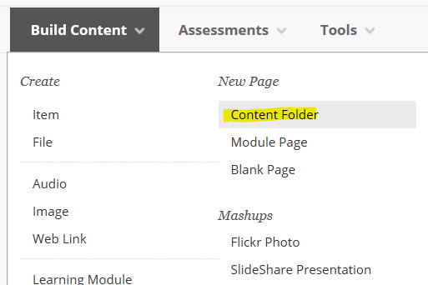
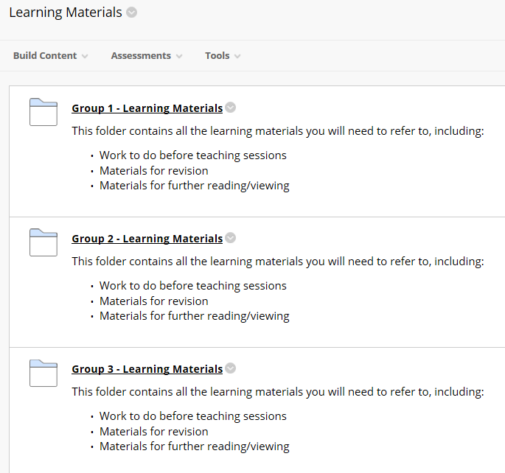
2. Click the edit options button for a group folder.
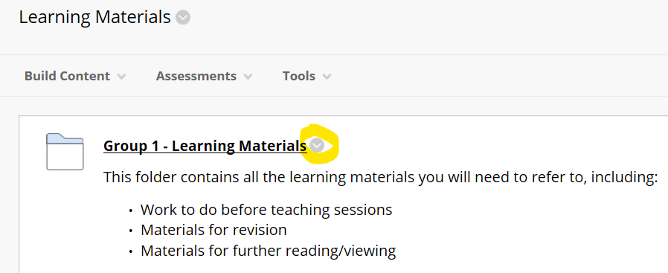
3. Click the Adaptive Release option. Adaptive release is used to control who has access to this content folder.
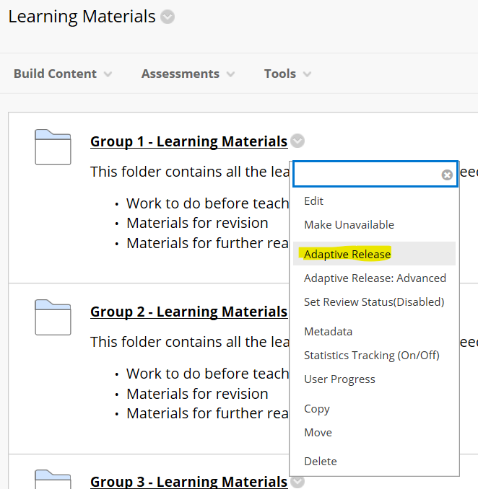
4. Scroll the screen down to the Membership panel. From the list of groups click on the group that you want to assign this content folder to, and click the arrow to move the group into the selected items window.
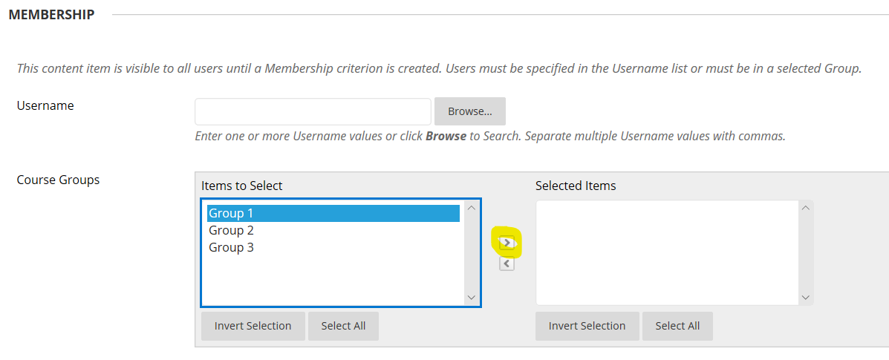
5. Click the Submit button.
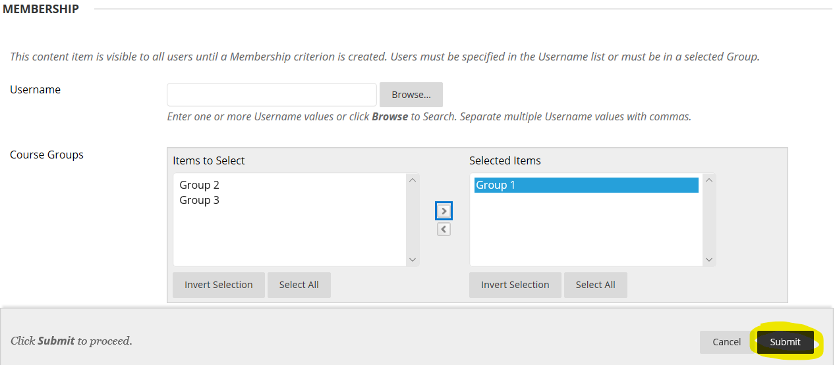
You will see a success message, and the Adaptive release enabled message will appear on the content folder.
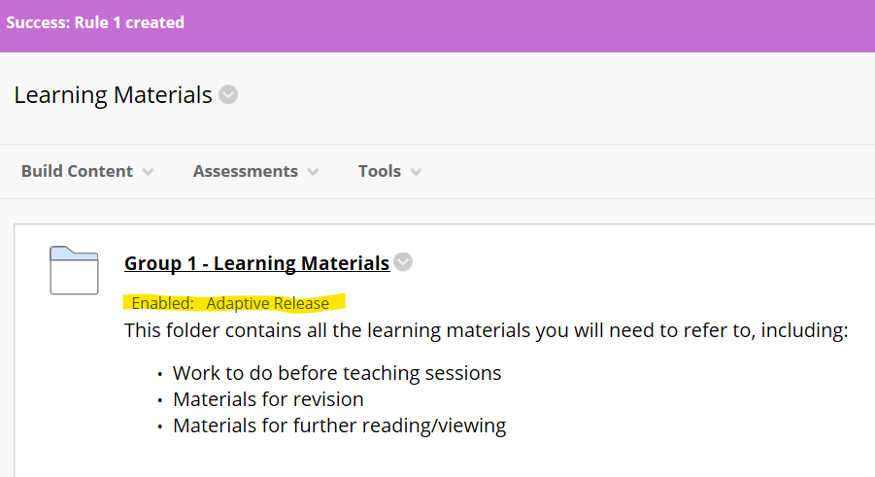
Repeat this process for all of your group content folders.
Having done this, a student from Group 1 will only see their Group content folder, and not that of any other Group.

