Controlling group access to specific Items in Blackboard

Learning outcomes
By the end of this guide you should know;
- How to use the Adaptive Release function in Blackboard to make individual items in Blackboard visible to specific Groups of students

Individual Items in a Blackboard module can be adapted to be visible only to a certain specified group. As follows:
This Item has been added to the Module Information area, it is currently visible to all students on the module.
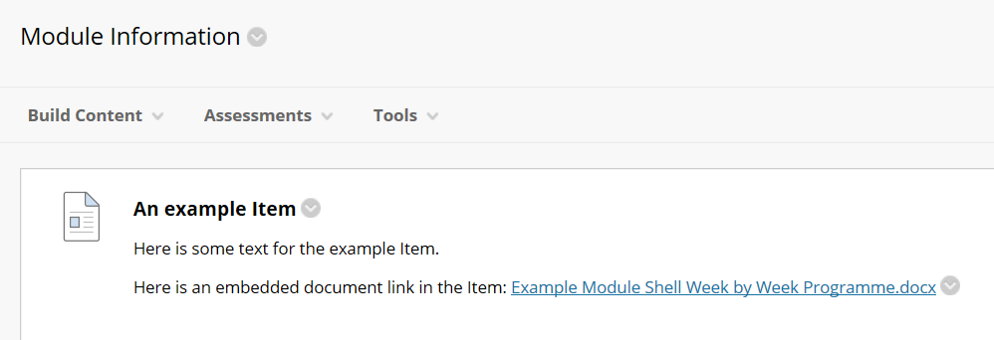
To make the Item visible to, e.g. Group 2 students only:
1. Click the Item option button
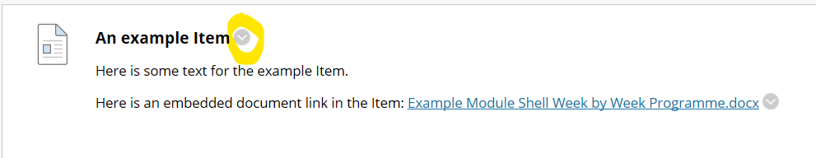
2. From the option menu select Adaptive Release.
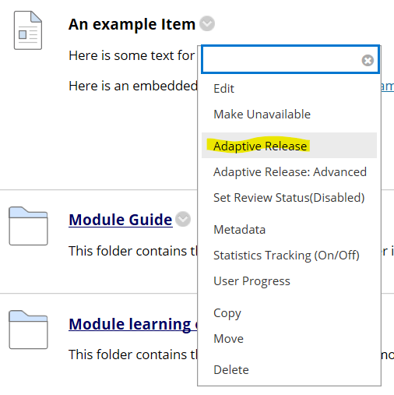
3. Click Group 2 from the group list and use the arrow button to move Group 2 into the selected items window.
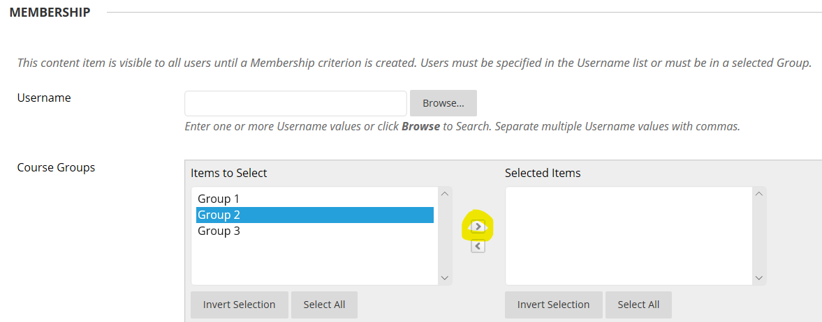
4. Click the submit button.
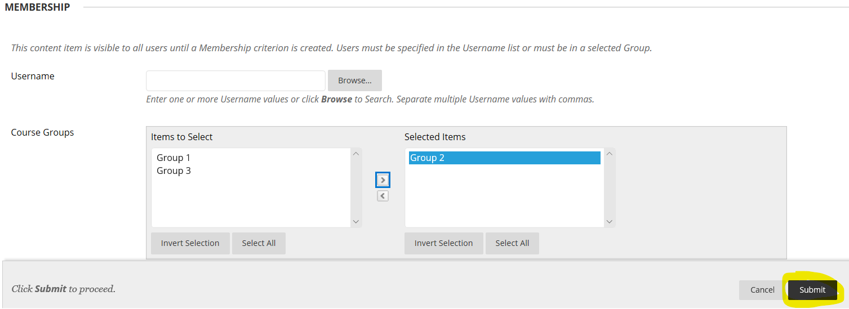
The Item will now only be visible to Group 2 students – despite it being in an open area of Blackboard. E.g.
Group 2 student view
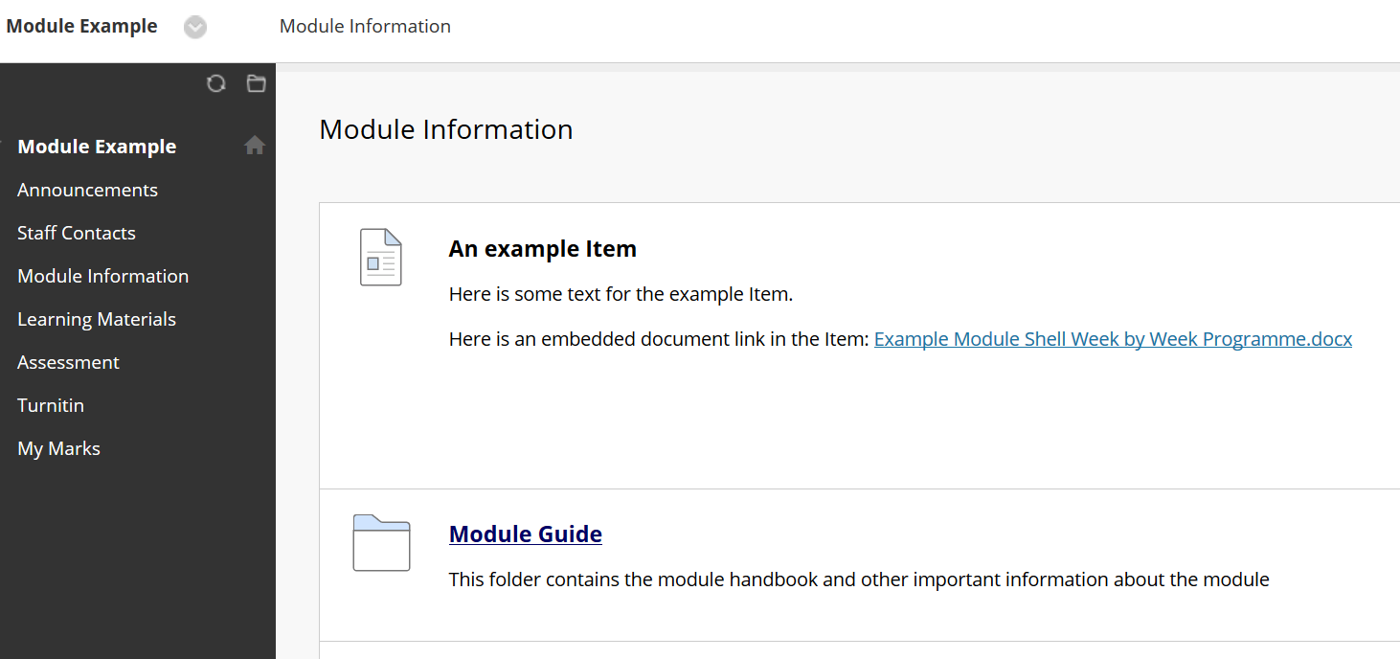
Group 1 student view (the Item is not visible)
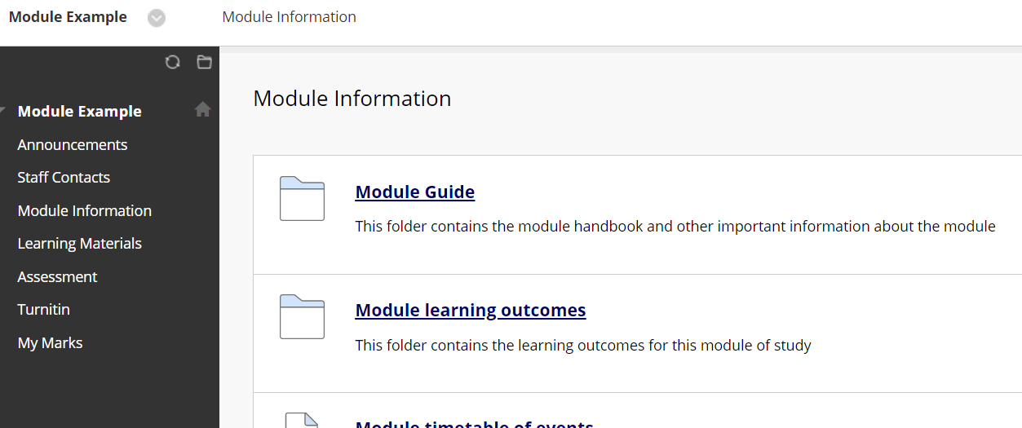
Can Turnitin submissions be limited to individual Groups?
The same method for applying an adaptive release to an Item can be applied to a Turnitin submission link. This allows specific Turnitin submissions to be setup for specific groups.
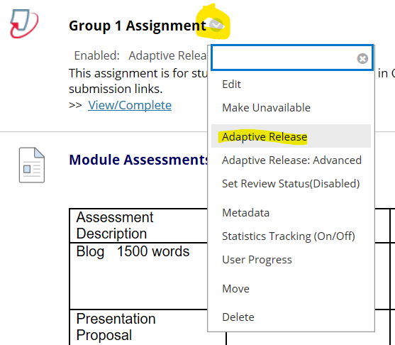
Can Blackboard online tests be limited to specific groups?
The same method for applying an adaptive release to an Item can be applied to an online test link. This allows specific online tests to be setup for specific groups.
