Using whiteboard editing tools
Note: When using the whiteboard it is important that:
We ensure the text (font and size) and colours are appropriate for all users.
We provide an audio report of any changes and additions to the white board.

Learning outcomes
By the end of this guide you should know;
- how to share a whiteboard and use the whiteboard tools.

How to
1. Having opened a Blackboard Collaborate Ultra session, click on the Open Collaborate panel button and Share Content.

2. Click on Share Blank Whiteboard.
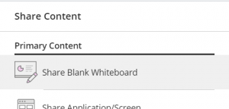

3. A blank whiteboard will appear – the controls appear toward the top left hand corner of the session.
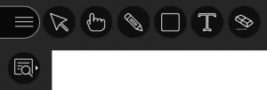

4. Select and use the desired tool as appropriate.

