Creating and using Breakout rooms
Note: By using Breakout rooms we can:
- Introduce elements of co-creation, collaboration and team building.

Learning outcomes
By the end of this guide you should know;
- how to move students and colleagues into a Breakout room and back to the Main room.

How to
1. Having joined a Blackboard Collaborate Ultra session, click on the Open Collaborate panel button and Share Content.
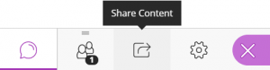

2. Click on Breakout Groups.
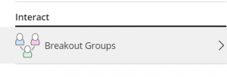

3. Click the three dots next to a Moderator (colleague) or Participant (student).
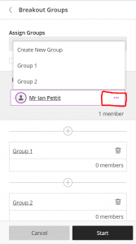

4. Click the Breakout Group to which you want to assign the person.
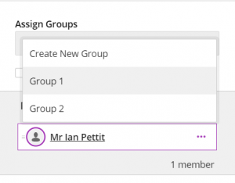

5. With the Moderators and Participants assigned, click Start.
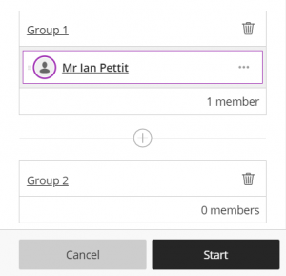

6. To move people between Breakout rooms, click the three dots, select the next room and click Update.
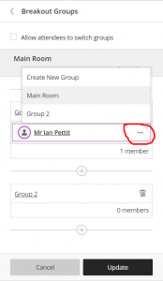

7. To stop the Breakout rooms and bring everyone back to the Main room, click End Breakout Groups.
