Managing chat
Note: When using the Chat panel we must:
- Consider how to frame the question – can the answer be stated in a limited number of words?
- Try not to have students trying to type essay answers to open ended questions.
- Include a slide with a possible answer.
- Consider connection issues if more than 20 students all type at same time
- Consider alternatives such as linking to forum for asynchronous follow up discussion.
- Think about asking students a reflective question to think about – give a time limit and then provide a slide with your thoughts. Further discussion can take place an asynchronous forum to minimise the chat activity.
- Consider if all students can use the chat panel as access can vary with device.
- Use the polling and multiple choice questions alongside teh Chat.
- Ensure that a slide with the correct answer is included and give sufficient time for students to think about and answer.

Learning outcomes
By the end of this guide you should know;
- how to access and use the Chat function.

How to
1. From the Blackboard Collaborate Ultra session, click the Open Collaborate panel button.

2. Click the Chat button.

3. The Chat panel will open.
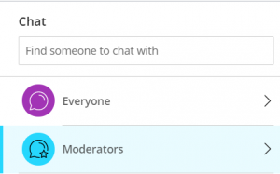

4. To send a Chat message to everyone, click on Everyone. To send a Chat message to staff only, click Moderators. Type your message and press return on the keyboard.
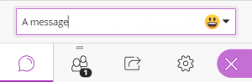

5. The message will appear for the desired group to see.
