Managing and delivering a Collaborate session
Note: Using Blackboard Collaborate Ultra we can:
- Interact with students in a live two-way ‘synchronous’ manner.
- Share content such as presentations and screen content.
- Manage a large group of students by assigning them into Breakout rooms.
- Enable students to support each other either by communicating verbally or using the Chat function.

Learning outcomes
By the end of this guide you should know;
- how to schedule a Blackboard Collaborate Ultra session,
- how to access either a scheduled session or the Blackboard shell’s Course Room, and
- where to find the tools to enable the pedagogical approaches supported by Blackboard Collaborate Ultra.

How to
1. Open a web browser and enter the Blackboard shell. Click the Blackboard Collaborate Ultra Tool link.
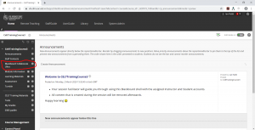

2. To create a scheduled session, click on the Create Session button.
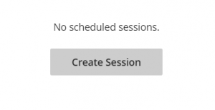

3. Set the options as desired, click Save.
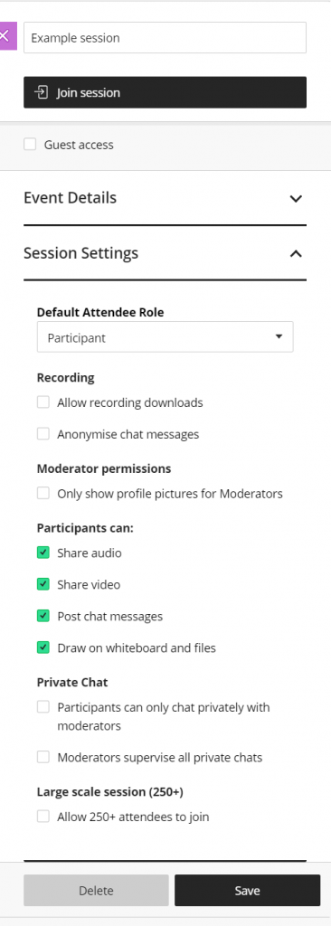

4. The scheduled session will appear in the list.
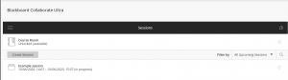

5. To enter either the Course Room or the Scheduled Session, click the room with the mouse and select Join Session.
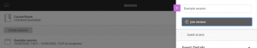

6. Share your microphone (and video if desired) by clicking the Share audio and Share video buttons.

7. Access all of the available teaching tools by clicking on the Open Collaborate panel button.

