Setting global and local controls for collaborate sessions
Note: When setting up a room it is important to think about the session controls because:
- Video and lots of chat may cause bandwidth issues for those with poor connectivity.
- It is often useful to switch off participant video feeds and chat – unless this is to be used in teaching.
- For the academic/facilitators – a good approach is to just put the video feed on at the start to welcome attendees and start the session – explain why it is then switched off. Switch on at the end of the session to reiterate learning outcomes (plenary).
- Use of the chat panel – if asking questions consider how to frame the question – can the answer be stated in limited number of words. Students trying to type essay answers to open ended questions is problematic.
- When asking questions, has a slide with a possible answer been included – it should.
- If large numbers of students and all type at the same time in chat it can cause connection issues and the facilitator will not have time to read all and answer in a time limited session. Alternatives – consider linking to forum for asynchronous follow up discussion. Leave reflective time – pause for students to think.
- Access can vary with device therefore not all students may have access to the chat panel.
- Ensure that the opening slide on the presentation explains to students (using images and text) how they can test their audio connection.

Learning outcomes
By the end of this guide you should know;
how to set the session controls ahead of starting a session.

How to
1. With the Blackboard Collaborate Ultra page on screen, click the Session options button.
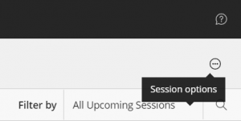

2. Click on Edit settings.
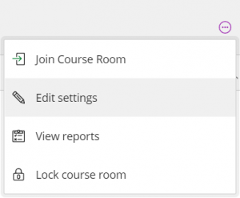

3. The session settings panel will appear from the right hand side. Change the settings as desired for the up-coming session.
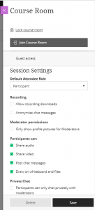

4. Once in the session, the settings can be accessed by opening the Collaborate panel and clicking My Settings.
