Accessing Collaborate statistics

Learning outcomes
By the end of this guide you should know;
- how to access the Blackboard Collaborate ultra statistics for a session.

How to
1. Having logged into Blackboard, click on Session settings then View reports.
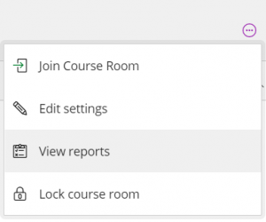

2. From the list, click on View report for the desired session.
