Assigning Blackboard Collaborate sessions to individual Groups

Learning outcomes
By the end of this guide you should know;
- How to set up a Blackboard Collaborate area for each group in the module
- How to access a Group Collaborate area

It is possible to setup a series of student Groups in Blackboard and give each group access to a Blackboard Collaborate session area that only members of the group can access; whilst allowing all instructors on the module to access and present in any Group area. This can be a useful approach to structuring and managing synchronous online group teaching activities.
Setting this up requires groups to be setup in Blackboard and each group assigned access to the Collaborate Tool.
A. If you have not set up any Groups in your module - follow this guide about setting up Groups in Blackboard. [opens website]
NOTE: when setting up the groups you MUST check the Blackboard Collaborate Ultra option in the Tool Availability panel
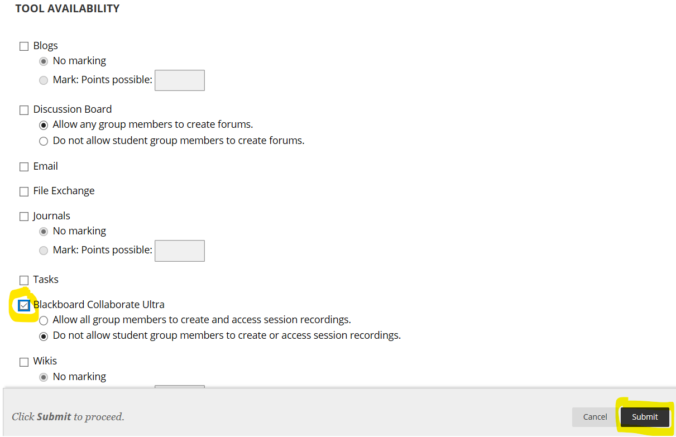
B. If you have already setup groups, but did not give the groups access to the Collaborate tool using the Tool Availability panel –
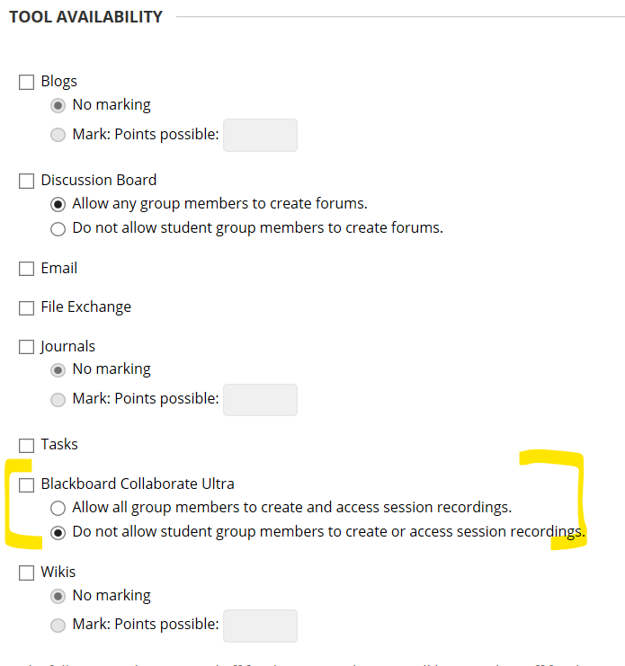
You will need to assign the Collaborate tool to each group individually as follows:
1. Navigate to the Groups list
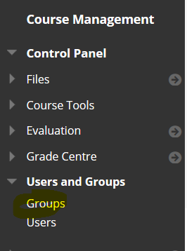
2. Click the Group option button
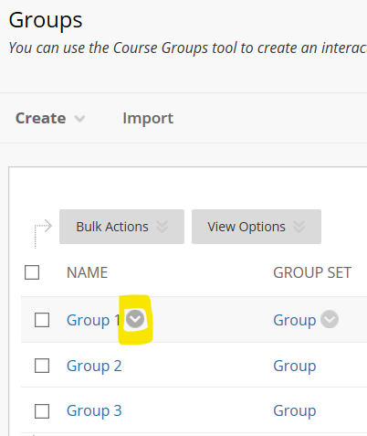
and select Edit Group
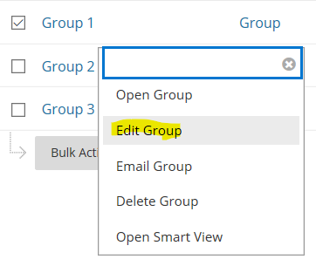
Scroll down the page to the Tool Availability panel and check the Blackboard Collaborate Ultra option – then click submit.
Repeat these steps for each group.

Joining a Group Collaborate session as an instructor
DO NOT use Microsoft Edge web browser to launch a Collaborate session – it does not work. Use Chrome or Firefox
1. Go into the module where you setup the groups and from Control panel > Users and Groups select Groups
In the groups list click on the name of the group.
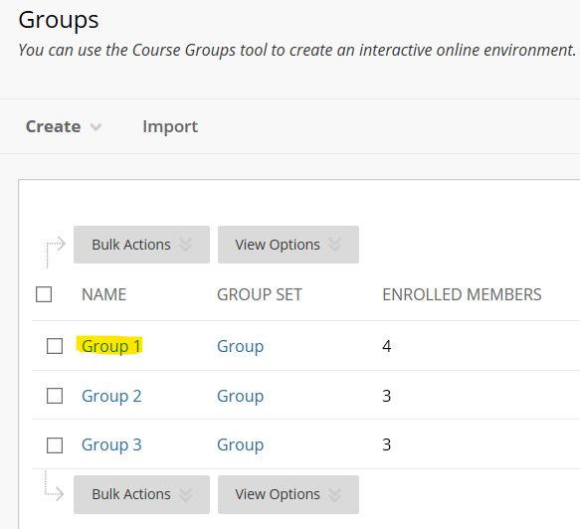
In the group tools panel click Collaborate
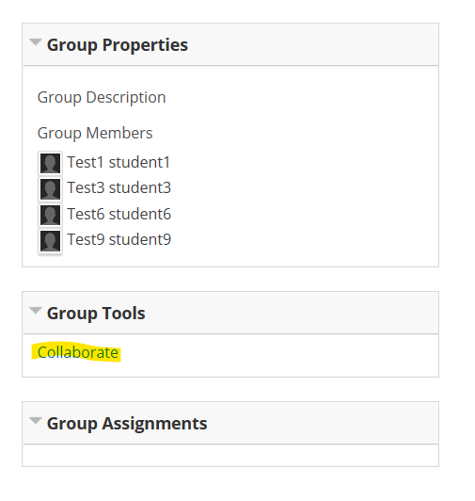
Click Join Room – the session will launch as normal, with you as the session Moderator.
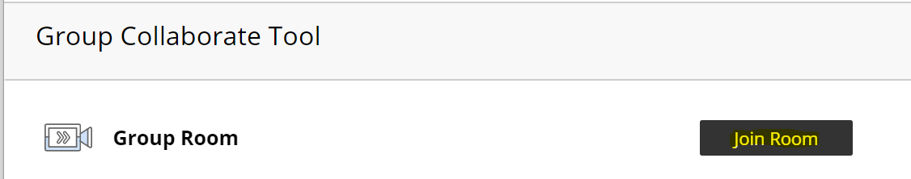
NOTE: Group rooms are always open; so it is not possible to create scheduled sessions as you can with the standard Collaborate setup.

Joining a group Collaborate session as a student
When a student logs in to the module they will see a group link in the main menu.
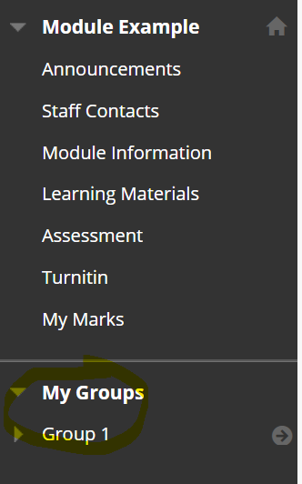
They click on the name of the group, then click Collaborate.
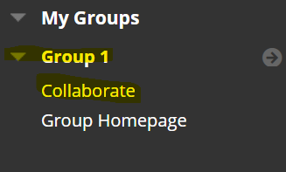
Then they click the Join Room button. The session will launch as normal with the student as a ‘presenter’.

