Editing DMU Replay recordings
DMU Replay recordings are edited in the web browser, there is no ‘editing software’ as such and the techniques below can be performed wherever a web connection exists.

This guide covers the following topics in the DMU Replay Editor.
- Opening the Editor
- Adding the automatically generated captions to a recording;
- Adding a quiz;
- Working with the Focus tool;
- Making cuts and edits;
- Manipulating Events;
- Manipulating Streams;
- Adding new content (slides or multimedia); and
- Merging recordings.

Note: The DMU Replay editor is of a ‘non-destructive’ nature. This means that when edits are made the sections that are removed are merely hidden and they are never fully deleted. Therefore, edits can always be reversed and nothing is ever lost when using this system.

What you will need
- An Internet connected PC; and
- Speakers or a headset.

Opening the Editor

- Once logged on to the computer, open your preferred web browser, navigate to replay.dmu.ac.uk and log in.

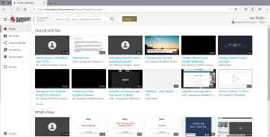

- Using the instructions detailed in the Managing your recordings guide, locate the recording that you wish to edit and click the Edit icon.

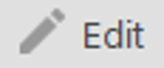

- The Editor will now open in the web browser.
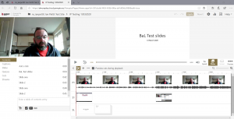

Adding automatic captions

Note: You may see captions that have already been added to your recording. If so, do not Import the Automatic Captions. The captions you see will have been generated by transcribers as a result of one or more of the students on the module having been signed off as requiring access to professionally transcribed, paid for captions. If you import the automatic captions it will over-write the paid for captions and they will be lost.

- Having clicked the Edit icon the Editor will be displayed.
- To add the automatic captions to the recording click the Captions link followed by Import automatic captions.

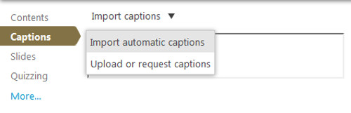

- The captions will now be displayed in the left hand side.
- To correct any mistakes, select with the mouse and overtype with the correct text.
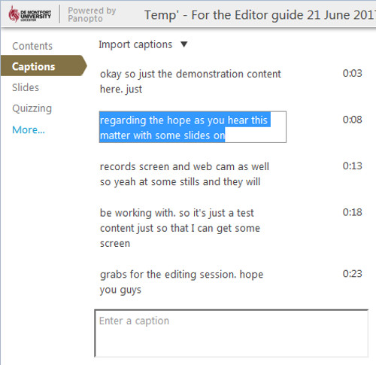

Add a quiz

- To add a quiz question, click the Quizzing link followed by Add a Quiz.

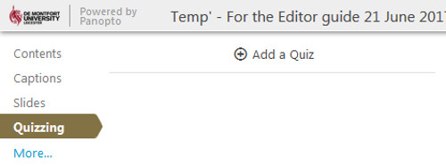

- The quiz builder screen will be displayed, using the fields presented type a question and the potential answers.
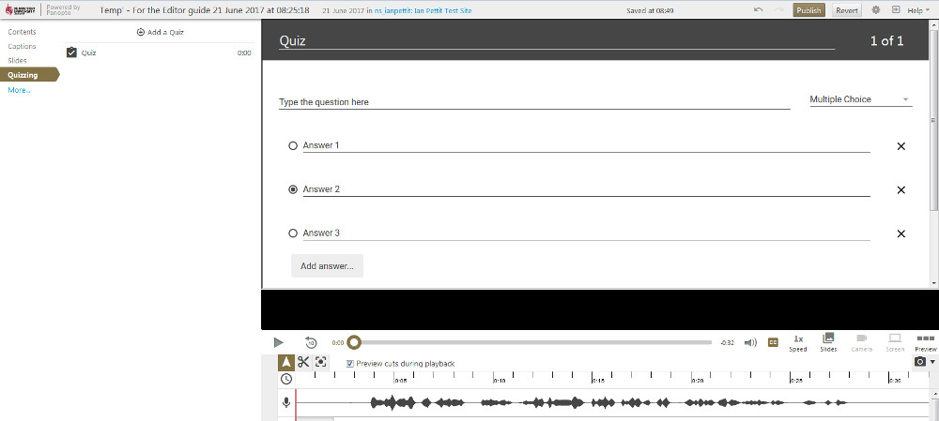

Note: In this example I have opted for a Multiple Choice question and using the radio button I have indicated that Answer 2 is the correct option.

- Once the question(s) are entered, scroll down and click the Done button.

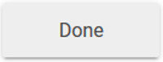

- The quiz options screen will now be displayed.

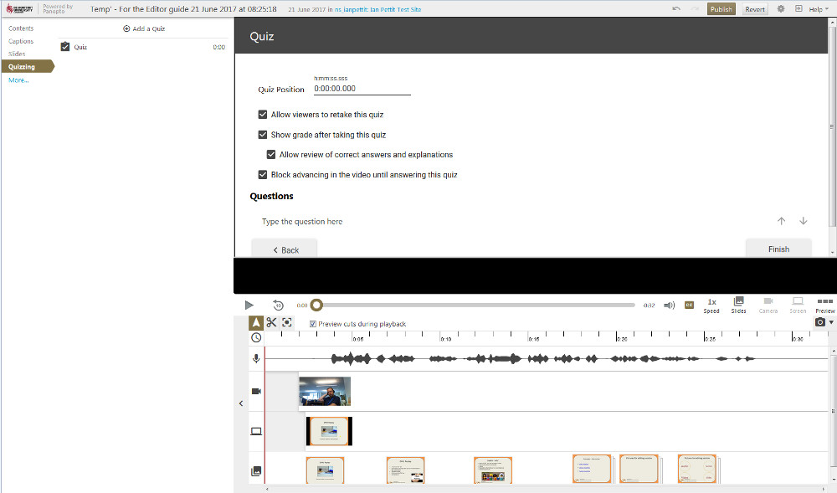

- Using the fields, firstly type in the Quiz Position the time at which you want the quiz to appear in the recording. For example; if the quiz is to be taken 30 seconds into the video type 0:00:30:000.
- Using the tick boxes tell DMU Replay whether you require students to be able re-take the quiz, see their score, see the correct answers in the event they get the question wrong and whether you need students to have answered the quiz before advancing further in the video.

Note: For this example I have set DMU Replay to display the quiz 30 seconds in, students will only be able to take the quiz once and they will see their score with the option to review the correct answer should they get the question wrong. DMU Replay will allow students to watch the entire video even if they opt not take the quiz.

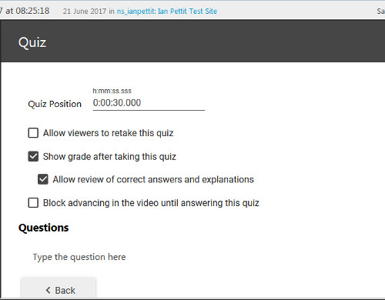

- Click the Finish button to add the quiz.

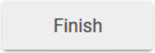

- The quiz will be inserted at the desired point and the recording will begin to play in the Editor view.

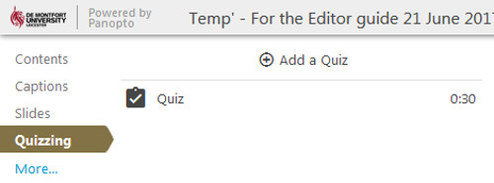

Note: Multiple quizzes can be added, to add another quiz click the Add a Quiz button and repeat.

Using the Focus tool
Note: In the example, multiple Secondary Streams were recorded. This prompts the DMU Replay Editor to make the Focus tool available for use. The Focus enables us to tell DMU Replay which of the visual streams should be displayed in order to ensure that students watch the correct visual element at the correct time. For example; I may talk to the webcam for 10 seconds and introduce the video but after this introduction I need the students to watch the screen content. Using the Focus tool we can force this scenario.

- Click on the Focus icon.

- Using the mouse, click and drag the stream that you need to be visible.

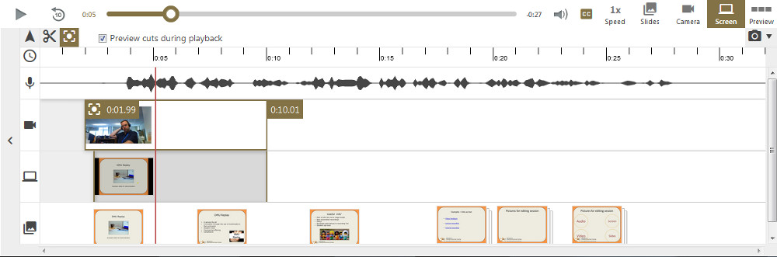

Note: Here I have dragged for 10 seconds on the top stream (the webcam). Notice that the opposing portion of the middle stream (the screen) is now greyed out. This indicates that when the students watch this video, only the webcam stream will be available to view for the first 10 seconds and the view will then switch to the screen stream.

Notice that the bottom stream (the slides) is unaffected. this is because the Focus tool cannot be applied to the slides but having applied it to the other stream(s) DMU Replay will display these as a priority over the slides.

- Continue to use the Focus tool as desired – in the example below I have now hidden the webcam to ensure only the screen displays after 10 seconds until 20 seconds.
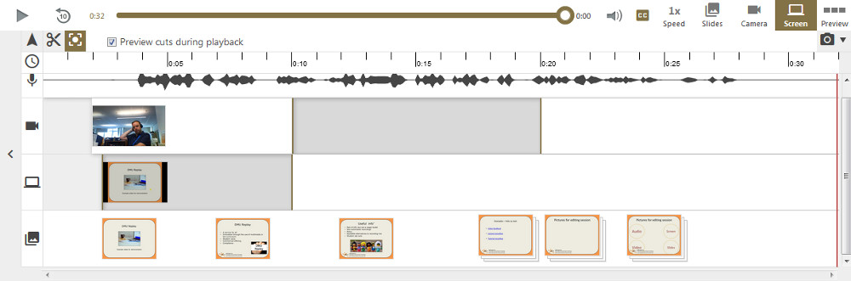

Making cuts/edits

- To make a rudimentary edit to a recording click on the Scissors icon.

- Having clicked this, a pair of handles will appear at the beginning and end of the recording.

Note: Clicking the scissors also adds handles around any Focus edits we may have made – using this technique we can fine tune our Focus edits.

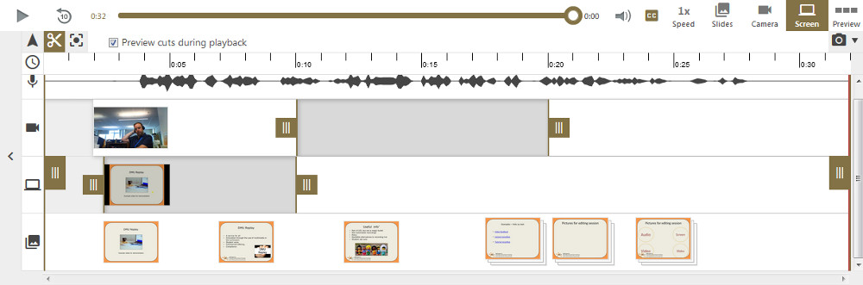

- Using the full height handles, top and tail the recording to hide any unwanted material that may have been captured at the beginning and end of the recording.

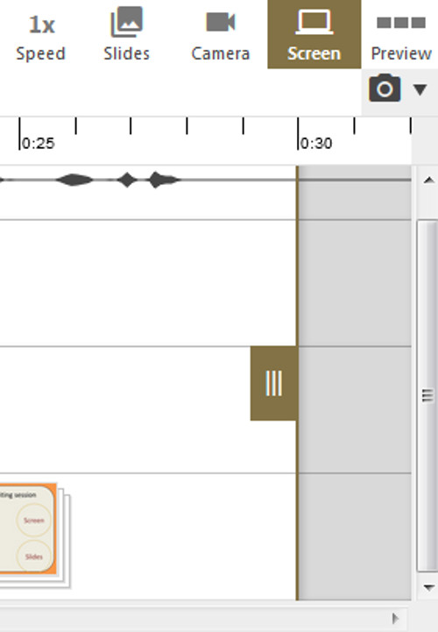

- To remove a section from the middle of the recording, click and drag the mouse over the audio (top) stream and a new pair of handles will appear. Fine tune the edit as desired.

Note: Repeat this step to add multiple edits if required.
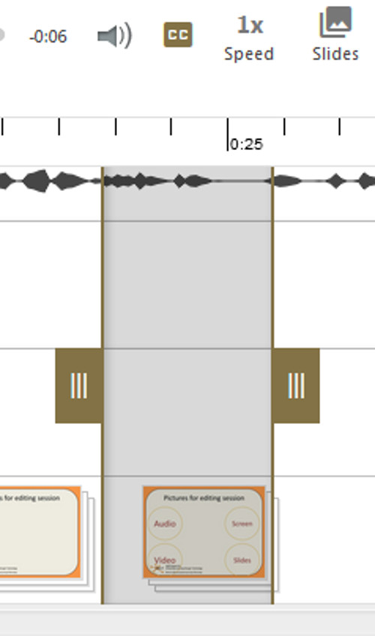

- Once all edits have been performed click the Apply button.

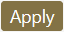

Note: You will see a message asking if you wish to quit the Editor. Answering Yes will play the recording with the edits in place once it has re-processed. Answering No will save your edits but you will remain in the Editor view.

Manipulating Events

- The Events appear as part of the Table of Contents. With the recording paused at the appropriate time, type a new Event where DMU Replay invites you to ‘Enter a table of contents entry’. Pressing Return on the keyboard will add the new Event at the current (paused) point on the timeline.

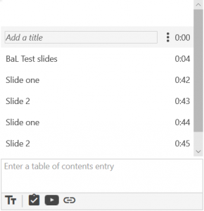

- To delete an event, move the mouse over the Settings button for the Event to be deleted and click Delete.

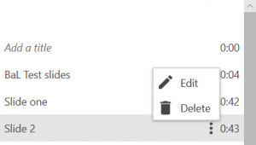

- To edit an Event, select Edit.
Note: When editing the Event we can change the following items:

- Time – this is the time at which the Event appears in the recording;
- Title – this is the wording that appears in the list of contents when the recording is being viewed;
- Searchable Metadata – this represents the key words that are associated with this Event and which will be picked up when viewers search the recording when watching it back; and
- Url – we can add a website address here and when the recording is being watched, the website will be displayed in the DMU Replay viewer at the time of the Event.

We can also delete the Event from this screen, once the desired changes have been made, click the OK button.
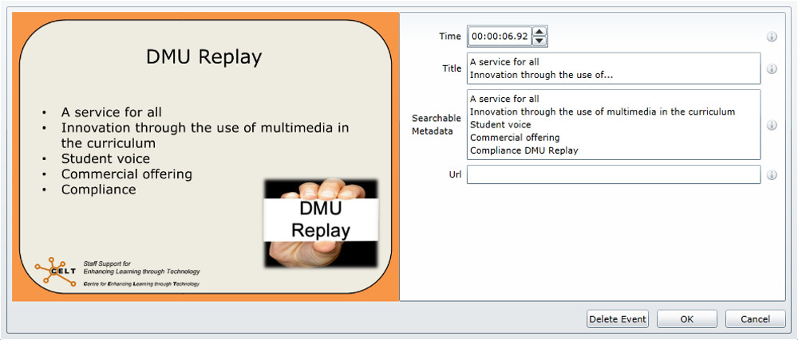

Manipulating Streams

Note: There will always be a ‘DV’ stream – in this example, this is the Audio stream. If when recording, a device or camera was recorded using the Primary Source this visual stream will be permanently attached to the audio and become part of the DV stream in the Editor. By recording all streams as Secondary Capture Devices we are able to edit and/or remove visual streams without interrupting the audio.

- Click the Streams link to display a list of the streams that were recorded.

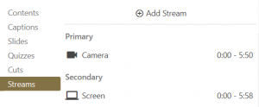

- To Edit a stream click the Stream’s Edit buttons and select Edit.

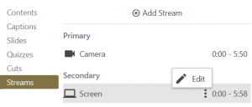

- The Edit Stream properties window will be displayed.

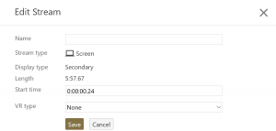
- If the video Stream was filmed using a 360 or 180 degree camera, use the VR type field to tell DMU Replay this. The system will then present the video in the appropriate format when viewed.
Note: It is not recommended that the timings are altered here as this will remove the synchronisation between streams.

- To delete a stream click the Settings button. This will open the main settings for the recording.

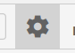

- Click on Streams to the left and using the ‘x’, delete the undesired Stream.

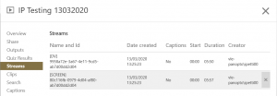

Adding and replacing slides

- Click on Slides and you will see a representation of any slides that were included in the original recording.

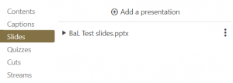

- Click on Add a presentation and browse to locate the slides to be imported.

Note: The new slides will be imported and processed – this can take a few minutes.

- Once the new slides are imported they will appear underneath the existing slides in the Slides menu.

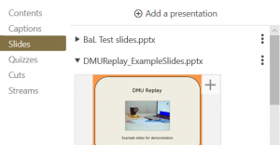

- Use the ‘+’ button that appears on each of the new slides to add to the Timeline as desired.

Merging sessions

- Click the Add content (+) button and select Add a clip.

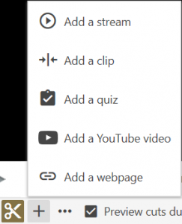

- Select the desired existing DMU Replay session to be merged and click Insert.
- The selected session will now be embedded on the Timeline.

Saving the work

Once all of the edits have been made, click the Apply button. The recording will re-encode and be temporarily unavailable for viewing whilst the edits are applied. However, even after saving, edits can be reversed due to the non-destructive nature of the Editor.

As the DMU Replay system will re-encode each time the Apply button is clicked it is recommended that edits are performed in batches rather than saving each individual change as whilst the re-encoding is taking place further edits cannot be made.

Use cases

Note: Using the DMU Replay Editor we can create a number of effects that can help to make our recordings more engaging and ensure that students are watching the correct stream at the correct time.
We can also upload traditional video files into DMU Replay in order to take advantage of the captioning service and augment videos by adding Events, quizzes etc. in the Editor.

Example 1
Note: This example pre-dates a major DMU Replay update – this effect can still be created using the Focus tools as described above.

This recording was created by recording the Screen and the Document Camera as Secondary Capture Devices. The lecturer displays screen content and then works with mathematical equations whilst using the document camera to show the students his workings. In capturing both of these streams and using the Editor, it was possible to create a switching effect by snipping the Screen and Object (document camera) streams independently.
To demonstrate – here’s a picture of the timeline for this recording, using the Scissors icon, multiple edits were added to each stream but as the audio (DV) stream remained independent the audio plays seamlessly as the visual switches.

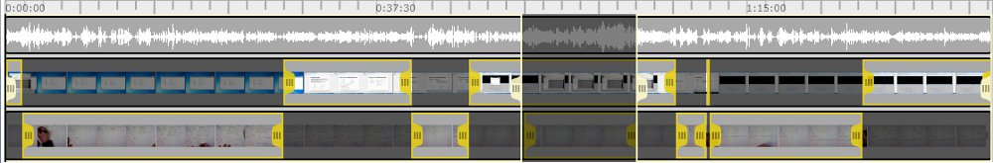

Example 2
In this example, a video that was recorded and produced using a traditional camera and Adobe Premiere Pro has been uploaded to DMU Replay. Events have been added to enable viewers to navigate and search the video as well as being able to use the comment and bookmark tools. There is also an Event with a URL at the end that displays a webpage as the video finishes.
If you wish to explore different ways in which DMU Replay may be able to help with innovation please contact your local ELT Project Officer.

