Create and deploy and online test in Blackboard
The Create Test feature allows you to add a test or quiz to any Content Area of your course site. Online tests and quizzes can be used very effectively as formative learning tools. You can use the Create Test feature to either create a new test, or to add an existing test to a Content Area. Tests created in Blackboard are automatically entered into the Grade Center.
Note: It is more efficient to create your questions in the Test Manager first, and then add the test in the Content Area (Course Information, Course Documents, and Assignments).
If you are thinking about conducting a 'summative' test online using Blackboard you must read the DMU eAssessment Guidelines before you proceed.
There are two ways to create a test:
Option 1:
- Click on a desired Content Menu where you would like to put a test, for example: Assignments, Syllabus, Course Documents… etc.
- In the Content Area, hover over the Assessments button and click on Test.

Option 2:
- Under the Control Panel, select Course Tools and then click on Tests, Surveys, and Pools. (This option works best when you have multiple tests to create)
Note: Option 2 (test Manager) is more efficient as it allows you to create a test/survey and then deploy the test/survey wherever and whenever you like. Option 1 is less efficient, because you have to create and then open a test/survey at the same time.

Managing Tests, Surveys, and Pools:
​The Test Manager feature creates and organises surveys and exams. Exam results can be graded and recorded in the online Grade Center. It is more efficient to create your questions in the Test Manager first and then add the test in the Content Area (Course Information, Course Documents, and Assignments).
- Locate the Test Manager by going to the Control Panel (located at bottom left of the page) selecting Course Tools, and then selecting Tests, Surveys, and Pools​
- Select whichever type of assessment you would like to manage. For this tutorial guide we will choose Tests.​
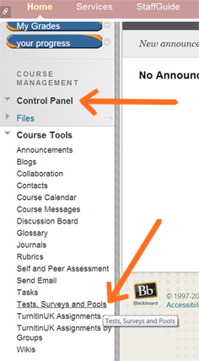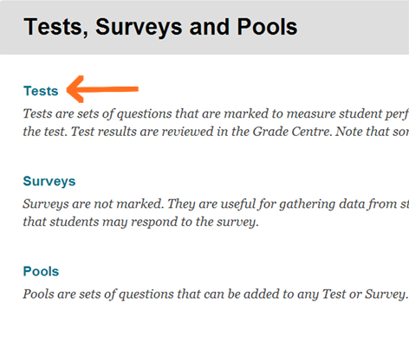
3. You can choose to Build Test or Import Test. By following the steps within this tutorial your test will be added to the list in the Test Manager area.
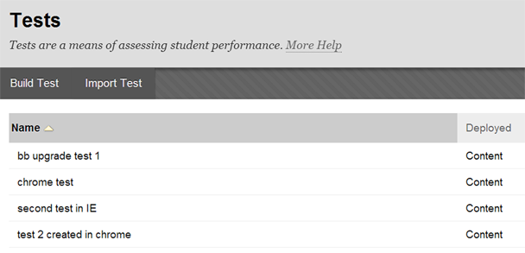
The Deployed column shows if the test has been deployed, and if so, where it is deployed.
4. The Test Manager area within Blackboard is a storage space for tests. It allows you to create, edit, copy, and run an Item Analysis on any of the tests in the list.
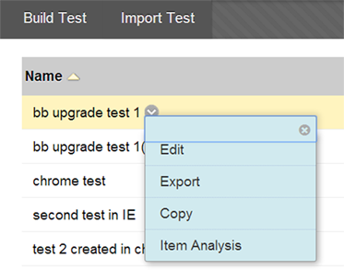
To perform these tasks click on the down arrow next to the test name, and choose the command required. (Item Analysis checks the effectiveness of a tests, see the "item Analysis" tutorial).
5. To make one or more of the tests available to students you must go into your chosen Content Area, such as Assignments, Course Documents, etc… hover over Assessments and select Test.
Note: To delete tests after they have been deployed please look at the "Edit a test" section below.

Create a Test

Option 1:
- Click on desired Content Menu (Syllabus, Course Documents, Assignments, etc…)
- In the Content Area on the right, hover over the Assessments button and click on Test.
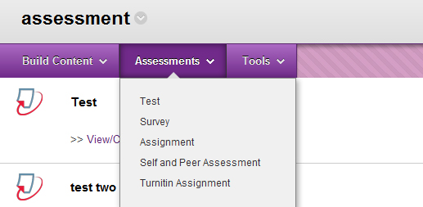
- Click on the Create Button and then select Submit
. 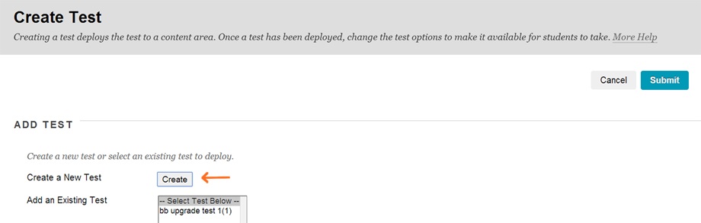
- Type the name of the test in the Name field; add a description in the Description field; and add the instructions in the Instructions field. Click Submit.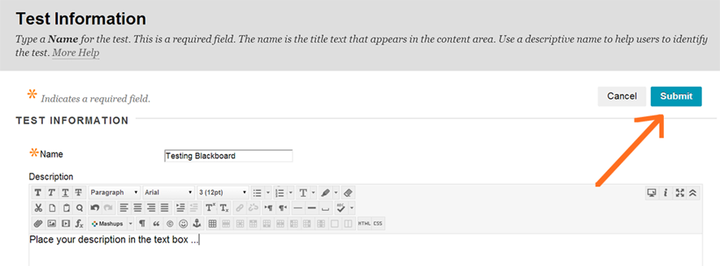
- You will then see the Test Canvas page. To add questions hover over Create Question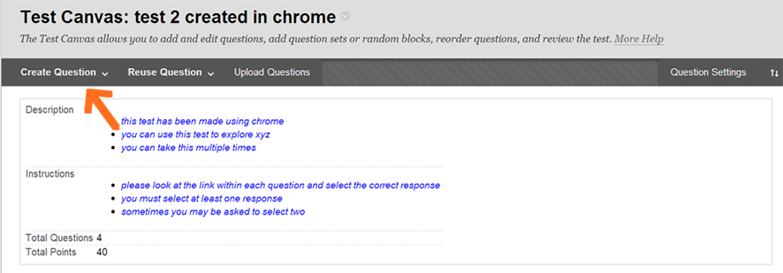
- To add further questions either repeat above or select the + icon. This icon allows you to add questions above or below other questions. For instructions on the specific question types (see "Question Types" below).
- Once all Questions, Question Settings and Grading Points are to your requirement, scroll down to the bottom of the test canvas page and select OK button.
- Your next step is to deploy the test and choose the deployment options. (see deployment tutorial)

Option 2:
- Go to Control Panel > Course Tools > Tests, Surveys and Pools > Tests > Build Test
Option 2 method: For a summary on how to build a test, click the 'Getting Started with Building a Test' image below:
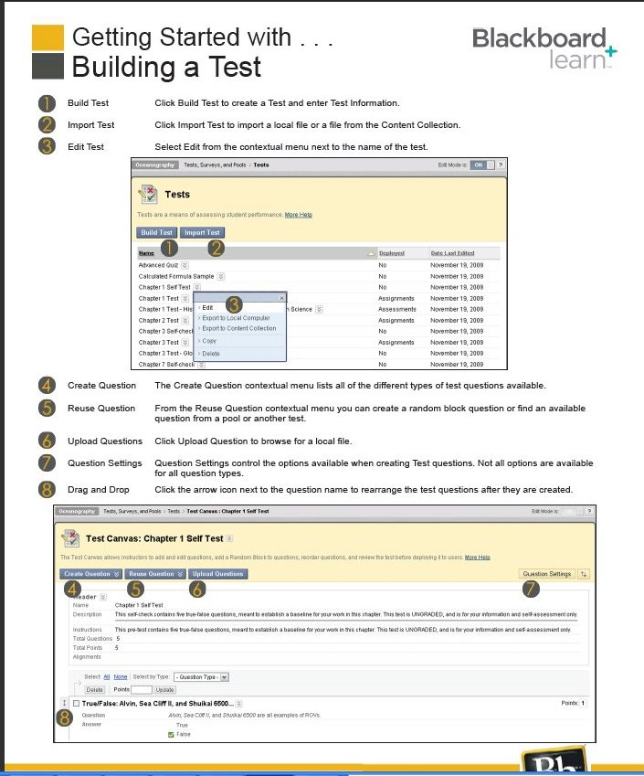
Adding point values and Question settings:
- Select the Question Setting button from the Test Canvas page:
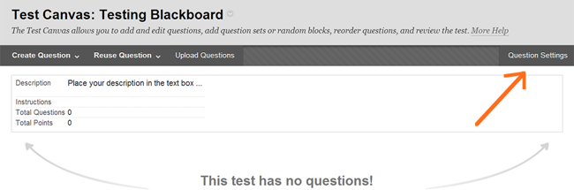
2. The test question settings panel provides you with choices on how you wish your test to work. Choose whether you wish the user to view feedback after the test; whether you wish to add images; and the Scoring and points value (NOTE: points can also be altered in the test canvas page view):
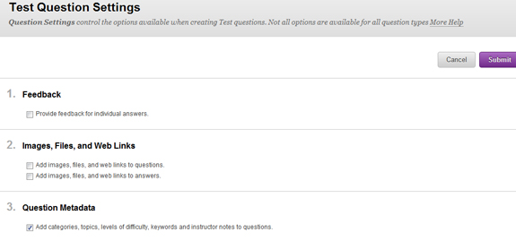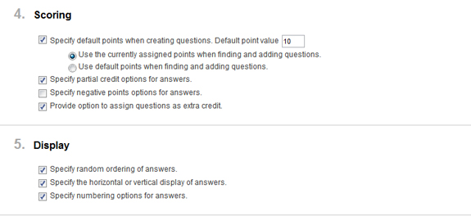
3. when you are happy with your choices select the Submit button
- Edit the point value from the test canvas page: select the point value box on the right, type in an alternative value, select submit:
Question Types
Adding your questions:
There are a total of 17 question types. Please select the individual links for more details and definitions on each question type: Calculated Formula and Calculated Numeric, Either/Or, File Response, Fill in the Blank, Fill in multiple Blanks, Hot Spot, Essay, Jumbled Sentence, Matching, Multiple Choice, Multiple Answer, Opinion, Ordering, Quiz bowl, Short Answer, and True or False.

- To add a question in the test canvas page hover over Create Question to see the dropdown menu; or select the + icon.
.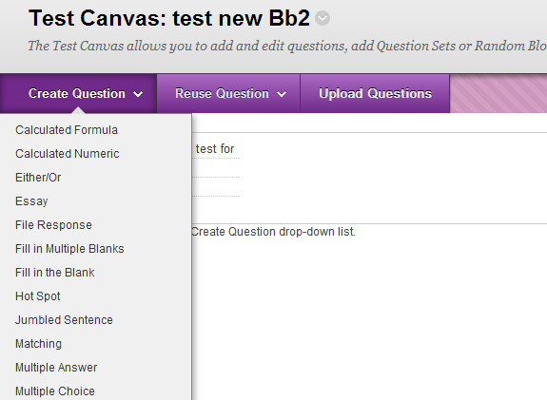

Calculated Formula and Calculated Numeric
- These question types allow you to add a mathematical, and or, algebra formula of numbers and or figures
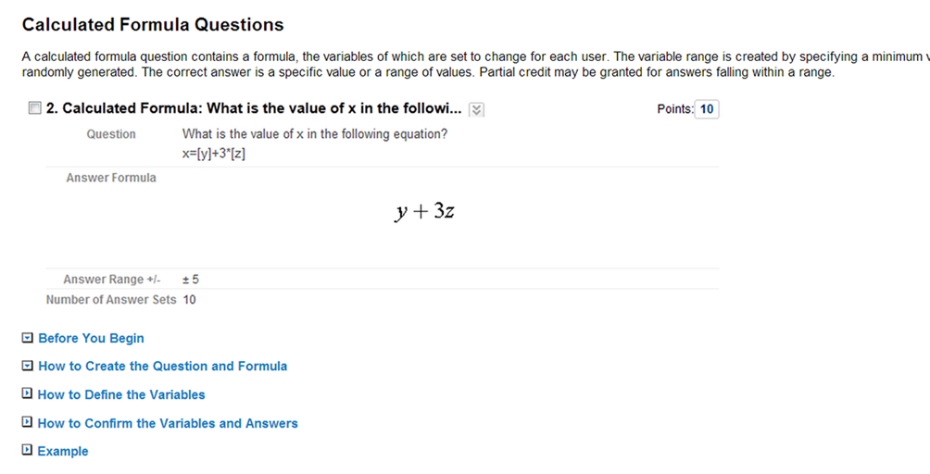​

Either/ or
- Selecting the either/or type question provides students with two choices
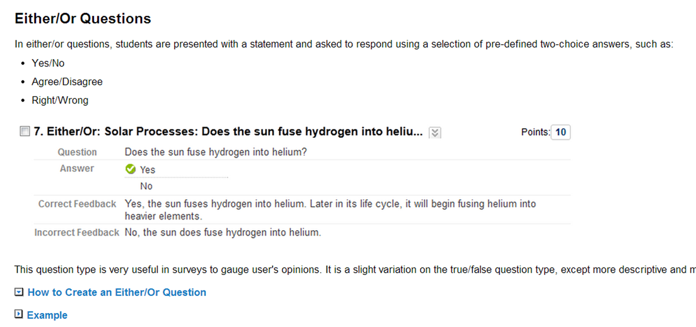

File Response
- A file response question requires the student to upload an essay type file in response to a set question
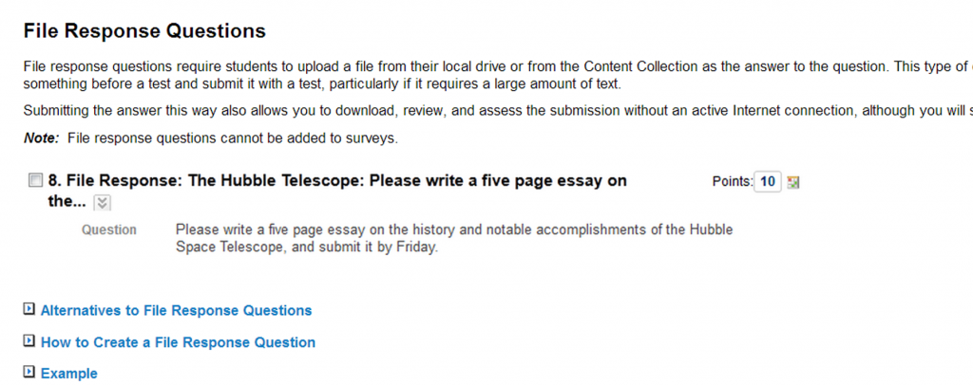

Fill in the Blank, and Fill in the multiple Blanks
- Type the question into the Question Text box
- Choose the number of answers from the dropdown box (max 100)
- Type your answers into the Answer boxes and select one of the dropdown options whether the words have to be "Exact Match", "Contain", or "Pattern Match".
- Decide and select whether the answer is case sensitive; useful for Acronyms and Algorithms
- To complete the question process, scroll down to the bottom and select the Submit button.
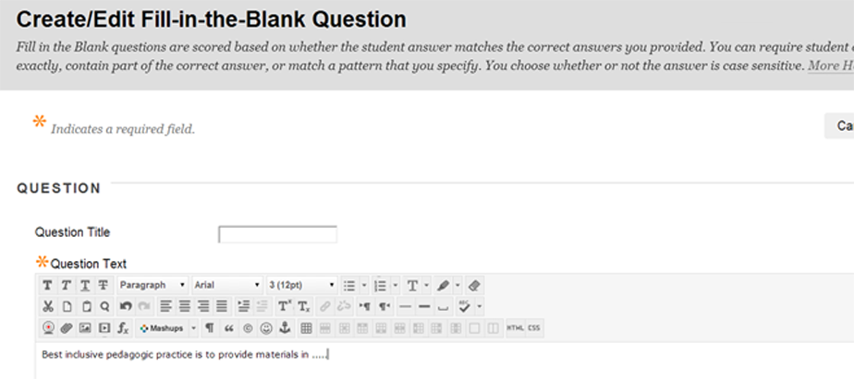

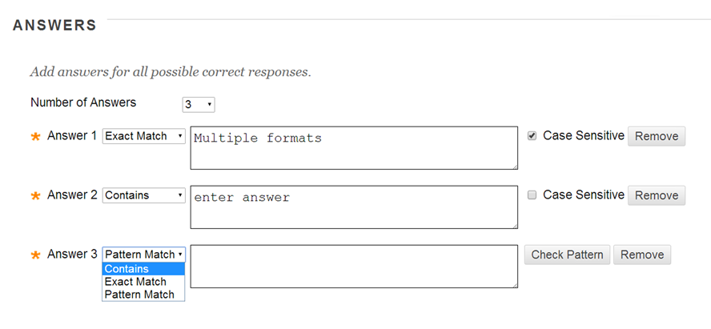

Hot Spot
- The hot spot question allows you to set an area on a picture/diagram/map that you wish your students to identify
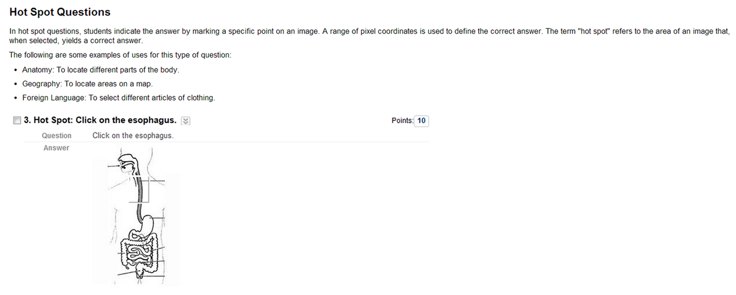

Essay
- Type the question into the Question Text box
- Enter an example, or add bullet-ed topic areas of the essay into the Answer field. (This can be typed or attach a file)
- Scroll down to the bottom and select the Submit button
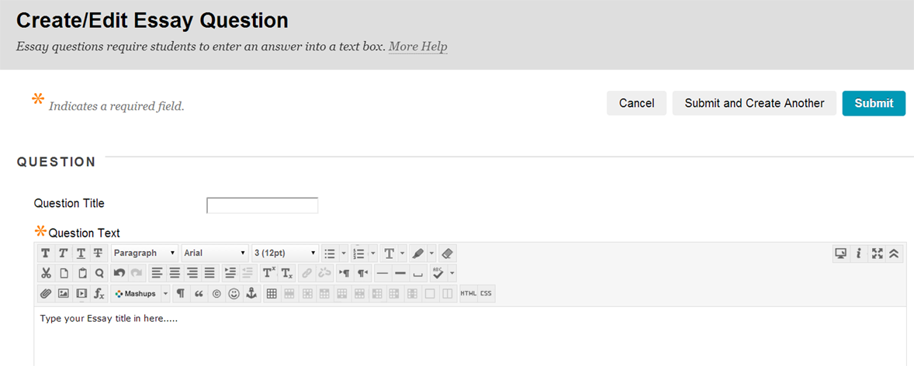

Jumbled Sentence
- This type of question requires the student to complete a sentence or phrase from a selection that appears in a dropdown menu
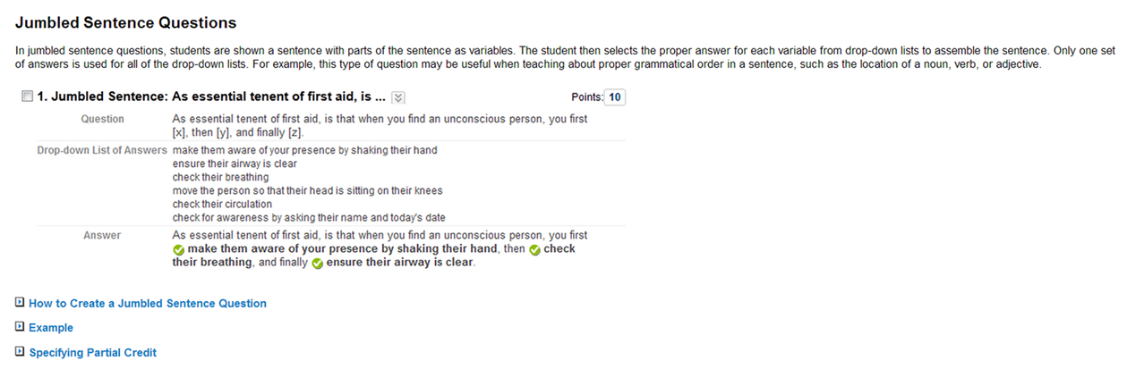

Matching
- Allows students to compare text answers from one column to another column
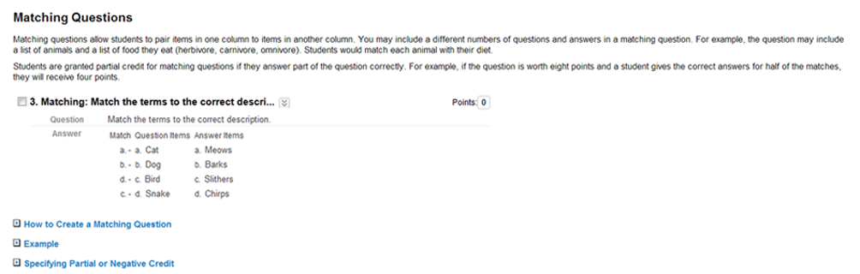

Multiple Choice
The multiple-choice question allows you to add a question, provide a choice of responses to that question (max 100), and the student has to select the correct response/answer.

- Add your question to the Question Text box
- Option settings - select your preference to the way the answers are displayed (i.e....... with a label or numeric label) and select the number of responses you wish to provide and whether you wish to give partial credit.
- Answer boxes - in each answer box type a response, making sure you select the radial button on the response/answer that is correct. To remove an answer box select the remove button
- Feedback - add feedback for correct and incorrect responses.
- Submit - the submit button is at the bottom of the page.
​ 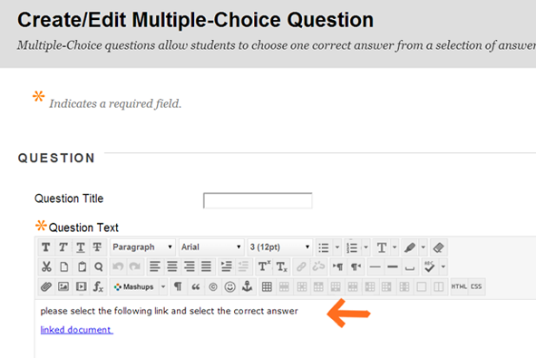 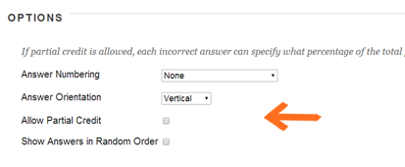
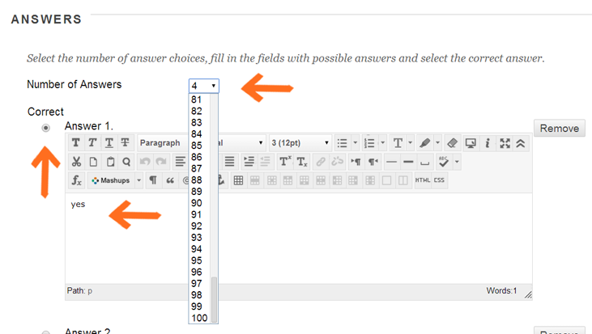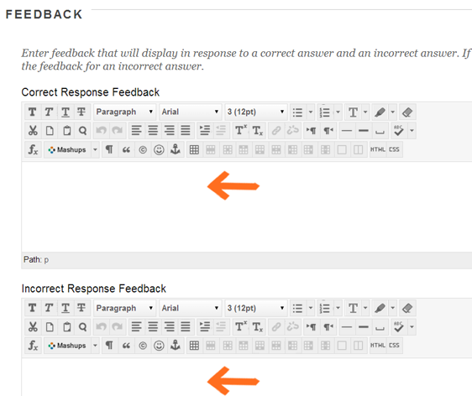

Multiple Answer
- This type of question allows the student to select more than one answer to a question.
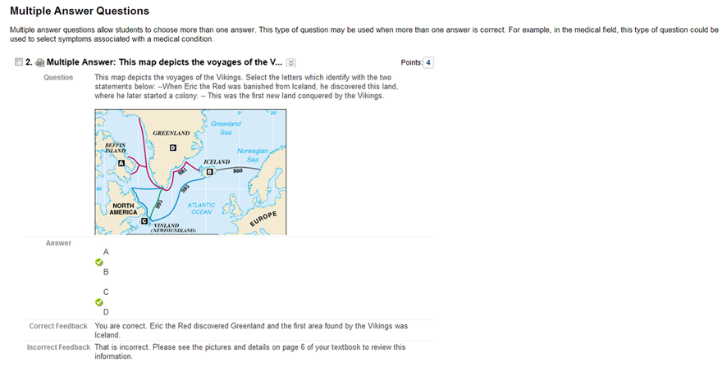

Opinion
- The opinion question type allows gather quantifiable data about a topic in your subject or a pedagogic practice
NOTE: research has suggested that when you add numerical sequence to the scale students become confused (i.e.... 1 strongly agree, 2 agree. 3 disagree) students see 1 as a low score and therefore would not chose this.
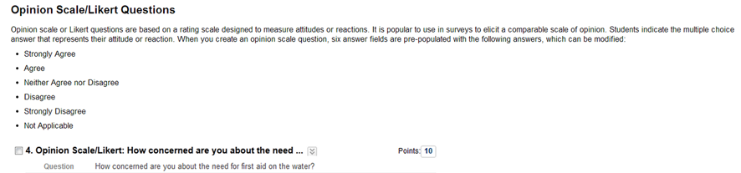

Ordering
- The Ordering question requires the students to move a list of variables into the correct order.
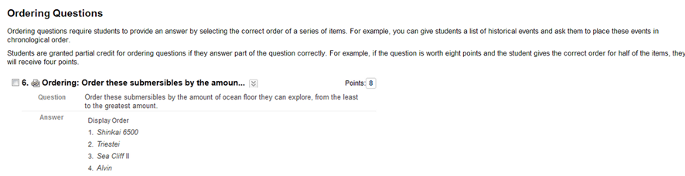

Quiz Bowl
- Further written information can be found by selecting this link
​ 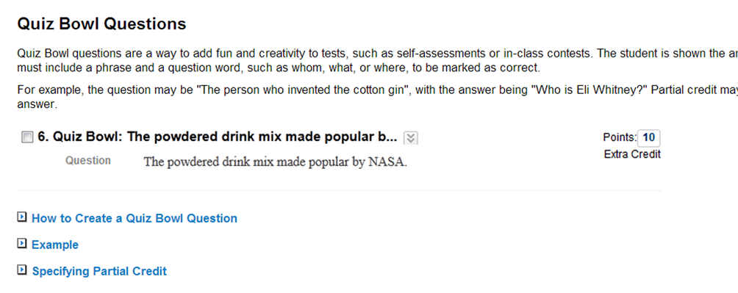

Short Answer
- This type of question is similar to an essay.

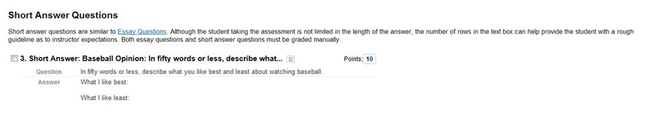

True or False
- The true or false question allows you to add a question or statement to the text box which your students have to decide whether the statement is true or false.
- To complete the process, add a question/statement to the text box.
​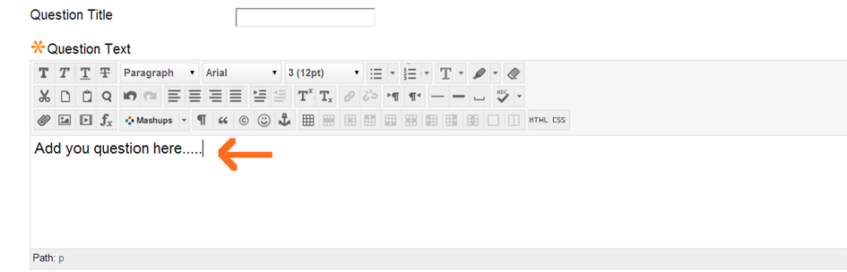
- in the options area select whether you wish to display the radial buttons vertically or horizontally
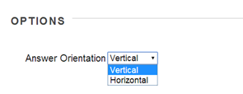
- select the correct radial button that aligns with your answer
- add any feedback, instructor information
- select submit.

Deploying a Test
Once a Test has been created it needs to be deployed for your students to access it. When you deploy a test you are provided with various Test Options. These options configure "how the test is displayed", "when it is displayed and to whom", and "how it is to be completed".
To complete the deployment and test options process please read the following.
1. To deploy a test you will need to choose the desired course menu (assessment, course tests etc) where you wish your students to access.
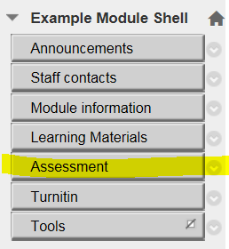
2. Hover over the Assessments label in the content area - from the drop-down menu select Test
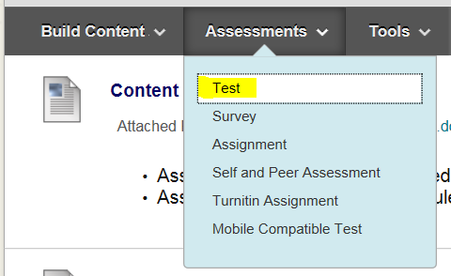
3. The Test menu will appear. Select which test you wish to deploy, and click submit
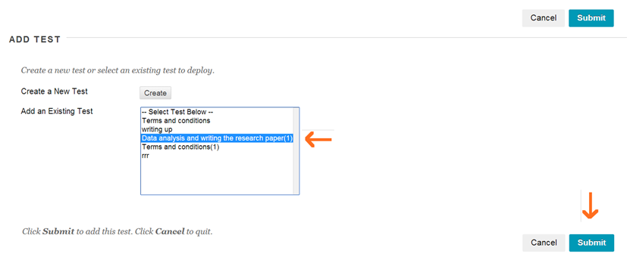
Test Options page:
Test Information:
- This allows you to add information about the test in the text box editor, change the colour of the title so that it differentiates from other content, and decide whether to display the test description and test instructions on the first page of the test and/or if the test should open in a new window.
- NOTE: critical evaluation will need to be made about adding the test information to the first page, as this information does appear within the test and it may be seen as information overload. Also, if you choose to open in a new window, please add comments in the text box that the test will open in a new window.
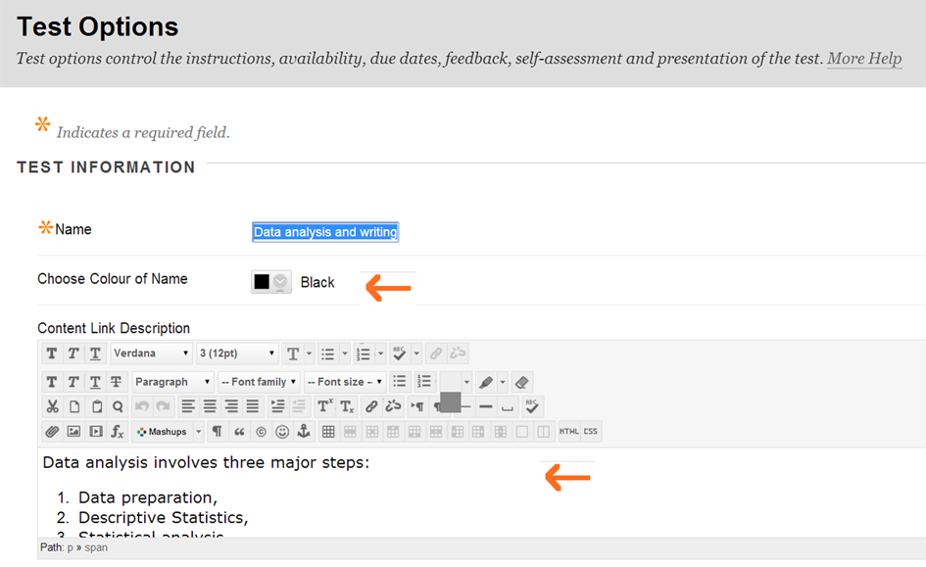
Test Availability:
- The options allow you to select when the test should be available, the number of attempts students are allowed and timing. A useful tool if you wish to create the test prior to the academic year. You can also: set a date for releasing the test, and closing the test: when the
- NOTE: You must select Make this Link Available or the test will NOT display for students.
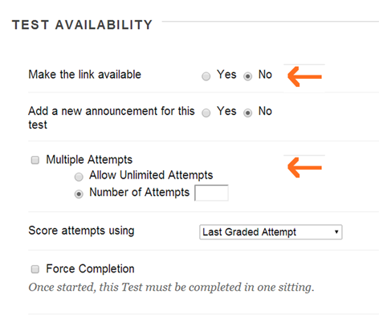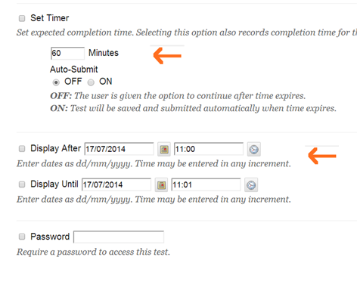
Test Exceptions:
- This feature allows you to select individual students or a group of students and alter the requirement for completing the test. This is a useful feature if you have students who are required extra time (Dyslexic) or different groups in the cohort are completing the tests at different times.
- To apply exceptions: select the add user group button
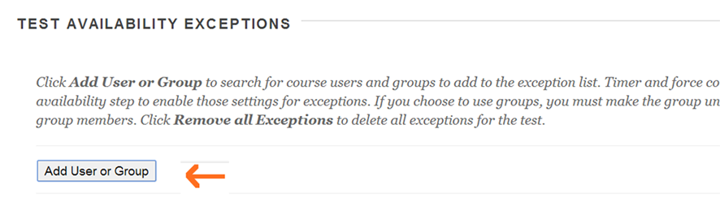
- Place a tick in the students or group you wish to provide an exception to, and select submit
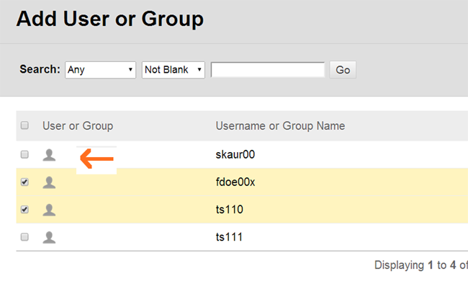
- You are able to select different commands from the drop-down menu and alternative dates according to each student’s requirement
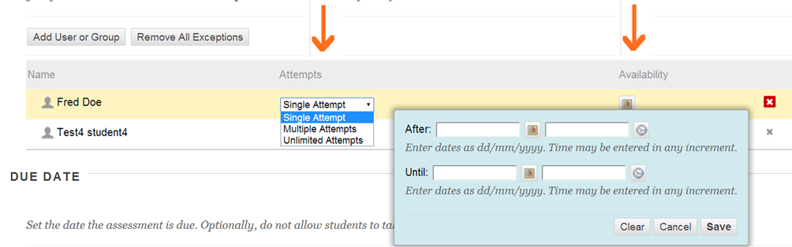
- When you are happy with the alterations select save. The alterations you make here to individual students will override the main configuration settings you have set in the test options.

Test Due Date:
- This option allows you to select a specific date the test is visible. plus you have the option to block the test for completion after the due date.​
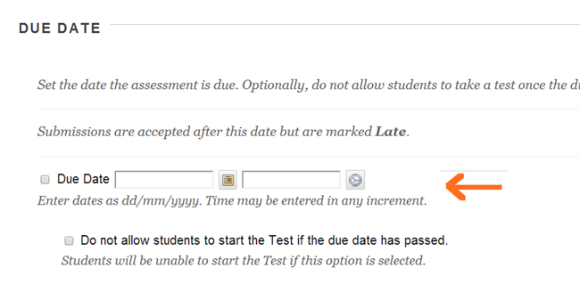
Test Self-Assessment:
- Allows you to select whether the grade is entered into the grade centre.
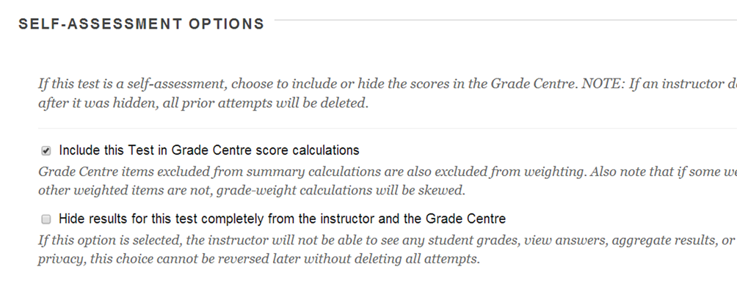
- Test feedback and Results to Students:
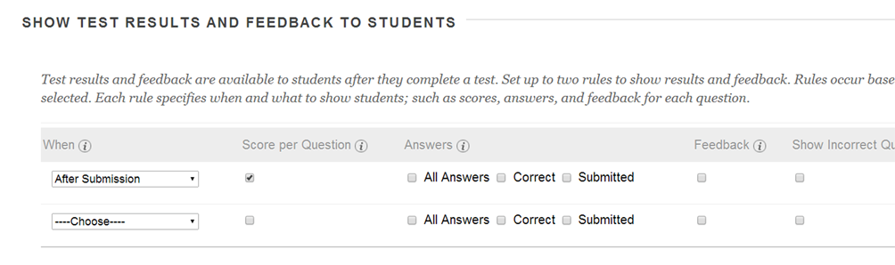
Test Presentation:
- How it looks is the final option where you can decide how the student engages with each question.
- When you are happy with all of the test options select submit.
​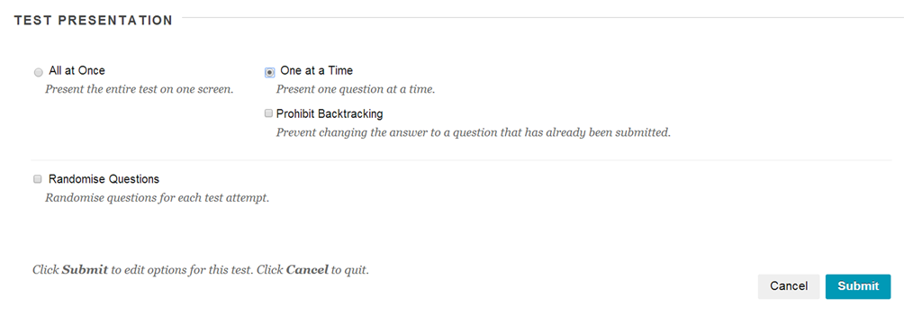
Edit a Test
- To edit a test once it has been deployed, click on the down arrow next to the test name.
- Select Edit the Test to edit the test questions and Edit the Test Options to change test options.
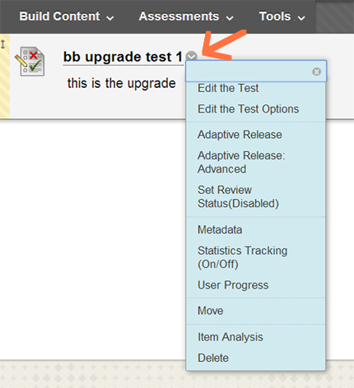
Please note: that once students have begun taking a test you will only be able to make minor textual changes through Edit the Test. Edit the Test Options are always available regardless of the status of a test.
From this drop-down menu you can also: Delete a test, Edit test options, Apply Adaptive Release rules, Move the test to a different location, and look at the Item Analysis of the test.
Exporting and Importing a Test/Uploading Questions
Exporting
- Navigate to the module from which you want to Export the test. and from the Course Tools menu select Tests, Surveys and Pools
2. Click Tests
3. From the list, click the button next to the test that you want to export and click Export
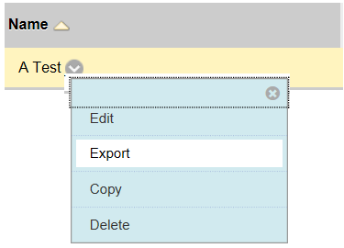
4. Save the file
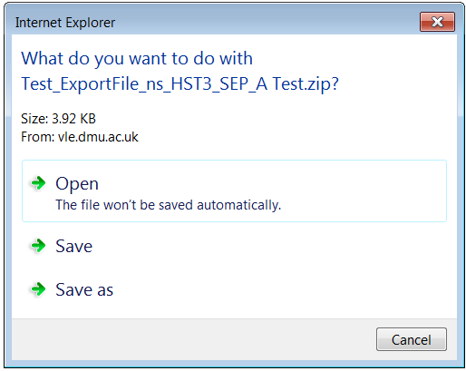
5. You can ignore and close the message that appears at the bottom of the screen
Importing a test
If there is an exported test you would like to reuse click on Control Panel > Tests, Surveys and Pools > Tests > Import Test. Generally we do not advise using this method of adding tests to Blackboard since it requires the file to be in a very specific format in order for it to upload correctly and usually creating a new test within Blackboard is easier and more efficient. See this video on using MS Excel for uploading test questions.
In addition to creating or reusing questions you can also upload them. Uploading questions is not recommended due to the difficulty of creating files in the correct format in order for them to upload correctly to Blackboard.

Creating a Question Pool or Assessment
- Select the pool or test to search from in the Select the Pools and Tests box.
- Select the questions that you want to search for by checking the boxes in the Question types area
Scroll down and click the Search button.
- Select which question(s) you want to use by checking the boxes.
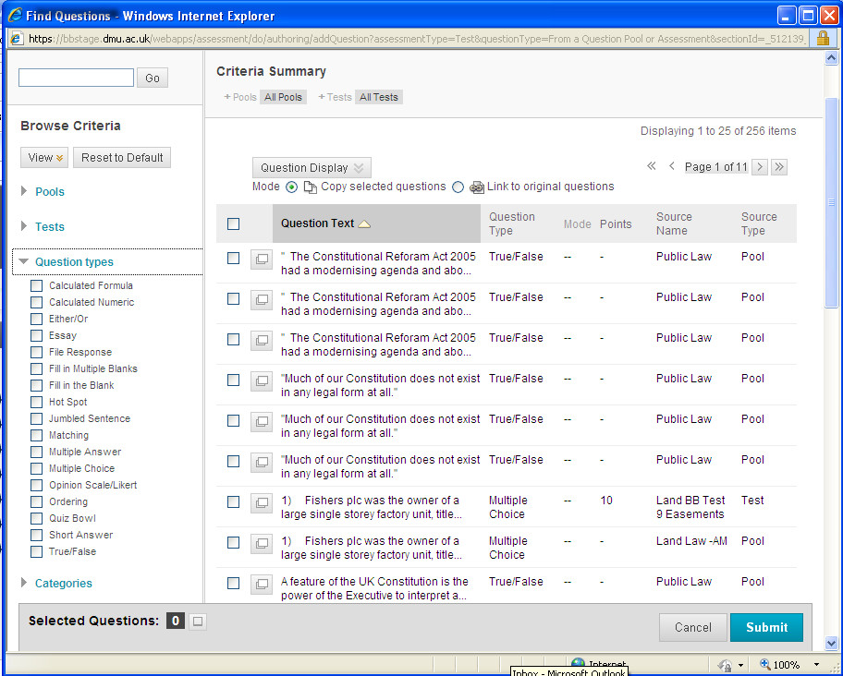
​
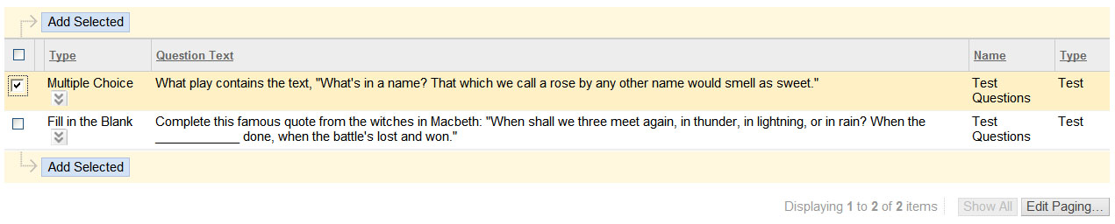
4. When you found your questions click on the Add Selected button.
3. On the next screen under 2) Test Availability set up when the test should be available, number of attempts students are allowed and timing. Please note that unless Make this Link Available is checked the test will NOT display for students. To set specific display dates for students use the Display After/ Display Until boxes.
Viewing Test Results
- If you have chosen to have the scores recorded in the Grade Center. Go to Control Panel > Grade Center > Tests.
- This will display all test submissions in your Grade Center in a smart view.
- To view results individually click on the double down arrows to the right of a submission and select View Grade Details.
- On the next screen click on View Attempt to see the student's test and submitted answers. You can also make changes to the points assigned to each question.
- To view the complete results of a Test go to the column for the survey in the Grade Center. Click on the double down arrows next to the Test name and select Download Results.
- On the Download Results menu the default for the format is Tab and By User and Valid Attempts are the included data. You do not need to adjust these selections. Select Click to Download Results. You can select to open this file with Microsoft Excel using the Open With tool on your computer and then view/save the file in this format.
- Test results can also be viewed by question with a breakdown of percentages for each answer. To do this go to Control Panel > Grade Center click on the double down arrows next to the Survey name and select Attempt Statistics. This will display a screen with all the survey questions with the percent answered for each response.

Item Analysis- checking the efficiency of the test
The new feature of Item Analysis allows you to look at, and analyse your test question. For example, if the majority in the cohort did not get one of the questions correct you can analyse whether this is because the question was too difficult or whether the students require further knowledge in that area. Likewise, if all students obtained 100 % in the test, you may feel the test was too easy.
- The Item Analysis feature can be accessed by many locations: you can access via the drop-down menu of a test; within the grade center column; or on the test menu page.
- The option below shows from the drop-down menu.
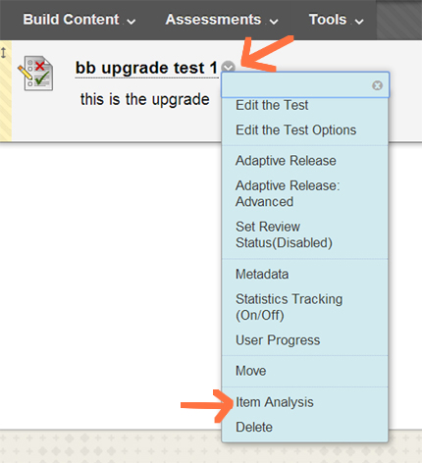

Test Access Log

This feature is useful for providing evidence when, and if, the system crashed whilst students were completing the test.
- To access the Test Access Log - go into the full grade center via > control panel> full grade center.
- Locate the student you need to look up and scroll towards the right until you reach the test column.
- Next to the icon/grade in the test column select the down pointing chevron and from the drop-down menu select the attempt (see image).
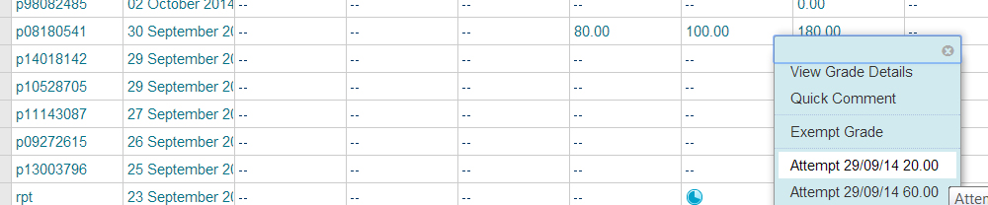
- In the attempt view the Access Log is located at the top left within Test Information (see image).
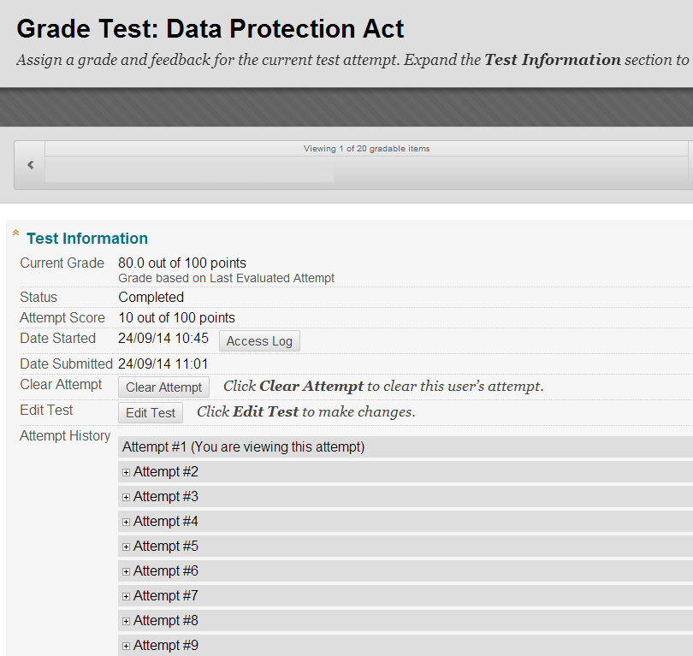
Clearing a Test Attempt
In the event that a test needs to be resubmitted and only one attempt is permitted by the test settings, you will need to clear the previous attempt in order for the student to retake the test.
Go to the Test in the Grade Center and click the double down arrows and select View Grade Details for the submission you want to change.
Then select Clear Attempt. You will receive a prompt asking if you want to "delete the attempt." Click OK and the submission will be deleted. The Grade History tab however will keep a record that this was done although the submission and all recorded answers were deleted.
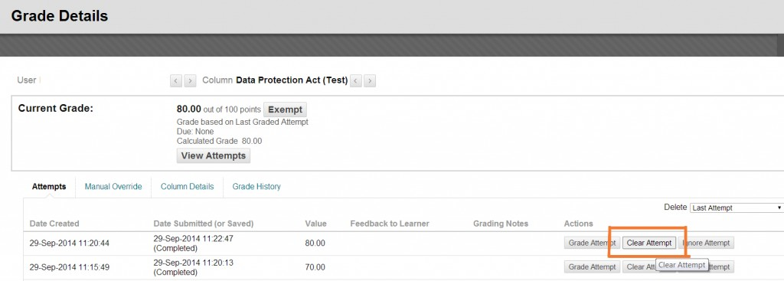
Grading Test by Question
There is the option for an instructor to grade tests by question as opposed to grading them one student submission at a time.
To use this feature, go to Control Panel > Grade Center > Tests and click on the double-down arrows to the right of the test.
From that dropdown select Grade Questions.
Then click on the number link under Responses.
Select EDIT for the question you wish to grade. This will open a drop-down where you can enter a score and feedback.
Click Submit when finished. A green bar will appear across the top of the graded question confirming your action. Graded questions now display with a green check-mark. Then you can proceed to grade the next submission.

Giving Advice to students taking a test in Blackboard
Before Taking an Online Test:
1. Before starting an on-line test, close all other software programs on your computer.
2. Disable all pop-up blockers. The steps for this will vary among browsers.
3. Use a hardwired connection rather than your wireless connection to the Internet to take an online test. Make sure that when you connect your network cable to your computer you also disable the wireless receiver so that it does not override or interfere with the wired connection.
4. If your computer is connected to the Internet through an ISP cable modem that is shared among a number of users (such as at an apartment complex), you will likely experience problems with on-line tests. Questions may be slow to display and your connection may be lost briefly, which will cut off your test session. You should try to find a computer for your on-line tests that is on a more stable connection.
5. Make sure you do not have more than one browser window opened to Blackboard; this can cause problems submitting your exam.
6. Make sure your computer is up-to-date on Windows patches and that it is virus and spyware free. If you are not sure of the reliability of your PC or are having problems, use a campus lab computer.
7. At the end of a test, click Submit ONLY ONCE. If your Internet connection is slow, you may think the quiz is not being sent. Wait at least 2-5 minutes for a confirmation that your quiz was received. The quiz must be sent, scored, and the results returned to you. Print out the receipt of the test submitted and keep it for your records.
8. If you must enter a password to begin the quiz, click the Submit button. Do not press the Enter key.
9. Blackboard Outages: Please be mindful (and wary) of taking the exams at times that time

Further advice for students taking a test online

More Information
Q: I have created a test in the Test Manager, but the students cannot see it.
A: The test needs to be added to a Content Areas using the Create Test link before it can be accessed. Tests also need to be made visible under the Modify test options before students can access them.
Q: I created a test earlier, but it doesn't show up in my Select an existing test box.
A: Tests can only be added to Content Areas once. If the test has been used before, it will not show up on the list of available tests.
Q: May I also create a link from the Announcements page?
A: You can create a link to the Content Areas where the test is located, but can no longer create a direct link to the test in the Announcements section. This is now done in the Announcements section using the Course Link function.
Q: How do I view grades?
A: When students take a test in Blackboard, their score is automatically entered in the Grade Center. If you want to view a student’s individual question responses, click on their score in the Grade Center.
Q: How do I grade the short answer questions?
A: From the Grade Center, access the student's test results by clicking on the Exclamation Point in the spreadsheet view. This will show you the student's individual answers. Add the points received in the Points field and click Submit. Q: How do I add an image, URL, or file to my question?
A: If you would like to add an image, URL or file to your question, click on the Question Settings, at the top of the test canvas page. From there you can choose to provide feedback to individual answers, add images, files and URLs to questions, add images and files to answers, and add categories to questions.
Q: What are the Correct and Incorrect Response text fields for?
A: If you choose to enable Show Feedback, students will see the text you place in these fields when they get the results of their quiz (specific to answering the question correctly or incorrectly). This area may be used for encouragement, for example, "Good job" or to point to a more specific information, "Incorrect, review chapter 15."
Q: I would like to add a new question between question 4 and 5. How do I do this?
A: Create a question as you normally would and once you’re done, drag and drop the question where you would like it to be place in the ordering.
Q: I finished my Test and saved it. Now I want to make a change and add more questions. How do I do that?
A: Click on the double down arrow, or chevron, next to the name of the test. Click on either Edit the Test or Edit the Test Options.
Q: I have finished the test; how do I make it available for my students?
A: Once the test has been created, enter the Content Area sections (Course Information, Course Documents, and Assignments) and hover over Evaluate and click on Create Test. Click on the test you want to add and click Submit. Click the radio button next to Yes for Make the Link
Available.

