Setting up and deploying a Wiki in Blackboard
Note: the screen images used in this guide are based on a different Blackboard interface. However, the setup and deployment process is the same in the current interface style.
A Wiki is a Web page(s) where people can work collaboratively. The most common example is Wikipedia, the online encyclopaedia that allows anyone in the world to contribute content to it. What makes a wiki unique is that multiple participants can edit the same page, and everyone can view it. The instructor can access the Wiki content and collaborate, too.
Blackboard has a wiki function available in its modules. The wiki located in Blackboard is available to only those users of Blackboard. More specifically, wikis used on your course modules will only be seen by those people (students and tutors) registered on your module.

Blackboard Wikis
Blackboard has two types of wiki, the Course Wiki and the Group Wiki.
Course Wiki
In a course wiki everyone enrolled on the Blackboard module will be able to view a course wiki. A wiki can be set up which allows all course members to add/edit and maintain the course wiki or as a tutor you can restrict students to add or edit the wiki.
Group Wiki
If there are groups set up in your Blackboard module you can allow the group the usage of the wiki tool within the group. This is one tool amongst many which the students in a group can use.

Wiki Features
You can create multiple linked web pages within the wiki. You can include images and hyperlinks without needing to know fully how to edit web pages. It is also possible to add comments to content created by others. Besides adding content to a wiki, any user can also edit existing content. Don’t worry that some content may be erased by a fellow user; the Blackboard wiki maintains a full history of every change that has been made, when and by whom. As a Tutor you can see the stages of the wiki development as well as being able to view relevant contribution of each team member.
Creating a Wiki
- Under Course Control Panel, on the bottom left side of the page, click on Course Tools and then click on Wikis.
- Click on the Create Wiki button.
- Fill in the Name and instructions for the Wiki.

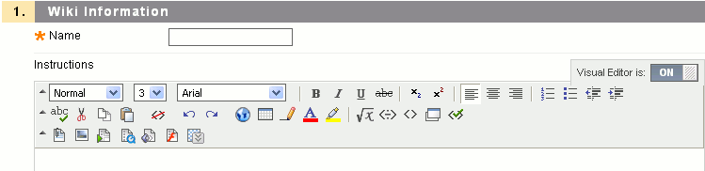
- You can also set the following options:
• Wiki Availability – Yes / No, and optional Display After and Until Dates.
• Student Access – Closed to editing / Open to editing.
• Grade Wiki – No grading / Grade with Points possible setting. If you set a grade a gradebook column will be created in GradeCenter
- Select Submit.
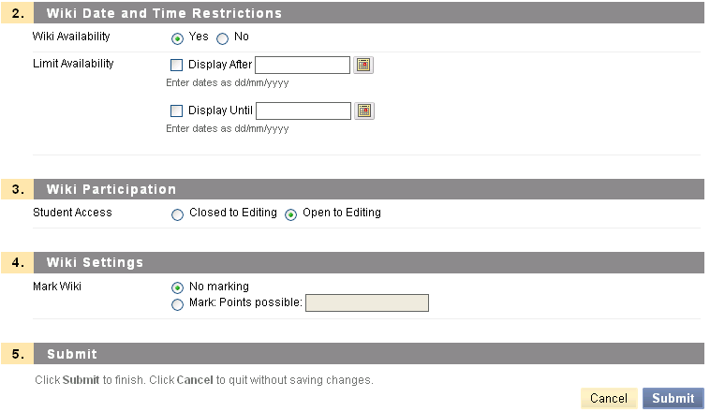
- Once your wiki is created you have to link to the wiki so that it is available to all users to use. To do this, in Edit Mode, go to the desired content area you desire to add your wiki.
- Under the 'Add Interactive Tool' button, select Wiki.
- Under the Create Link Wiki' page, select 'Link to a Wiki and select the wiki you have created in the list box.
- Click Next. Note in this view you can also create a new wiki.
- Add some useful information to your students about your wiki you can change the default name and add some descriptive text.
- Set the Options:
Available: Set this to Yes if you want your blog available.
Track Views: Set the tracking if you want to monitor access.
Date Restrictions: Set the date restrictions.
- Click Submit. The wiki is created.

When you first enter a newly created wiki, you will be need to create a 'first' or 'home' page as there are no pages. Once your page is created you can add more pages from the wiki: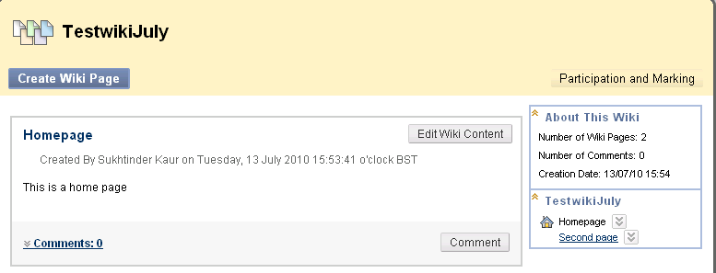
Create Wiki Page button allows you to create and add wiki pages.
'About This WIki' provides some information about the wiki and the below panel lists the pages in the wiki
'Participation and Marking' button - Each user's contributions to the Wiki are represented by Words Modified and Page Saves. If the wiki is markable, the participant can be marked by clicking his or her name.
You can view participation summary for other members by selecting their name from the 'View Contribution' list.
'Show All Members' button under 'View Contribution' allows you to view members who have not contributed, you can toggle this button to 'Hide Members without Contributions'.
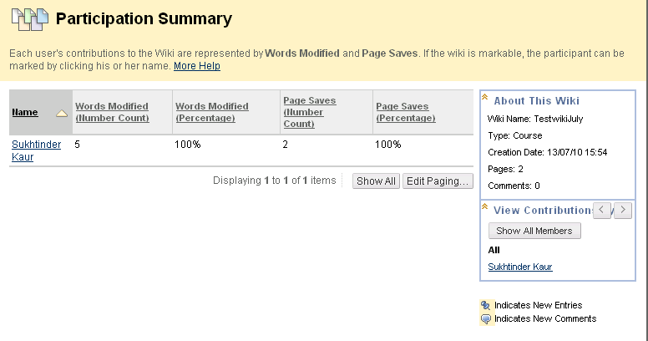
On selecting a user, you can further view their contribution in more detail as illustrated below:
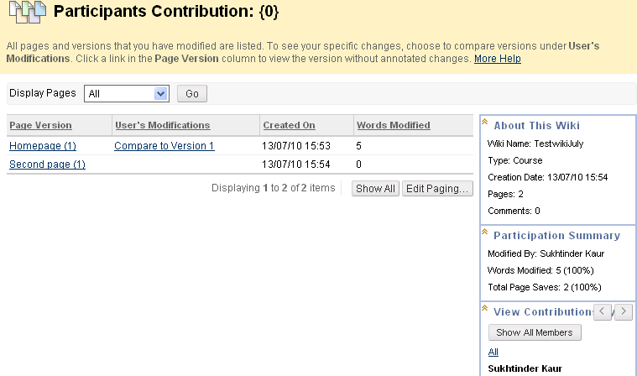
13. Click OK to take you back to the Wiki front page

Monitoring Student Participation
By reviewing participation, you can access student contributions to a wiki by total pages saved and by total lines modified. You can also see change history for any page and compare versions of the pages.
Selecting Participant Detail and Change History:
1. Click the View Participation button for a wiki.
2. Select the View Detail button for a participant.
3. Select the See Change History button for a page to review the revision history.
4. Select the View Diff button for a version of the page.
5. To view a previous version, click the Prev Diff button if applicable.
6. To view a newer version, click the Next Diff button if applicable.
Returning to Content Area History:
1. Click the Back to Revision History button to return to the page history.
2. Click the Go Back button to return the student participation detail page.
3. Click the Go Back button to return the members participation page.

Viewing Wiki Page History
Reviewing history allows you to view all the revisions made to any wiki page, to compare changes between different versions of the page, and to revert to any previous version.

* Green highlight indicates text has been added.
* Yellow highlight indicates text has been modified.
* Red highlight and strikethrough indicate text has been deleted.
To view wiki history:
1. Open the desired wiki (see Accessing the Course Wiki and Accessing Additional Wikis).
2. Click the History link in the wiki sidebar.
Selecting a participant version:
1. Click the View Diff button for a participant.
2. To view a previous version, click the Prev Diff button if applicable.
3. To view a newer version, click the Next Diff button if applicable.
4. Click the Back to Revision History button to return to the wiki participation page.

