Setting up and deploying a discussion forum in Blackboard.
The Discussion Board is a communication tool that can be used to enhance your Blackboard course. The discussion board can contain multiple forums, forum conversations are grouped in threads that contain a main posting and all related replies (messages). Generally, a forum is about a single topic. All students on your Blackboard course can contribute towards forums. Depending on how the discussion forum is set up, students can create threads and messages. You can also choose to grade and leave feedback to student messages in threads and forums and assign individual grades for student participation. Students can view grades/feedback from within the forum (only seeing their own).
If you use groups in Blackboard you can also set access to group discussion boards which only members in groups can view their discussion forums.

Creating a discussion board forum
- Navigate to a content area where you want to add a link to a discussion forum. Click the Tools tab and select Discussion Board.
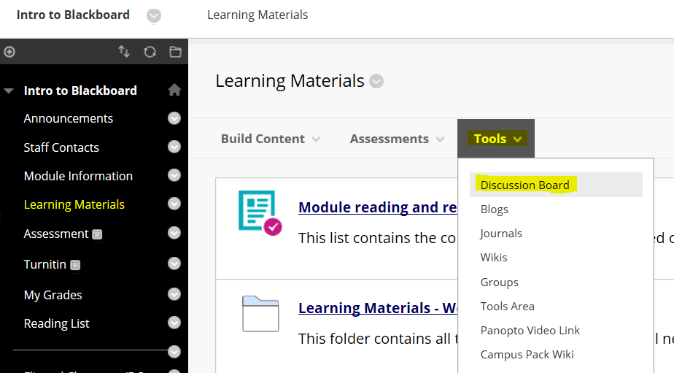
- Click on the Create New Forum button.
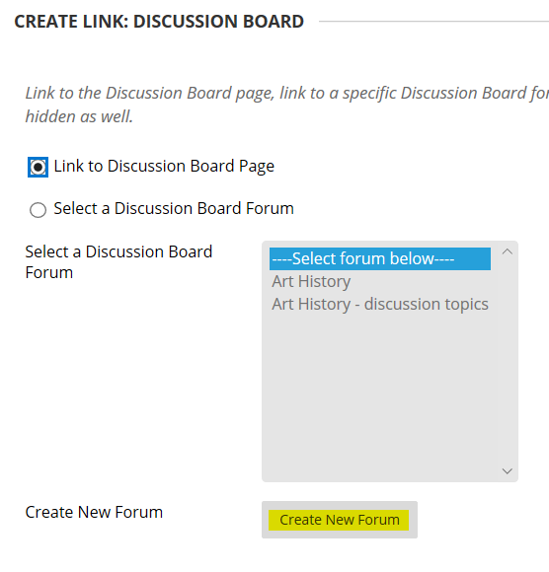
- Fill in the Name, Description, and Availability of the forum. There is no need to set the date/time restrictions.
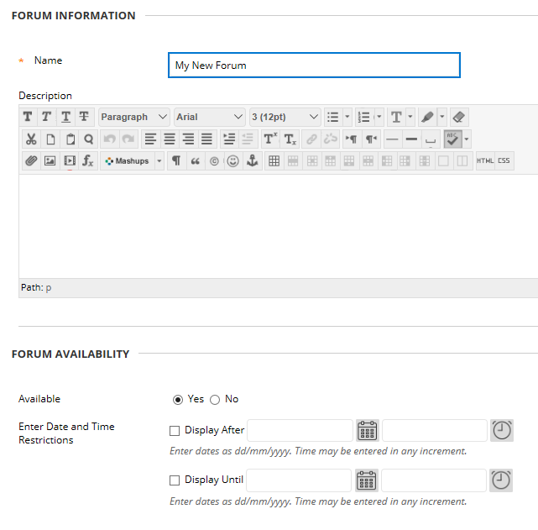
- You may select any of the forum settings. Forums have many different settings that affect how users interact with the forums. Setting can be selected by choosing the radio button or checkbox.
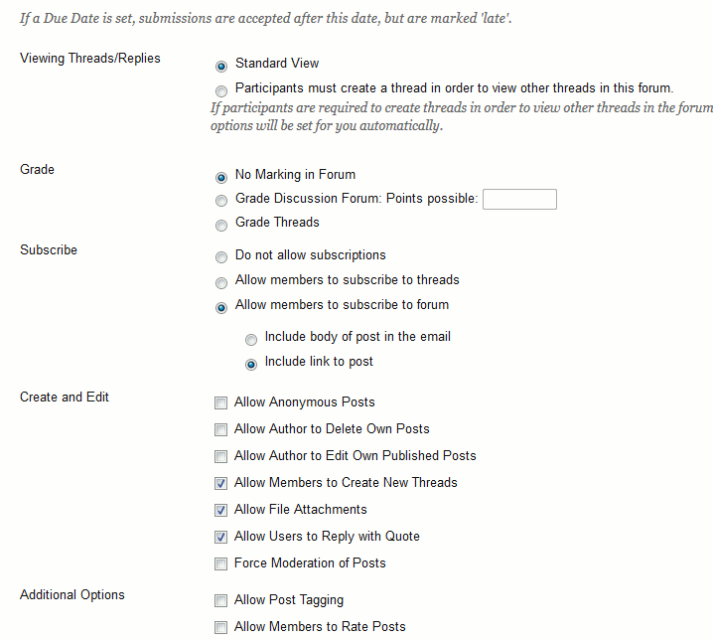
- Setting Options
Viewing Threads/Replies - A forum can be set so that students only see posts from other students once they themselves have posted a message. If you want to set this choose 'Particpants must create a thread in order to view other threads in this forum' or if you don't want this setting leave the 'Standard View'
Grade
You can choose to grade and leave feedback in forums or threads or not to grade a forum. If you choose to give grades a column will be automatically created in Blackboard's GradeCenter which will store all student marks. Users’ posts can be graded in two different ways.
* Grade Discussion Forum - Users can have their overall participation in a Forum graded. If you choose to grade the forum you need to decide how many posts a student should enter before the 'Needs Grading' status will show for that student. Selecting Grade Forum allows the option to select the box and the number of posts required to show participants in Needs Grading status. Applying this setting will show the Needs Grading icon in the Grade Centre and place the posts in the queue on the Needs Grading page after the specified number of posts have been made.
* Grade Threads - Users can be graded on a thread-by-thread basis. If you choose to grade threads, students will not be able to create new threads.
Subscribe
You can choose to allow students to subscribe to a thread or forum. If you choose for students to subscribe, they will receive an email whenever a new message is posted to a thread or forum. The following can be set:
Do not allow subscriptions
Allow members to subscribe to threads
Allow members to subscribe to forums
Once a subscription option is selected, users can select:
* Include body of post in the email: The entire post is sent in the body of the email message.
* Include link to post: A link to the post is sent in the body of the email message.
Create and Edit
Allow Anonymous Posts: Users can post to the Forum without revealing their Usernames. If Forums allow anonymous posts, they cannot be graded. If you choose to use option you may want to use this in conjunction with the further option below 'Force Moderation of Posts' to discourage inappropriate messages.
Allow Author to Delete Own Posts: Users can delete all their own posts or just posts without replies. Deleted posts cannot be recovered and you may want to limit this with 'Only posts with no replies'.
Allow Author to Edit Own Published Posts: Please note no record of the original post is kept if a student amends their original message. You may not want to set this option if you have chosen to grade the forum/thread.
Allow Members to Create New Threads: This setting is enabled by default. If Threads are graded, members cannot create new Threads and members cannot post anonymously.
Allow File Attachments: This setting is enabled by default. Attaching large files will slow down the Discussion Board.
Allow Users to Reply with Quote: This setting is enabled by default. When users click Quote, the message they are replying to is included in the post.
Force Moderation of Posts: This requires all messages to be reviewed by a Moderator before they can be published to the Forum. The Instructor is the Manager of the Forum and can moderate all posts. Others can be assigned the role of moderator to determine if posts are published to the Forum or returned to the author for editing.
Additional Options
Allow Post Tagging: Tagging is a way to add metadata to posts to make them easier to retrieve in searches.
Allow Members to Rate Posts: Users can rate the quality of the post, using a five-star system.
6. Select the Submit button.
7. Your new forum will be added to the list. Click Next
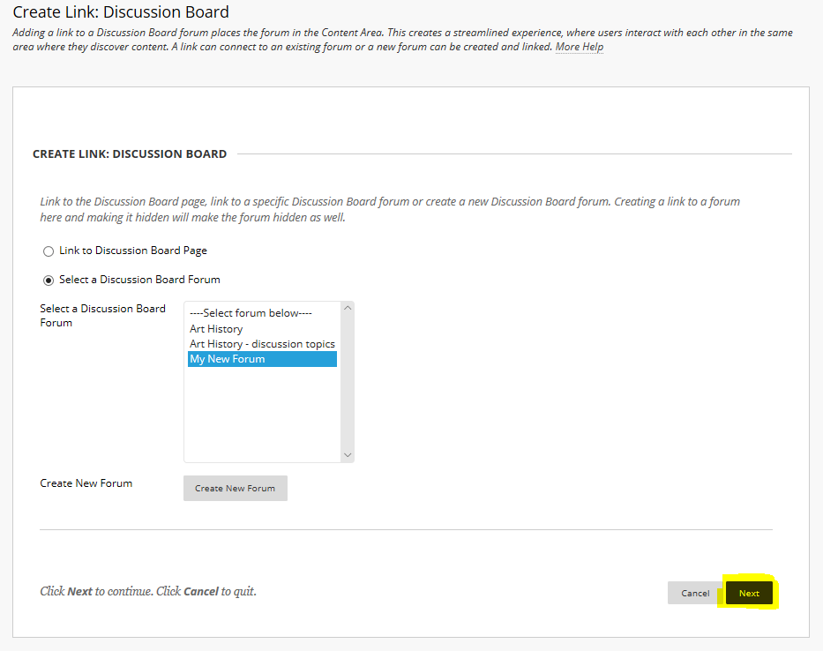
8. Click Submit
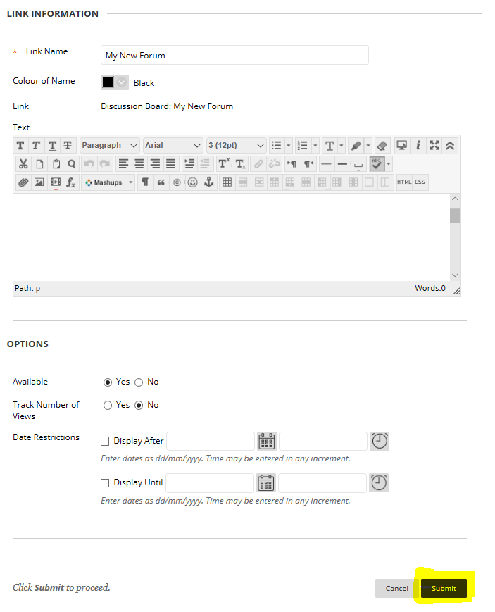
A link to the forum will now appear in the content area. This is the link that students click on to contribute to the forum. Staff can also use this link to view all of the discussion in the forum and make their own contribution.
