Installing DMU Replay on a non-DMU computer
This guide enables you to install the DMU Replay software on a non-DMU issued computer that may be used for work/academic purposes.
What you will need
- An Internet connected PC or Mac with administrator access

- Once logged on to the computer, open your preferred web browser and navigate to replay.dmu.ac.uk (this will re-direct you to dmureplay.cloud.panopto.eu)
2. Click the ‘Sign In’ button.
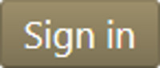
3. Log in using your usual Blackboard log in details.
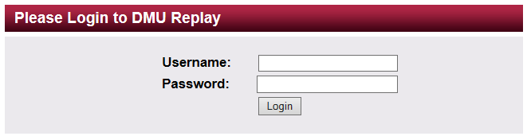
In order to log in here you must be an Instructor on a ‘Panopto provisioned’ Blackboard shell. Provisioning can be done by Instructors on the Blackboard shell, click here to view the guide.
4. You will now see the DMU Replay dashboard.
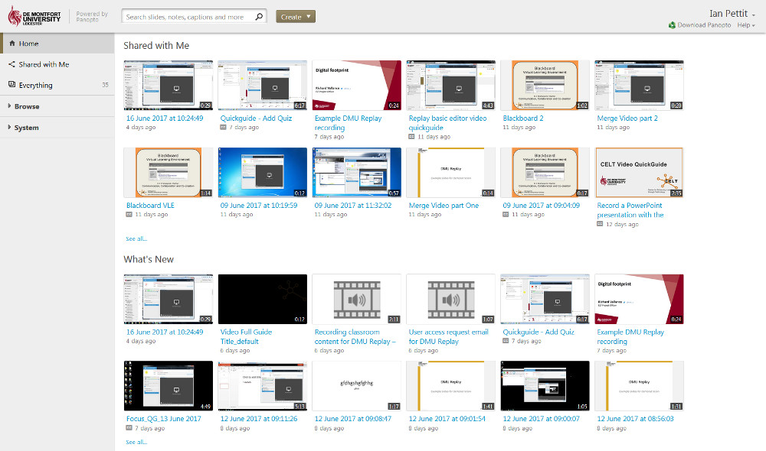
5. At the top right of the screen, you will see the ‘Download Recorder’ option.
6. Click the Download Recorder link.
7. Click the Download Panopto button.
8. Download and install the software as usual, ensuring that the ‘Panopto Web Server’ is set to dmureplay.cloud.panopto.eu
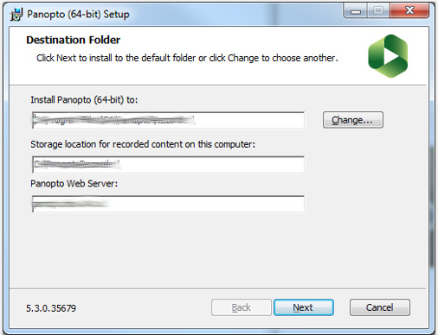
9. The software will now be installed.
Mac users may be presented with an additional popup (ensure that the Server name is dmureplay.cloud.panopto.eu; click ‘Find providers’ and select ‘DMU Replay’. Login using your usual Username and password. The Mac Version of the software will now open and you can record
10. The software is used in the same way as when making a recording at your desk.
If you wish to explore different ways in which Panopto may be able to help with innovation please contact your local ELT Project Officer.

