Accessing and re-using a Turnitin rubric template that was created by a colleague who has since left DMU.
1. Navigate to a Blackboard module where the rubric you want to access has been used to mark students’ work.
2. Open a student submission which has been marked using the rubric.
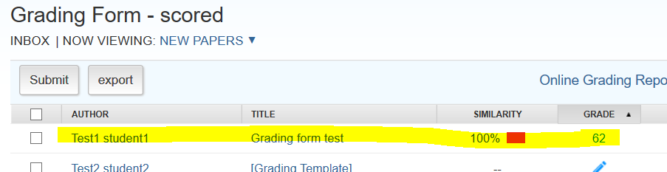
3. Display the rubric by clicking the display rubric button.
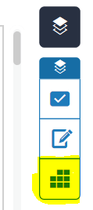
4. Click the cog button.
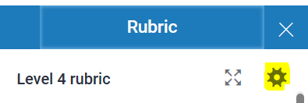
5. In the rubric panel click the burger menu.

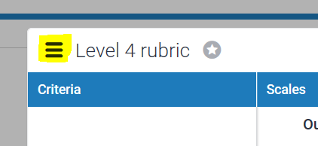
6. Click the Download option.

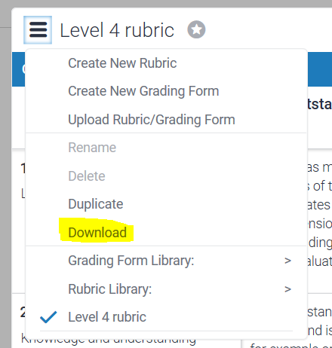
7. Save the rubric file to your computer.

8. Launch the Rubric /Form manager panel.
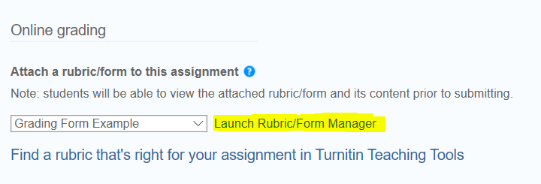
9. Click the Import/Export button and select Import.
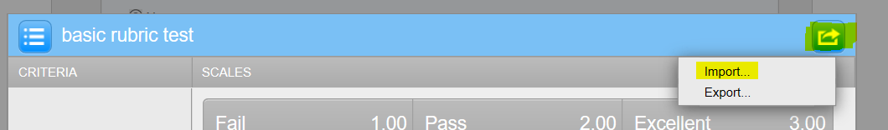
10. Click the Select Files button.

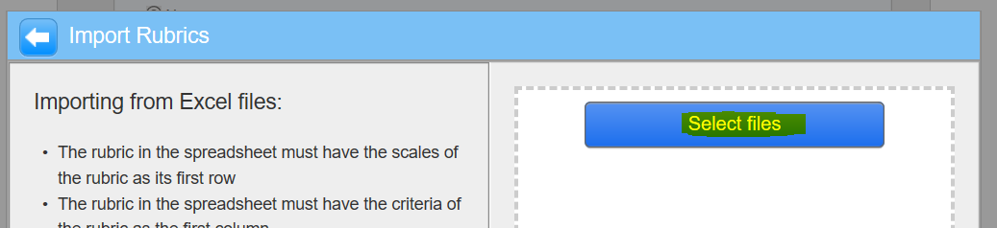
11. Locate the Rubric file that you downloaded to your PC, and open it.
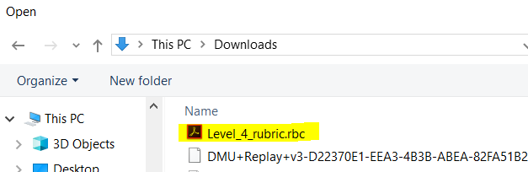
12. The rubric will be imported and added to your list of available rubrics.
